[](https://www.comsol.com/)

Phase c m

|  |  |
| --- | --- |
| Report date | Apr 29, 2025, 11:17:13 AM |

Contents

1. Global Definitions

1.1. Shared Properties

2. Component 1

2.1. Definitions

2.2. Geometry 1

2.3. Materials

2.4. Laminar Flow

2.5. Heat Transfer in Solids 2

2.6. Heat Transfer in Fluids 3

2.7. Mesh 1

3. Study 1

3.1. Time Dependent

3.2. Solver Configurations

4. Results

4.1. Data Sets

4.2. Derived Values

4.3. Plot Groups

# Global Definitions

|  |  |
| --- | --- |
| Date | Apr 29, 2025, 6:12:16 AM |

Global settings

|  |  |
| --- | --- |
| Name | Phase c m.mph |
| Path | C:\Users\chaud\OneDrive\c++\Desktop\phase c m.mph |
| Version | COMSOL Multiphysics 6.3 (Build: 335) |
| Unit system | SI |

Used products

|  |
| --- |
| COMSOL Multiphysics |

Computer information

|  |  |
| --- | --- |
| CPU | Intel64 Family 6 Model 140 Stepping 1, 4 cores, 7.69 GB RAM |
| Operating system | Windows 11 |

## Shared Properties

### Default Model Inputs

|  |  |
| --- | --- |
| Tag | cminpt |

# Component 1

|  |  |
| --- | --- |
| Date | Apr 28, 2025, 9:03:29 AM |

Settings

| **Description** | **Value** |
| --- | --- |
| Unit system | Same as global system (SI) |
| Geometry shape function | Automatic |
| Avoid inverted elements by curving interior domain elements | Off |

Spatial frame coordinates

| **First** | **Second** | **Third** |
| --- | --- | --- |
| x | y | z |

Material frame coordinates

| **First** | **Second** | **Third** |
| --- | --- | --- |
| X | Y | Z |

Geometry frame coordinates

| **First** | **Second** | **Third** |
| --- | --- | --- |
| Xg | Yg | Zg |

Mesh frame coordinates

| **First** | **Second** | **Third** |
| --- | --- | --- |
| Xm | Ym | Zm |

## Definitions

### Nonlocal Couplings

#### Average 1

|  |  |
| --- | --- |
| Coupling type | Average |
| Operator name | aveop2 |

Selection

|  |  |
| --- | --- |
| Geometric entity level | Domain |
| Selection | Geometry geom1: Dimension 3: Domain 2 |

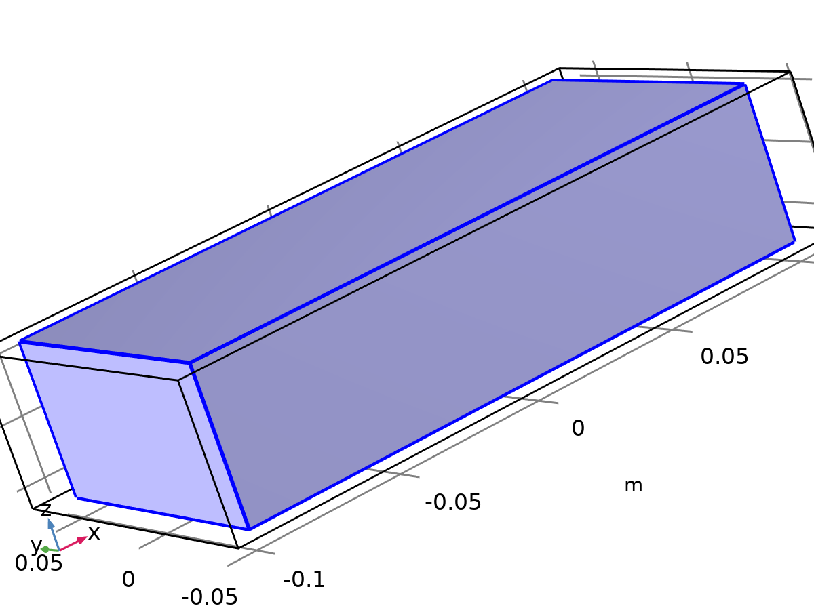

Selection

### Coordinate Systems

#### Boundary System 1

|  |  |
| --- | --- |
| Coordinate system type | Boundary system |
| Tag | sys1 |

Coordinate names

| **First** | **Second** | **Third** |
| --- | --- | --- |
| t1 | t2 | n |

## Geometry 1

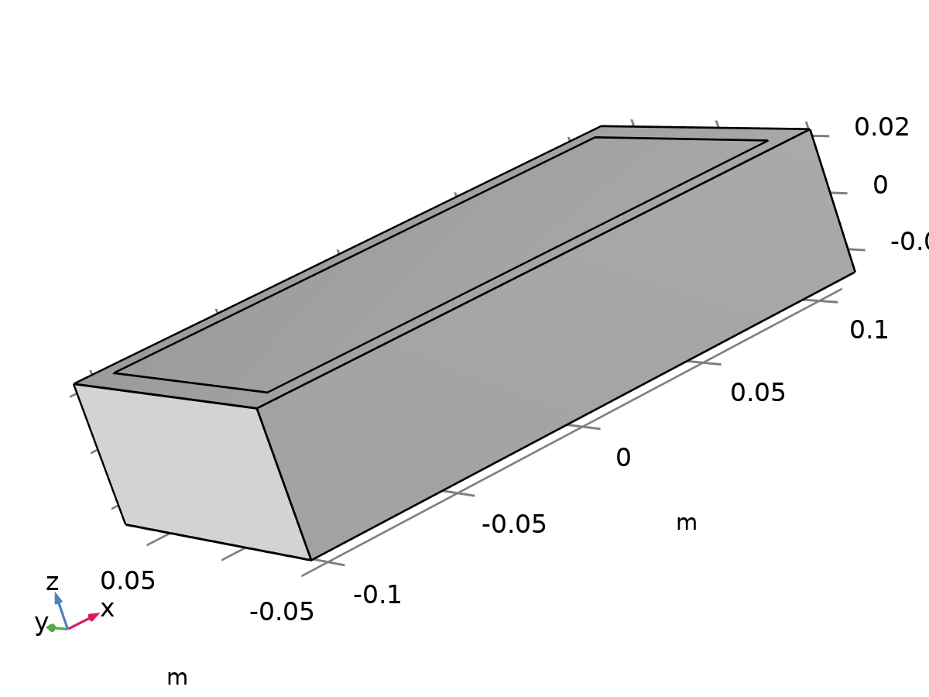

Geometry 1

Units

|  |  |
| --- | --- |
| Length unit | m |
| Angular unit | deg |

Geometry statistics

| **Description** | **Value** |
| --- | --- |
| Space dimension | 3 |
| Number of domains | 2 |
| Number of boundaries | 12 |
| Number of edges | 24 |
| Number of vertices | 16 |

### Battery Block (blk1)

Size and shape

| **Description** | **Value** |
| --- | --- |
| Width | 0.2 |
| Depth | 0.1 |
| Height | 0.05 |

Position

| **Description** | **Value** |
| --- | --- |
| Base | Center |
| Position | {0, 0, 0} |

Axis

| **Description** | **Value** |
| --- | --- |
| Axis type | z - axis |

### PCM Layer (blk2)

Size and shape

| **Description** | **Value** |
| --- | --- |
| Width | 0.22 |
| Depth | 0.12 |
| Height | 0.05 |

Position

| **Description** | **Value** |
| --- | --- |
| Base | Center |
| Position | {0, 0, 0} |

Axis

| **Description** | **Value** |
| --- | --- |
| Axis type | z - axis |

### Form Union (fin)

Information

| **Description** | **Value** |
| --- | --- |
| Build message | Formed union of 2 solid objects. Union has 2 domains, 12 boundaries, 24 edges, and 16 vertices. |

## Materials

### Battery block



Battery block

Selection

|  |  |
| --- | --- |
| Geometric entity level | Domain |
| Selection | Geometry geom1: Dimension 3: Domain 2 |

Material parameters

| **Name** | **Value** | **Unit** | **Property group** |
| --- | --- | --- | --- |
| Dynamic viscosity | eta(T) | Pa·s | Basic |
| Ratio of specific heats | 1.4 | 1 | Basic |
| Heat capacity at constant pressure | 1000 | J/(kg·K) | Basic |
| Density | 2500 | kg/m³ | Basic |
| Thermal conductivity | 1 | W/(m·K) | Basic |

Basic

| **Description** | **Value** | **Unit** |
| --- | --- | --- |
| Dynamic viscosity | eta(T) | Pa·s |
| Ratio of specific heats | 1.4 | 1 |
| Heat capacity at constant pressure | 1000 | J/(kg·K) |
| Density | 2500 | kg/m³ |
| Thermal conductivity | 1 | W/(m·K) |

Functions

| **Function name** | **Type** |
| --- | --- |
| eta | Piecewise |
| Cp | Piecewise |
| rho | Analytic |
| k | Piecewise |
| cs | Analytic |
| alpha_p | Analytic |
| muB | Analytic |

#### Piecewise

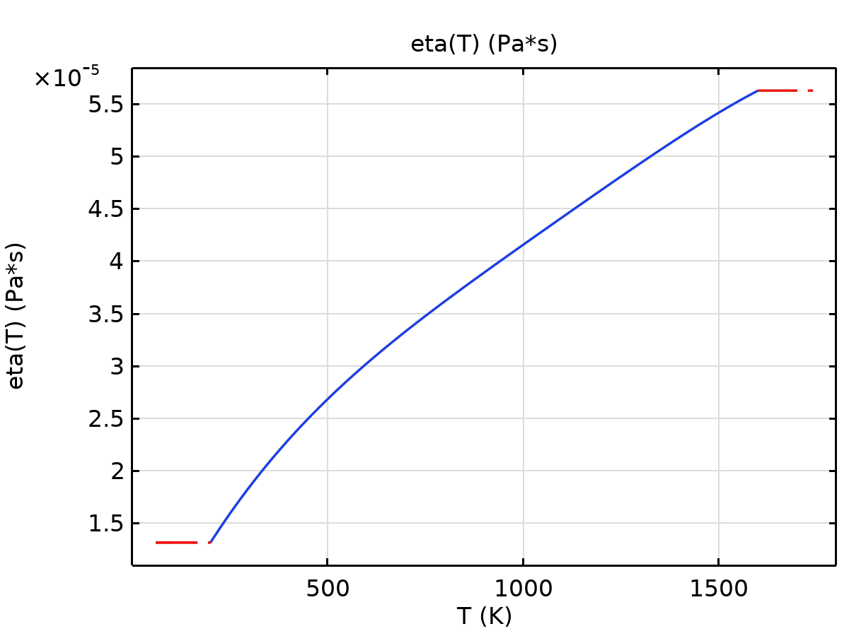

eta

#### Piecewise 2

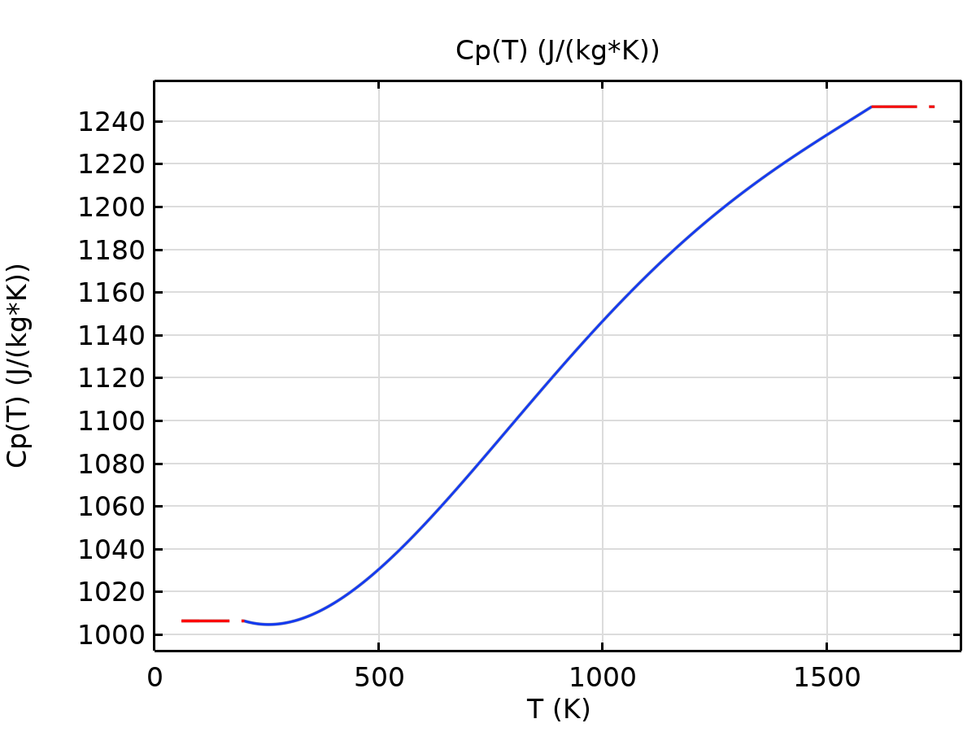

Cp

#### Analytic

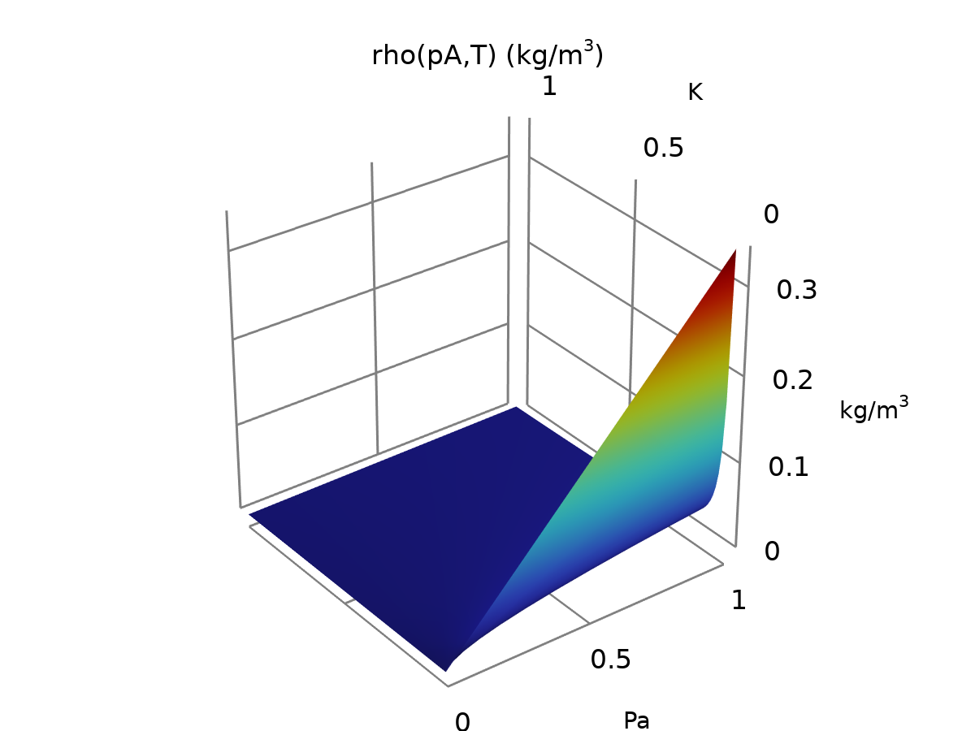

rho

#### Piecewise 3

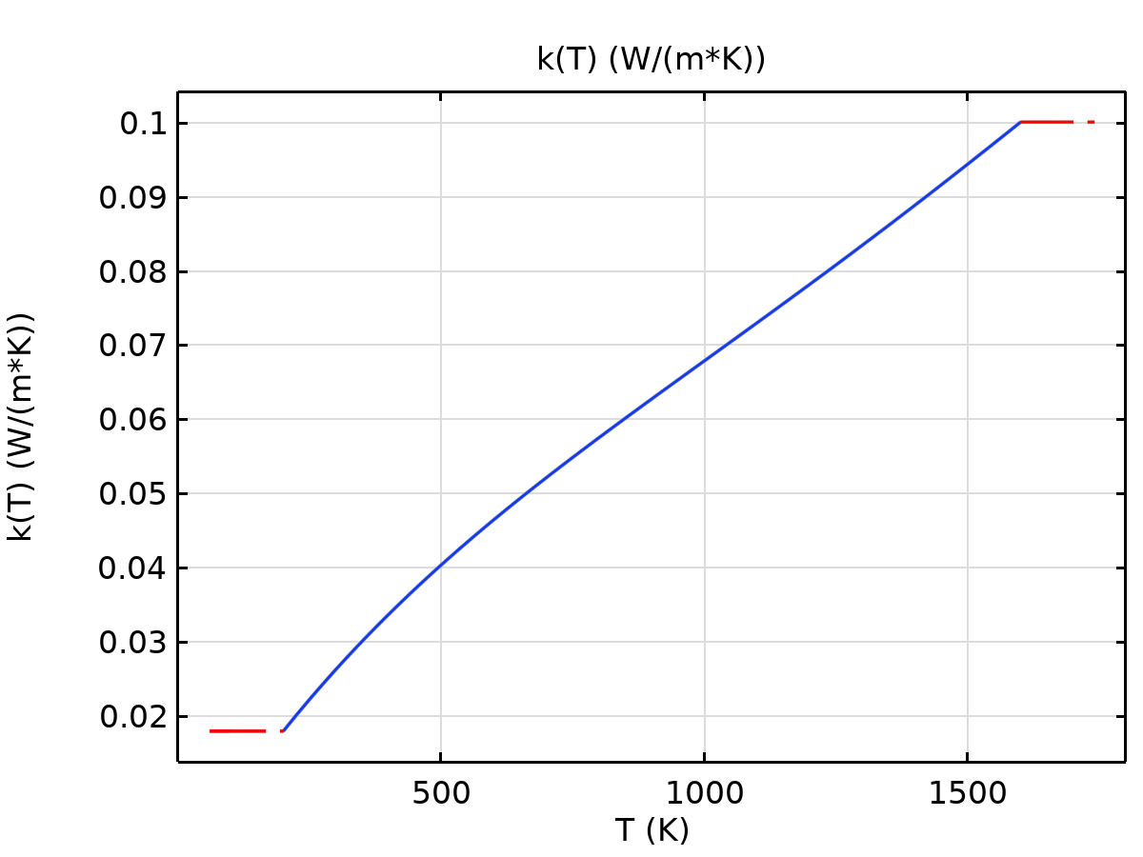

k

#### Analytic 2

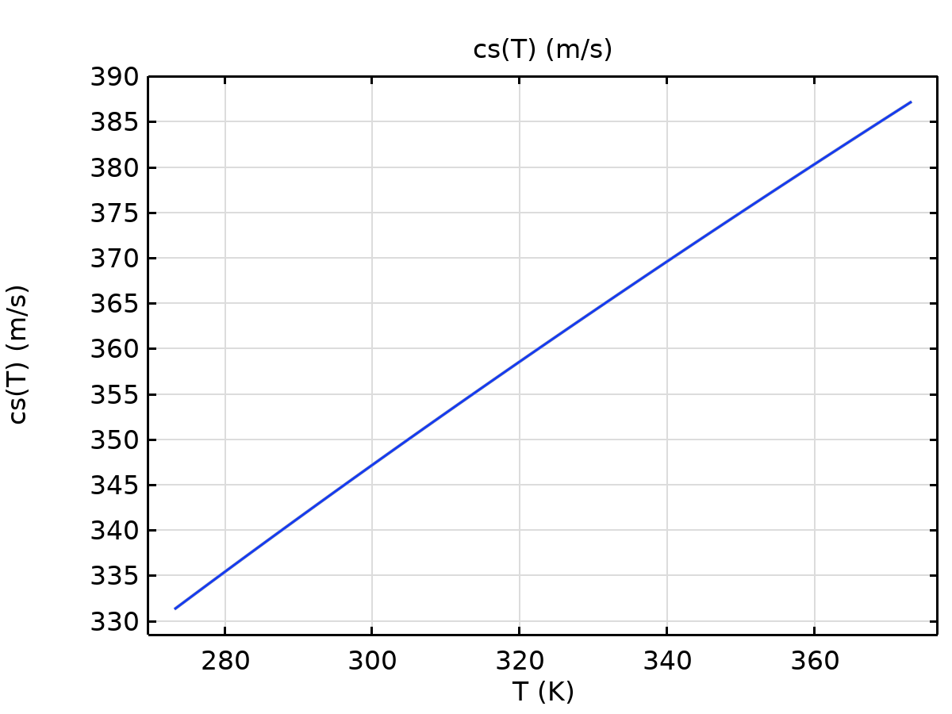

cs

#### Analytic 1

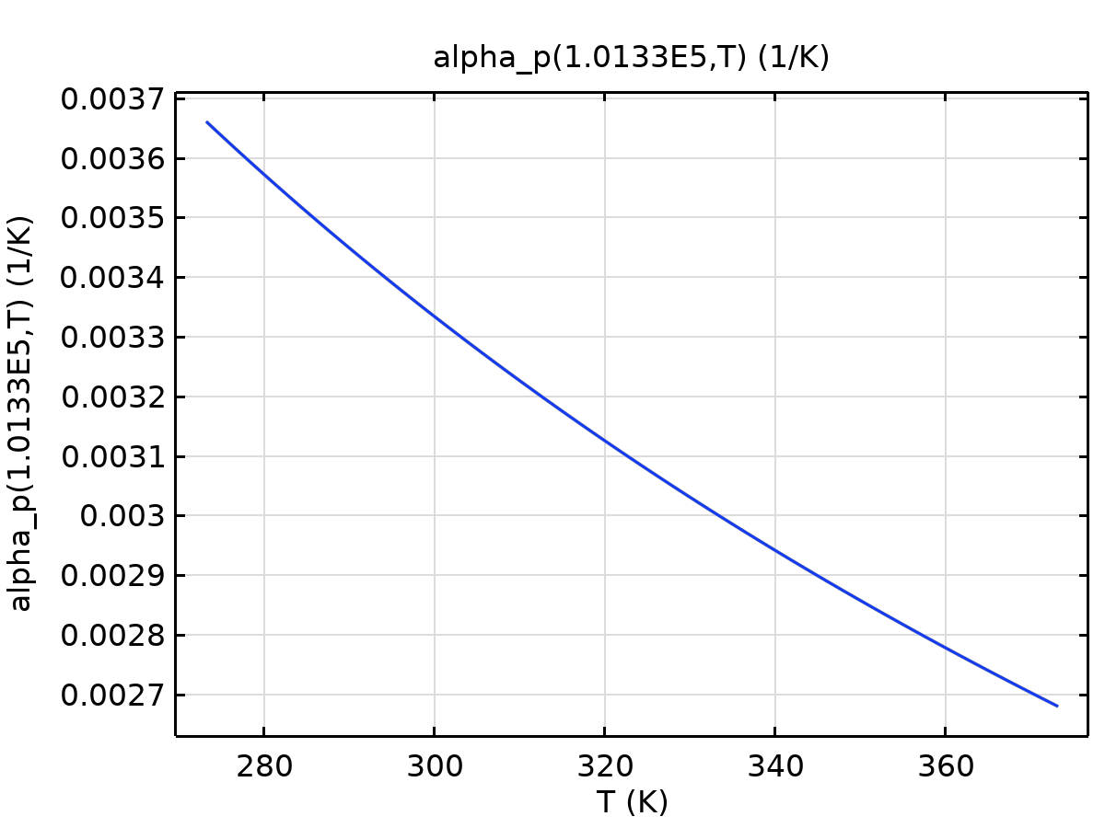

alpha_p

#### Analytic 2a

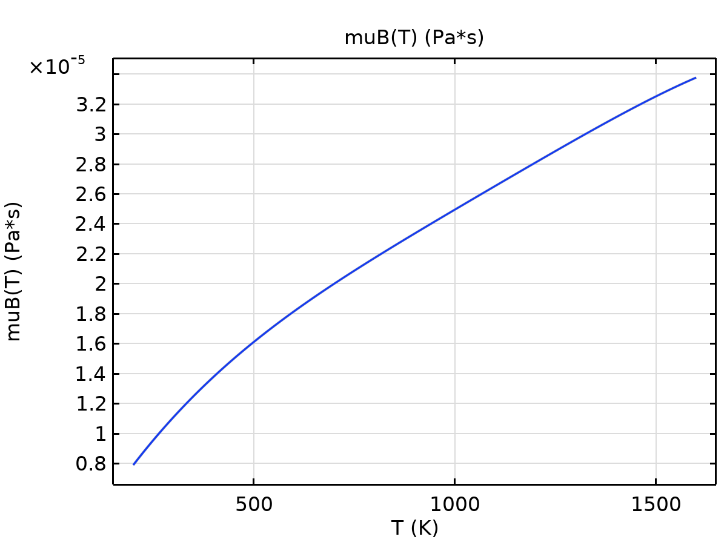

muB

### PCM Layer

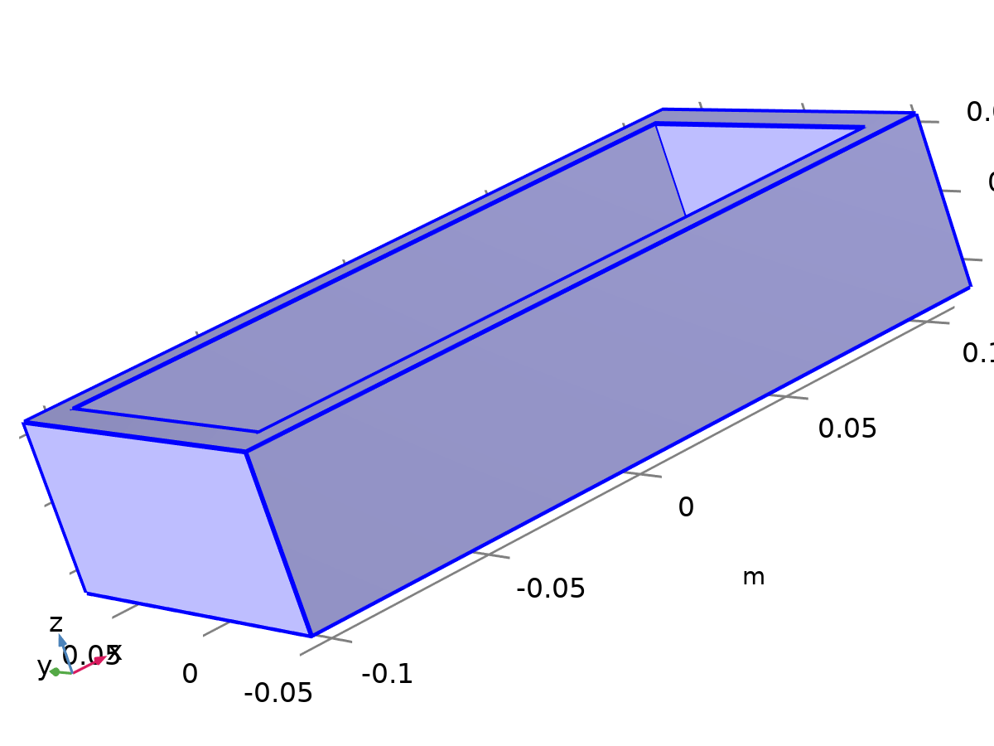

PCM Layer

Selection

|  |  |
| --- | --- |
| Geometric entity level | Domain |
| Selection | Geometry geom1: Dimension 3: Domain 1 |

Material parameters

| **Name** | **Value** | **Unit** | **Property group** |
| --- | --- | --- | --- |
| Dynamic viscosity | eta(T) | Pa·s | Basic |
| Ratio of specific heats | 1.4 | 1 | Basic |
| Heat capacity at constant pressure | 2000 | J/(kg·K) | Basic |
| Density | 800 | kg/m³ | Basic |
| Thermal conductivity | 0.2 | W/(m·K) | Basic |

Basic

| **Description** | **Value** | **Unit** |
| --- | --- | --- |
| Dynamic viscosity | eta(T) | Pa·s |
| Ratio of specific heats | 1.4 | 1 |
| Heat capacity at constant pressure | 2000 | J/(kg·K) |
| Density | 800 | kg/m³ |
| Thermal conductivity | 0.2 | W/(m·K) |

Functions

| **Function name** | **Type** |
| --- | --- |
| eta | Piecewise |
| Cp | Piecewise |
| rho | Analytic |
| k | Piecewise |
| cs | Analytic |
| alpha_p | Analytic |
| muB | Analytic |

#### Piecewise



eta

#### Piecewise 2



Cp

#### Analytic



rho

#### Piecewise 3



k

#### Analytic 2



cs

#### Analytic 1



alpha_p

#### Analytic 2a



muB

### Coolin Pipes

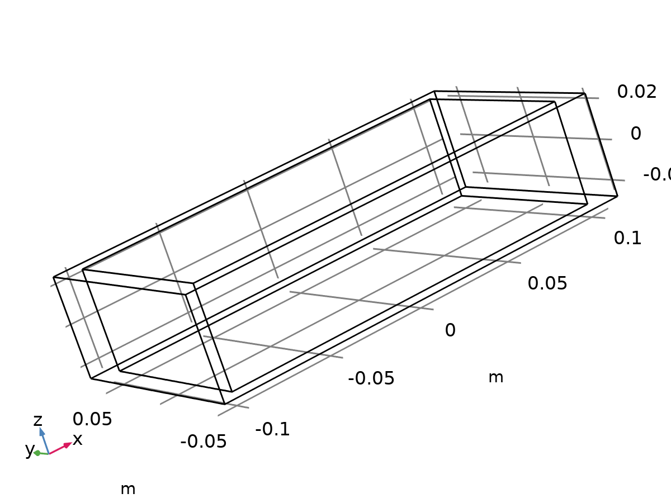

Coolin Pipes

Selection

|  |  |
| --- | --- |
| Geometric entity level | Domain |
| Selection | Geometry geom1: Dimension 3: No domains |

Basic

| **Description** | **Value** | **Unit** |
| --- | --- | --- |
| Coefficient of thermal expansion | alpha_p(pA, T) | 1/K |
| Mean molar mass | 0.02897 | kg/mol |
| Bulk viscosity | muB(T) | Pa·s |
| Relative permeability | 1 | 1 |
| Relative permittivity | 1 | 1 |
| Dynamic viscosity | eta(T) | Pa·s |
| Ratio of specific heats | 1.4 | 1 |
| Electric conductivity | 0 | S/m |
| Heat capacity at constant pressure | 4180 | J/(kg·K) |
| Density | 1050 | kg/m³ |
| Thermal conductivity | 0.6 | W/(m·K) |
| Speed of sound | cs(T) | m/s |

Functions

| **Function name** | **Type** |
| --- | --- |
| eta | Piecewise |
| Cp | Piecewise |
| rho | Analytic |
| k | Piecewise |
| cs | Analytic |
| alpha_p | Analytic |
| muB | Analytic |

#### Piecewise



eta

#### Piecewise 2



Cp

#### Analytic



rho

#### Piecewise 3



k

#### Analytic 2



cs

#### Analytic 1



alpha_p

#### Analytic 2a



muB

Refractive index

| **Description** | **Value** |
| --- | --- |
| Refractive index, real part | 1 |
| Refractive index, imaginary part | 0 |

Nonlinear model

| **Description** | **Value** |
| --- | --- |
| Parameter of nonlinearity | (def.gamma + 1)/2 |

## Laminar Flow

Used products

|  |
| --- |
| COMSOL Multiphysics |

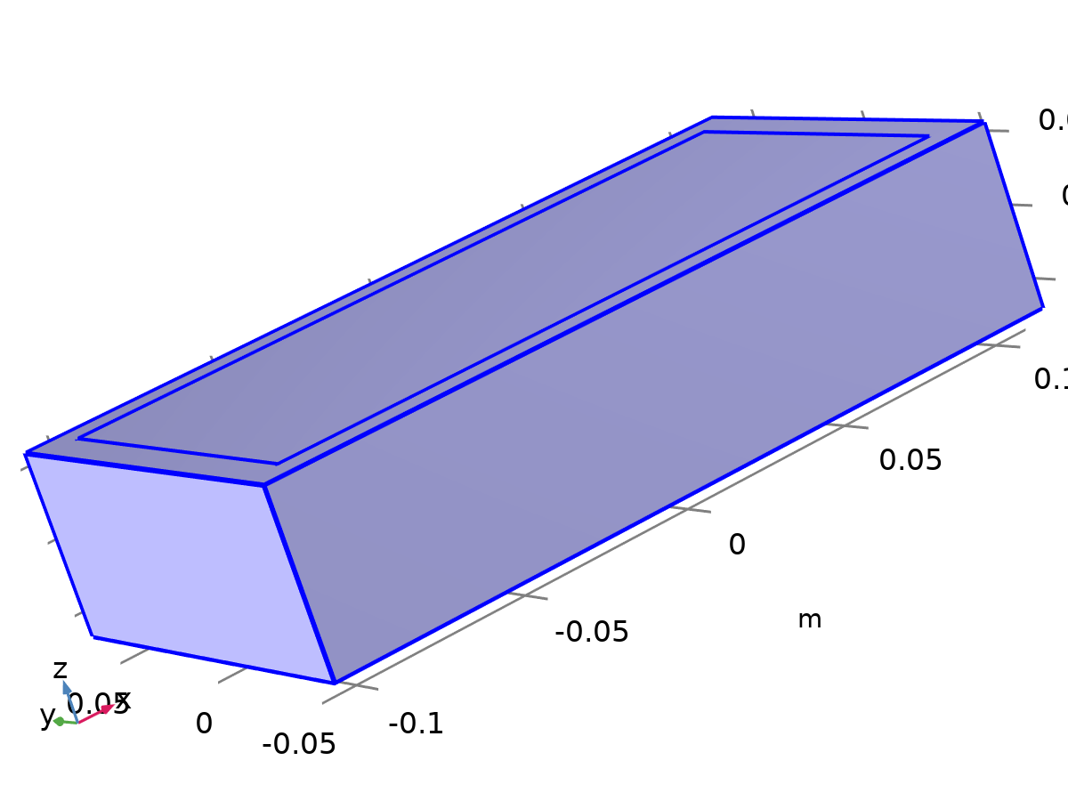

Laminar Flow

Selection

|  |  |
| --- | --- |
| Geometric entity level | Domain |
| Selection | Geometry geom1: Dimension 3: All domains |

Equations

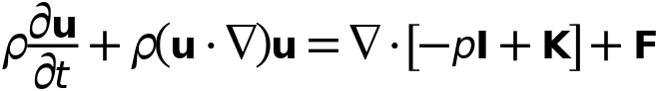



### Interface Settings

#### Discretization

Settings

| **Description** | **Value** |
| --- | --- |
| Discretization of fluids | P1 + P1 |

Settings

| **Description** | **Value** |
| --- | --- |
| Equation form | Study controlled |

#### Physical Model

Settings

| **Description** | **Value** | **Unit** |
| --- | --- | --- |
| Neglect inertial term (Stokes flow) | Off |  |
| Compressibility | Incompressible flow |  |
| Enable porous media domains | Off |  |
| Include gravity | Off |  |
| Reference temperature | User defined |  |
| Reference temperature | 293.15 | K |
| Reference pressure level | 1.0133E5 | Pa |

#### Turbulence

Settings

| **Description** | **Value** |
| --- | --- |
| Turbulence model type | None |

### Variables

| **Name** | **Expression** | **Unit** | **Description** | **Selection** | **Details** |
| --- | --- | --- | --- | --- | --- |
| spf.Tref | model.input.Tref | K | Reference temperature | Global | Meta |
| spf.dz | 1 | m | Thickness | Domains 1–2 |  |
| spf.pref | 1[atm] | Pa | Reference pressure level | Domains 1–2 |  |
| spf.pA | p+spf.pref | Pa | Absolute pressure | Domains 1–2 |  |
| spf.hasWF | 0 |  | Help variable | Boundaries 1–5, 8–9, 12 |  |
| spf.hasWF_u | 0 |  | Help variable | Boundaries 6–7, 10–11 |  |
| spf.hasWF_d | 0 |  | Help variable | Boundaries 6–7, 10–11 |  |
| spf.dt_CFL | 1/max(spf.maxop(sqrt(emetric_spatial(u-d(x,TIME),v-d(y,TIME),w-d(z,TIME)))),eps) | s | Time step, CFL=1 | Global |  |
| spf.CFL_number | timestep/spf.dt_CFL | 1 | CFL number | Global |  |
| spf.Qvd_tot | spf.intop(spf.Qvd) | W | Total viscous dissipation | Global |  |
| spf.K_stressx | spf.K_stress_tensorxx*spf.nxmesh+spf.K_stress_tensorxy*spf.nymesh+spf.K_stress_tensorxz*spf.nzmesh | N/m² | Viscous stress, exterior boundaries, x-component | Boundaries 1–5, 8–9, 12 |  |
| spf.K_stressy | spf.K_stress_tensoryx*spf.nxmesh+spf.K_stress_tensoryy*spf.nymesh+spf.K_stress_tensoryz*spf.nzmesh | N/m² | Viscous stress, exterior boundaries, y-component | Boundaries 1–5, 8–9, 12 |  |
| spf.K_stressz | spf.K_stress_tensorzx*spf.nxmesh+spf.K_stress_tensorzy*spf.nymesh+spf.K_stress_tensorzz*spf.nzmesh | N/m² | Viscous stress, exterior boundaries, z-component | Boundaries 1–5, 8–9, 12 |  |
| spf.T_stressx | spf.T_stress_tensorxx*spf.nxmesh+spf.T_stress_tensorxy*spf.nymesh+spf.T_stress_tensorxz*spf.nzmesh | N/m² | Total traction, exterior boundaries, x-component | Boundaries 1–5, 8–9, 12 |  |
| spf.T_stressy | spf.T_stress_tensoryx*spf.nxmesh+spf.T_stress_tensoryy*spf.nymesh+spf.T_stress_tensoryz*spf.nzmesh | N/m² | Total traction, exterior boundaries, y-component | Boundaries 1–5, 8–9, 12 |  |
| spf.T_stressz | spf.T_stress_tensorzx*spf.nxmesh+spf.T_stress_tensorzy*spf.nymesh+spf.T_stress_tensorzz*spf.nzmesh | N/m² | Total traction, exterior boundaries, z-component | Boundaries 1–5, 8–9, 12 |  |
| spf.K_stress_dx | down(spf.K_stress_tensorxx)*spf.nxmesh+down(spf.K_stress_tensorxy)*spf.nymesh+down(spf.K_stress_tensorxz)*spf.nzmesh | N/m² | Viscous stress, interior boundaries, downside, x-component | Boundaries 6–7, 10–11 |  |
| spf.K_stress_dy | down(spf.K_stress_tensoryx)*spf.nxmesh+down(spf.K_stress_tensoryy)*spf.nymesh+down(spf.K_stress_tensoryz)*spf.nzmesh | N/m² | Viscous stress, interior boundaries, downside, y-component | Boundaries 6–7, 10–11 |  |
| spf.K_stress_dz | down(spf.K_stress_tensorzx)*spf.nxmesh+down(spf.K_stress_tensorzy)*spf.nymesh+down(spf.K_stress_tensorzz)*spf.nzmesh | N/m² | Viscous stress, interior boundaries, downside, z-component | Boundaries 6–7, 10–11 |  |
| spf.K_stress_dx | down(spf.K_stress_tensorxx)*spf.dnxmesh+down(spf.K_stress_tensorxy)*spf.dnymesh+down(spf.K_stress_tensorxz)*spf.dnzmesh | N/m² | Viscous stress, interior boundaries, downside, x-component | Boundaries 1–5, 8–9, 12 |  |
| spf.K_stress_dy | down(spf.K_stress_tensoryx)*spf.dnxmesh+down(spf.K_stress_tensoryy)*spf.dnymesh+down(spf.K_stress_tensoryz)*spf.dnzmesh | N/m² | Viscous stress, interior boundaries, downside, y-component | Boundaries 1–5, 8–9, 12 |  |
| spf.K_stress_dz | down(spf.K_stress_tensorzx)*spf.dnxmesh+down(spf.K_stress_tensorzy)*spf.dnymesh+down(spf.K_stress_tensorzz)*spf.dnzmesh | N/m² | Viscous stress, interior boundaries, downside, z-component | Boundaries 1–5, 8–9, 12 |  |
| spf.K_stress_ux | -up(spf.K_stress_tensorxx)*spf.nxmesh-up(spf.K_stress_tensorxy)*spf.nymesh-up(spf.K_stress_tensorxz)*spf.nzmesh | N/m² | Viscous stress, interior boundaries, upside, x-component | Boundaries 6–7, 10–11 |  |
| spf.K_stress_uy | -up(spf.K_stress_tensoryx)*spf.nxmesh-up(spf.K_stress_tensoryy)*spf.nymesh-up(spf.K_stress_tensoryz)*spf.nzmesh | N/m² | Viscous stress, interior boundaries, upside, y-component | Boundaries 6–7, 10–11 |  |
| spf.K_stress_uz | -up(spf.K_stress_tensorzx)*spf.nxmesh-up(spf.K_stress_tensorzy)*spf.nymesh-up(spf.K_stress_tensorzz)*spf.nzmesh | N/m² | Viscous stress, interior boundaries, upside, z-component | Boundaries 6–7, 10–11 |  |
| spf.T_stress_dx | down(spf.T_stress_tensorxx)*spf.nxmesh+down(spf.T_stress_tensorxy)*spf.nymesh+down(spf.T_stress_tensorxz)*spf.nzmesh | N/m² | Total traction, interior boundaries, downside, x-component | Boundaries 6–7, 10–11 |  |
| spf.T_stress_dy | down(spf.T_stress_tensoryx)*spf.nxmesh+down(spf.T_stress_tensoryy)*spf.nymesh+down(spf.T_stress_tensoryz)*spf.nzmesh | N/m² | Total traction, interior boundaries, downside, y-component | Boundaries 6–7, 10–11 |  |
| spf.T_stress_dz | down(spf.T_stress_tensorzx)*spf.nxmesh+down(spf.T_stress_tensorzy)*spf.nymesh+down(spf.T_stress_tensorzz)*spf.nzmesh | N/m² | Total traction, interior boundaries, downside, z-component | Boundaries 6–7, 10–11 |  |
| spf.T_stress_dx | down(spf.T_stress_tensorxx)*spf.dnxmesh+down(spf.T_stress_tensorxy)*spf.dnymesh+down(spf.T_stress_tensorxz)*spf.dnzmesh | N/m² | Total traction, interior boundaries, downside, x-component | Boundaries 1–5, 8–9, 12 |  |
| spf.T_stress_dy | down(spf.T_stress_tensoryx)*spf.dnxmesh+down(spf.T_stress_tensoryy)*spf.dnymesh+down(spf.T_stress_tensoryz)*spf.dnzmesh | N/m² | Total traction, interior boundaries, downside, y-component | Boundaries 1–5, 8–9, 12 |  |
| spf.T_stress_dz | down(spf.T_stress_tensorzx)*spf.dnxmesh+down(spf.T_stress_tensorzy)*spf.dnymesh+down(spf.T_stress_tensorzz)*spf.dnzmesh | N/m² | Total traction, interior boundaries, downside, z-component | Boundaries 1–5, 8–9, 12 |  |
| spf.T_stress_ux | -up(spf.T_stress_tensorxx)*spf.nxmesh-up(spf.T_stress_tensorxy)*spf.nymesh-up(spf.T_stress_tensorxz)*spf.nzmesh | N/m² | Total traction, interior boundaries, upside, x-component | Boundaries 6–7, 10–11 |  |
| spf.T_stress_uy | -up(spf.T_stress_tensoryx)*spf.nxmesh-up(spf.T_stress_tensoryy)*spf.nymesh-up(spf.T_stress_tensoryz)*spf.nzmesh | N/m² | Total traction, interior boundaries, upside, y-component | Boundaries 6–7, 10–11 |  |
| spf.T_stress_uz | -up(spf.T_stress_tensorzx)*spf.nxmesh-up(spf.T_stress_tensorzy)*spf.nymesh-up(spf.T_stress_tensorzz)*spf.nzmesh | N/m² | Total traction, interior boundaries, upside, z-component | Boundaries 6–7, 10–11 |  |
| spf.T_tracx | spf.T_stressx | N/m² | Total applied traction, exterior boundaries, x-component | Boundaries 1–5, 8–9, 12 |  |
| spf.T_tracy | spf.T_stressy | N/m² | Total applied traction, exterior boundaries, y-component | Boundaries 1–5, 8–9, 12 |  |
| spf.T_tracz | spf.T_stressz | N/m² | Total applied traction, exterior boundaries, z-component | Boundaries 1–5, 8–9, 12 |  |
| spf.T_trac_dx | spf.T_stress_dx | N/m² | Total applied traction, downside boundaries, x-component | Boundaries 6–7, 10–11 |  |
| spf.T_trac_dy | spf.T_stress_dy | N/m² | Total applied traction, downside boundaries, y-component | Boundaries 6–7, 10–11 |  |
| spf.T_trac_dz | spf.T_stress_dz | N/m² | Total applied traction, downside boundaries, z-component | Boundaries 6–7, 10–11 |  |
| spf.T_trac_dx | spf.T_stress_dx | N/m² | Total applied traction, downside boundaries, x-component | Boundaries 1–5, 8–9, 12 |  |
| spf.T_trac_dy | spf.T_stress_dy | N/m² | Total applied traction, downside boundaries, y-component | Boundaries 1–5, 8–9, 12 |  |
| spf.T_trac_dz | spf.T_stress_dz | N/m² | Total applied traction, downside boundaries, z-component | Boundaries 1–5, 8–9, 12 |  |
| spf.T_trac_ux | spf.T_stress_ux | N/m² | Total applied traction, upside boundaries, x-component | Boundaries 6–7, 10–11 |  |
| spf.T_trac_uy | spf.T_stress_uy | N/m² | Total applied traction, upside boundaries, y-component | Boundaries 6–7, 10–11 |  |
| spf.T_trac_uz | spf.T_stress_uz | N/m² | Total applied traction, upside boundaries, z-component | Boundaries 6–7, 10–11 |  |
| spf.usePseudoTimeStepping | isrunningpseudotimestepping | 1 | Help variable | Global |  |
| spf.localCFLvalue | 1.3^min(niterCMP,9)+if(niterCMP>=25,9*1.3^min(-25+niterCMP,9),0)+if(niterCMP>=45,90*1.3^min(-45+niterCMP,9),0) |  | Local CFL number | Domains 1–2 |  |
| spf.locCFL | max(CFLCMP,sqrt(eps)) | 1 | Local CFL number | Global |  |
| spf.geometryLengthScale | 0.012500000000000002 | m | Geometry length scale | Domains 1–2 |  |
| spf.time_step_inv | max(sqrt(emetric_spatial(u,v,w)*2^gmg_level^2),spf.nu/spf.geometryLengthScale^2) | Hz | Inverse time step | Domains 1–2 |  |
| spf.tsti | nojac(spf.time_step_inv/spf.locCFL) | 1/s | Help variable | Domains 1–2 |  |
| spf.nx | nx | 1 | Normal vector, x-component | Boundaries 6–7, 10–11 |  |
| spf.ny | ny | 1 | Normal vector, y-component | Boundaries 6–7, 10–11 |  |
| spf.nz | nz | 1 | Normal vector, z-component | Boundaries 6–7, 10–11 |  |
| spf.nx | dnx | 1 | Normal vector, x-component | Boundaries 1–5, 8–9, 12 |  |
| spf.ny | dny | 1 | Normal vector, y-component | Boundaries 1–5, 8–9, 12 |  |
| spf.nz | dnz | 1 | Normal vector, z-component | Boundaries 1–5, 8–9, 12 |  |
| spf.nxmesh | nxmesh | 1 | Normal vector, x-component | Boundaries 6–7, 10–11 |  |
| spf.nymesh | nymesh | 1 | Normal vector, y-component | Boundaries 6–7, 10–11 |  |
| spf.nzmesh | nzmesh | 1 | Normal vector, z-component | Boundaries 6–7, 10–11 |  |
| spf.nxmesh | dnxmesh | 1 | Normal vector, x-component | Boundaries 1–5, 8–9, 12 |  |
| spf.nymesh | dnymesh | 1 | Normal vector, y-component | Boundaries 1–5, 8–9, 12 |  |
| spf.nzmesh | dnzmesh | 1 | Normal vector, z-component | Boundaries 1–5, 8–9, 12 |  |

### Fluid Properties 1



Fluid Properties 1

Selection

|  |  |
| --- | --- |
| Geometric entity level | Domain |
| Selection | Geometry geom1: Dimension 3: All domains |

Equations

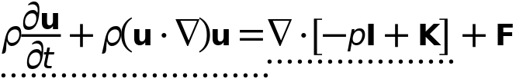



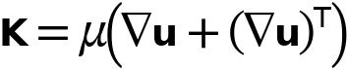

#### Fluid Properties

Settings

| **Description** | **Value** |
| --- | --- |
| Density | From material |
| Constitutive relation | Specify dynamic viscosity |
| Dynamic viscosity | From material |

#### Model Input

Settings

| **Description** | **Value** |
| --- | --- |
| Temperature | Common model input |

Properties from material

| **Property** | **Material** | **Property group** |
| --- | --- | --- |
| Density | Battery block | Basic |
| Dynamic viscosity | Battery block | Basic |
| Density | PCM Layer | Basic |
| Dynamic viscosity | PCM Layer | Basic |

#### Variables

| **Name** | **Expression** | **Unit** | **Description** | **Selection** | **Details** |
| --- | --- | --- | --- | --- | --- |
| spf.mu | material.mu | Pa·s | Dynamic viscosity | Domains 1–2 | Meta |
| spf.rho | subst(material.rho,spf.fp1.minput_temperature,spf.Trho,spf.fp1.minput_pressure,spf.prho) | kg/m³ | Density | Domains 1–2 | Meta |
| spf.Trho | spf.Tref | K | Temperature for density evaluation | Domains 1–2 |  |
| spf.prho | spf.pref | Pa | Pressure for the evaluation of density | Domains 1–2 |  |
| spf.rhoref | subst(material.rho,spf.fp1.minput_temperature,spf.Tref,spf.fp1.minput_pressure,spf.pref) | kg/m³ | Reference density | Domains 1–2 | Meta |
| spf.mumat | material.mu | Pa·s | Dynamic viscosity | Domains 1–2 | Meta |
| spf.srijxx | ux | 1/s | Strain rate tensor, xx-component | Domains 1–2 |  |
| spf.srijyx | 0.5*(vx+uy) | 1/s | Strain rate tensor, yx-component | Domains 1–2 |  |
| spf.srijzx | 0.5*(wx+uz) | 1/s | Strain rate tensor, zx-component | Domains 1–2 |  |
| spf.srijxy | 0.5*(uy+vx) | 1/s | Strain rate tensor, xy-component | Domains 1–2 |  |
| spf.srijyy | vy | 1/s | Strain rate tensor, yy-component | Domains 1–2 |  |
| spf.srijzy | 0.5*(wy+vz) | 1/s | Strain rate tensor, zy-component | Domains 1–2 |  |
| spf.srijxz | 0.5*(uz+wx) | 1/s | Strain rate tensor, xz-component | Domains 1–2 |  |
| spf.srijyz | 0.5*(vz+wy) | 1/s | Strain rate tensor, yz-component | Domains 1–2 |  |
| spf.srijzz | wz | 1/s | Strain rate tensor, zz-component | Domains 1–2 |  |
| spf.rrijxx | 0 | 1/s | Rotation rate tensor, xx-component | Domains 1–2 |  |
| spf.rrijyx | 0.5*(vx-uy) | 1/s | Rotation rate tensor, yx-component | Domains 1–2 |  |
| spf.rrijzx | 0.5*(wx-uz) | 1/s | Rotation rate tensor, zx-component | Domains 1–2 |  |
| spf.rrijxy | 0.5*(uy-vx) | 1/s | Rotation rate tensor, xy-component | Domains 1–2 |  |
| spf.rrijyy | 0 | 1/s | Rotation rate tensor, yy-component | Domains 1–2 |  |
| spf.rrijzy | 0.5*(wy-vz) | 1/s | Rotation rate tensor, zy-component | Domains 1–2 |  |
| spf.rrijxz | 0.5*(uz-wx) | 1/s | Rotation rate tensor, xz-component | Domains 1–2 |  |
| spf.rrijyz | 0.5*(vz-wy) | 1/s | Rotation rate tensor, yz-component | Domains 1–2 |  |
| spf.rrijzz | 0 | 1/s | Rotation rate tensor, zz-component | Domains 1–2 |  |
| spf.sr | sqrt(2*spf.srijxx^2+2*spf.srijxy^2+2*spf.srijxz^2+2*spf.srijyx^2+2*spf.srijyy^2+2*spf.srijyz^2+2*spf.srijzx^2+2*spf.srijzy^2+2*spf.srijzz^2+eps) | 1/s | Shear rate | Domains 1–2 |  |
| spf.rr | sqrt(2*spf.rrijxx^2+2*spf.rrijxy^2+2*spf.rrijxz^2+2*spf.rrijyx^2+2*spf.rrijyy^2+2*spf.rrijyz^2+2*spf.rrijzx^2+2*spf.rrijzy^2+2*spf.rrijzz^2+eps) | 1/s | Rotation rate | Domains 1–2 |  |
| spf.divu | ux+vy+wz | 1/s | Divergence of velocity field | Domains 1–2 |  |
| spf.Fx | 0 | N/m³ | Volume force, x-component | Domains 1–2 | + operation |
| spf.Fy | 0 | N/m³ | Volume force, y-component | Domains 1–2 | + operation |
| spf.Fz | 0 | N/m³ | Volume force, z-component | Domains 1–2 | + operation |
| spf.U | sqrt(u^2+v^2+w^2) | m/s | Velocity magnitude | Domains 1–2 |  |
| spf.vorticityx | wy-vz | 1/s | Vorticity field, x-component | Domains 1–2 |  |
| spf.vorticityy | -wx+uz | 1/s | Vorticity field, y-component | Domains 1–2 |  |
| spf.vorticityz | vx-uy | 1/s | Vorticity field, z-component | Domains 1–2 |  |
| spf.vort_magn | sqrt(spf.vorticityx^2+spf.vorticityy^2+spf.vorticityz^2) | 1/s | Vorticity magnitude | Domains 1–2 |  |
| spf.cellRe | 0.25*spf.rho*sqrt(emetric_spatial(u-d(x,TIME),v-d(y,TIME),w-d(z,TIME))/emetric2_spatial)/spf.mu | 1 | Cell Reynolds number | Domains 1–2 |  |
| spf.nu | spf.mu/spf.rho | m²/s | Kinematic viscosity | Domains 1–2 |  |
| spf.betaT | 0 | 1/Pa | Isothermal compressibility coefficient | Domains 1–2 |  |
| spf.Qm | 0 | kg/(m³·s) | Source term | Domains 1–2 | + operation |
| spf.Fgtotx | 0 | N/m³ | Gravity force, x-component | Domains 1–2 | + operation |
| spf.Fgtoty | 0 | N/m³ | Gravity force, y-component | Domains 1–2 | + operation |
| spf.Fgtotz | 0 | N/m³ | Gravity force, z-component | Domains 1–2 | + operation |
| spf.Qm_aco | 0 | kg/(m³·s) | Acoustic mass source | Domains 1–2 |  |
| spf.F_acox | 0 | N/m³ | Acoustic volume force, x-component | Domains 1–2 |  |
| spf.F_acoy | 0 | N/m³ | Acoustic volume force, y-component | Domains 1–2 |  |
| spf.F_acoz | 0 | N/m³ | Acoustic volume force, z-component | Domains 1–2 |  |
| spf.gamma_sr | sqrt(2*spf.srijxx^2+2*spf.srijxy^2+2*spf.srijxz^2+2*spf.srijyx^2+2*spf.srijyy^2+2*spf.srijyz^2+2*spf.srijzx^2+2*spf.srijzy^2+2*spf.srijzz^2+eps) | 1/s | Shear rate | Domains 1–2 |  |
| spf.mu_eff | spf.mu+spf.muT | Pa·s | Effective dynamic viscosity | Domains 1–2 |  |
| spf.muT | 0 | Pa·s | Turbulent dynamic viscosity | Domains 1–2 | + operation |
| spf.T_stress_tensorxx | spf.K_stress_tensorxx-p | N/m² | Total stress tensor, xx-component | Domains 1–2 | + operation |
| spf.T_stress_tensoryx | spf.K_stress_tensoryx | N/m² | Total stress tensor, yx-component | Domains 1–2 | + operation |
| spf.T_stress_tensorzx | spf.K_stress_tensorzx | N/m² | Total stress tensor, zx-component | Domains 1–2 | + operation |
| spf.T_stress_tensorxy | spf.K_stress_tensorxy | N/m² | Total stress tensor, xy-component | Domains 1–2 | + operation |
| spf.T_stress_tensoryy | spf.K_stress_tensoryy-p | N/m² | Total stress tensor, yy-component | Domains 1–2 | + operation |
| spf.T_stress_tensorzy | spf.K_stress_tensorzy | N/m² | Total stress tensor, zy-component | Domains 1–2 | + operation |
| spf.T_stress_tensorxz | spf.K_stress_tensorxz | N/m² | Total stress tensor, xz-component | Domains 1–2 | + operation |
| spf.T_stress_tensoryz | spf.K_stress_tensoryz | N/m² | Total stress tensor, yz-component | Domains 1–2 | + operation |
| spf.T_stress_tensorzz | spf.K_stress_tensorzz-p | N/m² | Total stress tensor, zz-component | Domains 1–2 | + operation |
| spf.K_stress_tensorxx | 2*spf.mu_eff*ux | N/m² | Viscous stress tensor, xx-component | Domains 1–2 | + operation |
| spf.K_stress_tensoryx | spf.mu_eff*(vx+uy) | N/m² | Viscous stress tensor, yx-component | Domains 1–2 | + operation |
| spf.K_stress_tensorzx | spf.mu_eff*(wx+uz) | N/m² | Viscous stress tensor, zx-component | Domains 1–2 | + operation |
| spf.K_stress_tensorxy | spf.mu_eff*(uy+vx) | N/m² | Viscous stress tensor, xy-component | Domains 1–2 | + operation |
| spf.K_stress_tensoryy | 2*spf.mu_eff*vy | N/m² | Viscous stress tensor, yy-component | Domains 1–2 | + operation |
| spf.K_stress_tensorzy | spf.mu_eff*(wy+vz) | N/m² | Viscous stress tensor, zy-component | Domains 1–2 | + operation |
| spf.K_stress_tensorxz | spf.mu_eff*(uz+wx) | N/m² | Viscous stress tensor, xz-component | Domains 1–2 | + operation |
| spf.K_stress_tensoryz | spf.mu_eff*(vz+wy) | N/m² | Viscous stress tensor, yz-component | Domains 1–2 | + operation |
| spf.K_stress_tensorzz | 2*spf.mu_eff*wz | N/m² | Viscous stress tensor, zz-component | Domains 1–2 | + operation |
| spf.K_stress_tensor_testxx | 2*spf.mu_eff*test(ux) | N/m² | Viscous stress tensor test, xx-component | Domains 1–2 | + operation |
| spf.K_stress_tensor_testyx | spf.mu_eff*(test(vx)+test(uy)) | N/m² | Viscous stress tensor test, yx-component | Domains 1–2 | + operation |
| spf.K_stress_tensor_testzx | spf.mu_eff*(test(wx)+test(uz)) | N/m² | Viscous stress tensor test, zx-component | Domains 1–2 | + operation |
| spf.K_stress_tensor_testxy | spf.mu_eff*(test(uy)+test(vx)) | N/m² | Viscous stress tensor test, xy-component | Domains 1–2 | + operation |
| spf.K_stress_tensor_testyy | 2*spf.mu_eff*test(vy) | N/m² | Viscous stress tensor test, yy-component | Domains 1–2 | + operation |
| spf.K_stress_tensor_testzy | spf.mu_eff*(test(wy)+test(vz)) | N/m² | Viscous stress tensor test, zy-component | Domains 1–2 | + operation |
| spf.K_stress_tensor_testxz | spf.mu_eff*(test(uz)+test(wx)) | N/m² | Viscous stress tensor test, xz-component | Domains 1–2 | + operation |
| spf.K_stress_tensor_testyz | spf.mu_eff*(test(vz)+test(wy)) | N/m² | Viscous stress tensor test, yz-component | Domains 1–2 | + operation |
| spf.K_stress_tensor_testzz | 2*spf.mu_eff*test(wz) | N/m² | Viscous stress tensor test, zz-component | Domains 1–2 | + operation |
| spf.upwind_helpx | u-d(x,TIME) | m/s | Upwind term, x-component | Domains 1–2 | + operation |
| spf.upwind_helpy | v-d(y,TIME) | m/s | Upwind term, y-component | Domains 1–2 | + operation |
| spf.upwind_helpz | w-d(z,TIME) | m/s | Upwind term, z-component | Domains 1–2 | + operation |
| spf.continuityEquation | spf.rho*spf.divu-spf.Qm | kg/(m³·s) | Continuity equation | Domains 1–2 |  |
| spf.contCoeff | spf.rho | kg/m³ | Help variable | Domains 1–2 |  |
| spf.Qvd | spf.K_stress_tensorxx*ux+spf.K_stress_tensorxy*uy+spf.K_stress_tensorxz*uz+spf.K_stress_tensoryx*vx+spf.K_stress_tensoryy*vy+spf.K_stress_tensoryz*vz+spf.K_stress_tensorzx*wx+spf.K_stress_tensorzy*wy+spf.K_stress_tensorzz*wz | W/m³ | Viscous dissipation | Domains 1–2 | + operation |
| spf.epsilon_p | 1 | 1 | Porosity | Domains 1–2 |  |
| spf.epsilon_p_pos | max(1,sqrt(eps)) | 1 | Positive porosity | Domains 1–2 |  |
| spf.Fst_tensorxx | 0 | N/m² | Surface tension force, xx-component | Domains 1–2 | + operation |
| spf.Fst_tensoryx | 0 | N/m² | Surface tension force, yx-component | Domains 1–2 | + operation |
| spf.Fst_tensorzx | 0 | N/m² | Surface tension force, zx-component | Domains 1–2 | + operation |
| spf.Fst_tensorxy | 0 | N/m² | Surface tension force, xy-component | Domains 1–2 | + operation |
| spf.Fst_tensoryy | 0 | N/m² | Surface tension force, yy-component | Domains 1–2 | + operation |
| spf.Fst_tensorzy | 0 | N/m² | Surface tension force, zy-component | Domains 1–2 | + operation |
| spf.Fst_tensorxz | 0 | N/m² | Surface tension force, xz-component | Domains 1–2 | + operation |
| spf.Fst_tensoryz | 0 | N/m² | Surface tension force, yz-component | Domains 1–2 | + operation |
| spf.Fst_tensorzz | 0 | N/m² | Surface tension force, zz-component | Domains 1–2 | + operation |
| spf.res_u | spf.rho*ut*spf.switch_NS+px+spf.rho*u*ux+spf.rho*v*uy+spf.rho*w*uz-(d(2*ux,x)+d(uy+vx,y)+d(uz+wx,z))*spf.mu-spf.Fx | N/m³ | Equation residual | Domains 1–2 |  |
| spf.res_v | spf.rho*vt*spf.switch_NS+spf.rho*u*vx+py+spf.rho*v*vy+spf.rho*w*vz-(d(vx+uy,x)+d(2*vy,y)+d(vz+wy,z))*spf.mu-spf.Fy | N/m³ | Equation residual | Domains 1–2 |  |
| spf.res_w | spf.rho*wt*spf.switch_NS+spf.rho*u*wx+spf.rho*v*wy+pz+spf.rho*w*wz-(d(wx+uz,x)+d(wy+vz,y)+d(2*wz,z))*spf.mu-spf.Fz | N/m³ | Equation residual | Domains 1–2 |  |
| spf.res_p | spf.rho*spf.divu-spf.Qm | kg/(m³·s) | Pressure equation residual | Domains 1–2 |  |

#### Shape functions

| **Name** | **Shape function** | **Unit** | **Description** | **Shape frame** | **Selection** |
| --- | --- | --- | --- | --- | --- |
| u | Lagrange (Linear) | m/s | Velocity field, x-component | Spatial | Domains 1–2 |
| v | Lagrange (Linear) | m/s | Velocity field, y-component | Spatial | Domains 1–2 |
| w | Lagrange (Linear) | m/s | Velocity field, z-component | Spatial | Domains 1–2 |
| u | Lagrange (Linear) | m/s | Velocity field, x-component | Spatial | Domains 1–2 |
| v | Lagrange (Linear) | m/s | Velocity field, y-component | Spatial | Domains 1–2 |
| w | Lagrange (Linear) | m/s | Velocity field, z-component | Spatial | Domains 1–2 |
| p | Lagrange (Linear) | Pa | Pressure | Spatial | Domains 1–2 |

#### Weak Expressions

| **Weak expression** | **Integration order** | **Integration frame** | **Selection** |
| --- | --- | --- | --- |
| spf.rho*(-ut*test(u)-vt*test(v)-wt*test(w)) | 2 | Spatial | Domains 1–2 |
| (p-spf.K_stress_tensorxx)*test(ux)-spf.K_stress_tensorxy*test(uy)-spf.K_stress_tensorxz*test(uz)-spf.K_stress_tensoryx*test(vx)+(p-spf.K_stress_tensoryy)*test(vy)-spf.K_stress_tensoryz*test(vz)-spf.K_stress_tensorzx*test(wx)-spf.K_stress_tensorzy*test(wy)+(p-spf.K_stress_tensorzz)*test(wz) | 2 | Spatial | Domains 1–2 |
| spf.Fx*test(u)+spf.Fy*test(v)+spf.Fz*test(w) | 2 | Spatial | Domains 1–2 |
| spf.rho*(-(d(u,x)*u+d(u,y)*v+d(u,z)*w)*test(u)-(d(v,x)*u+d(v,y)*v+d(v,z)*w)*test(v)-(d(w,x)*u+d(w,y)*v+d(w,z)*w)*test(w)) | 2 | Spatial | Domains 1–2 |
| -spf.continuityEquation*test(p) | 2 | Spatial | Domains 1–2 |
| spf.streamlinens | 2 | Spatial | Domains 1–2 |
| spf.crosswindns | 2 | Spatial | Domains 1–2 |

### Initial Values 1



Initial Values 1

Selection

|  |  |
| --- | --- |
| Geometric entity level | Domain |
| Selection | Geometry geom1: Dimension 3: All domains |

#### Initial Values

Settings

| **Description** | **Value** | **Unit** |
| --- | --- | --- |
| Velocity field, x-component | 0 | m/s |
| Velocity field, y-component | 0 | m/s |
| Velocity field, z-component | 0 | m/s |
| Pressure | 0 | Pa |

#### Coordinate System Selection

Settings

| **Description** | **Value** |
| --- | --- |
| Coordinate system | Global coordinate system |

#### Variables

| **Name** | **Expression** | **Unit** | **Description** | **Selection** |
| --- | --- | --- | --- | --- |
| spf.u_initx | 0 | m/s | Velocity field, x-component | Domains 1–2 |
| spf.u_inity | 0 | m/s | Velocity field, y-component | Domains 1–2 |
| spf.u_initz | 0 | m/s | Velocity field, z-component | Domains 1–2 |
| spf.p_init | 0 | Pa | Pressure | Domains 1–2 |

### Wall 1



Wall 1

Selection

|  |  |
| --- | --- |
| Geometric entity level | Boundary |
| Selection | Geometry geom1: Dimension 2: All boundaries |

Equations



#### Boundary Condition

Settings

| **Description** | **Value** |
| --- | --- |
| Wall condition | No slip |

#### Wall Movement

Settings

| **Description** | **Value** |
| --- | --- |
| Translational velocity | Automatic from frame |
| Sliding wall | Off |

### Inlet 1



Inlet 1

Selection

|  |  |
| --- | --- |
| Geometric entity level | Boundary |
| Selection | Geometry geom1: Dimension 2: No boundaries |

Equations



#### Boundary Condition

Settings

| **Description** | **Value** |
| --- | --- |
| Boundary condition | Velocity |

#### Velocity

Settings

| **Description** | **Value** | **Unit** |
| --- | --- | --- |
| Velocity field componentwise | Normal inflow velocity |  |
| Normal inflow velocity | 1 | m/s |

### Outlet 1

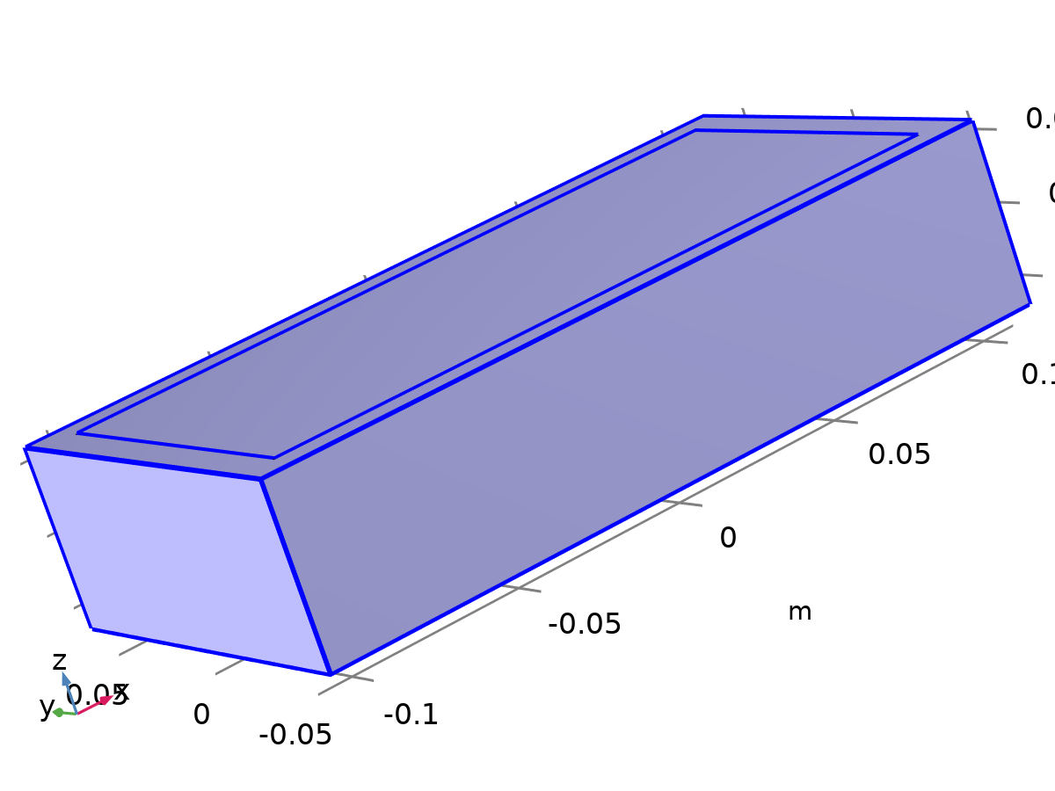

Outlet 1

Selection

|  |  |
| --- | --- |
| Geometric entity level | Boundary |
| Selection | Geometry geom1: Dimension 2: Boundaries 1–5, 8–9, 12 |

Equations





#### Boundary Condition

Settings

| **Description** | **Value** |
| --- | --- |
| Boundary condition | Pressure |

#### Pressure Conditions

Settings

| **Description** | **Value** | **Unit** |
| --- | --- | --- |
| Pressure | Static |  |
| Pressure | 0 | Pa |
| Normal flow | Off |  |
| Suppress backflow | On |  |

#### Variables

| **Name** | **Expression** | **Unit** | **Description** | **Selection** |
| --- | --- | --- | --- | --- |
| spf.meshVol | meshvol_spatial | m² |  | Boundaries 1–5, 8–9, 12 |
| spf.meshVolInt | down(meshvol_spatial) | m³ | Volume of interior mesh element | Boundaries 1–5, 8–9, 12 |
| spf.rhoFace | down(spf.rho) | kg/m³ | Density face value | Boundaries 1–5, 8–9, 12 |
| spf.umxTnFace | spf.upwind_helpx*spf.nxmesh+spf.upwind_helpy*spf.nymesh+spf.upwind_helpz*spf.nzmesh | m/s | Relative velocity on face | Boundaries 1–5, 8–9, 12 |
| spf.p0 | 0 | Pa | Pressure | Boundaries 1–5, 8–9, 12 |
| spf.out1.Uav | 0 | m/s | Average velocity | Global |
| spf.out1.Uavfdf | 0 | m/s | Average velocity | Global |
| spf.out1.dz | spf.dz | m | Channel thickness | Boundaries 1–5, 8–9, 12 |
| spf.out1.Mflow | spf.out1.massFlowRate | kg/s | Mass flow | Global |
| spf.f0 | spf.p0+spf.uNormal*(spf.backflowPenaltyDiff-spf.backflowPenaltyConv)*(spf.uNormal<0) | N/m² | Normal stress | Boundaries 1–5, 8–9, 12 |
| spf.uNormal | u*nojac(spf.nxmesh)+v*nojac(spf.nymesh)+w*nojac(spf.nzmesh) | m/s | Normal velocity | Boundaries 1–5, 8–9, 12 |
| spf.out1.c_here | 144/spf.epsilon_p | 1 | Intermediate variable | Boundaries 1–5, 8–9, 12 |
| spf.backflowPenaltyDiff | spf.out1.c_here*min((down(spf.mu)+spf.muT)*spf.meshVol/spf.meshVolInt,down(spf.rho)*abs(spf.uNormal)/down(spf.epsilon_p)) | Pa·s/m | Backflow penalty parameter, diffusive contribution | Boundaries 1–5, 8–9, 12 |
| spf.backflowPenaltyConv | spf.rhoFace*spf.umxTnFace/spf.epsilon_p^2 | kg/(m²·s) | Backflow penalty parameter, convective contribution | Boundaries 1–5, 8–9, 12 |
| spf.out1.upwind_ns | spf.backflowPenaltyConv*spf.uNormal | Pa | Upwind term | Boundaries 1–5, 8–9, 12 |
| spf.out1.volumeFlowRate | spf.out1.intop(u*spf.nxmesh+v*spf.nymesh+w*spf.nzmesh) | m³/s | Outward volume flow rate across feature selection | Global |
| spf.out1.massFlowRate | spf.out1.intop(spf.rho*(u*spf.nxmesh+v*spf.nymesh+w*spf.nzmesh)) | kg/s | Outward mass flow rate across feature selection | Global |
| spf.out1.pAverage | spf.out1.aveop(p) | Pa | Pressure average over feature selection | Global |

#### Weak Expressions

| **Weak expression** | **Integration order** | **Integration frame** | **Selection** |
| --- | --- | --- | --- |
| -spf.f0*(test(u)*spf.nxmesh+test(v)*spf.nymesh+test(w)*spf.nzmesh) | 2 | Spatial | Boundaries 1–5, 8–9, 12 |

## Heat Transfer in Solids 2

Used products

|  |
| --- |
| COMSOL Multiphysics |



Heat Transfer in Solids 2

Selection

|  |  |
| --- | --- |
| Geometric entity level | Domain |
| Selection | Geometry geom1: Dimension 3: Domains 1–2 |

Equations

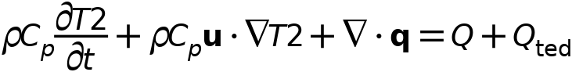



### Interface Settings

#### Discretization

Settings

| **Description** | **Value** |
| --- | --- |
| Temperature | Quadratic Lagrange |

Settings

| **Description** | **Value** |
| --- | --- |
| Equation form | Study controlled |

#### Physical Model

Settings

| **Description** | **Value** | **Unit** |
| --- | --- | --- |
| Reference temperature | User defined |  |
| Reference temperature | 293.15 | K |

### Variables

| **Name** | **Expression** | **Unit** | **Description** | **Selection** | **Details** |
| --- | --- | --- | --- | --- | --- |
| ht2.Tref | model.input.Tref | K | Reference temperature | Global | Meta |
| ht2.C_effExt | 0 | J/(m³·K) | Effective volumetric heat capacity | Domains 1–2 | + operation |
| ht2.EMatExt | 0 | Pa | Young's modulus | Domains 1–2 | + operation |
| ht2.Tvar | T2 | K | Temperature | Domains 1–2 |  |
| ht2.Tvar | T2 | K | Temperature | Boundaries 1–12 |  |
| ht2.Tvar | T2 | K | Temperature | Edges 1–24 |  |
| ht2.Tvar | T2 | K | Temperature | Points 1–16 |  |
| ht2.nknExt | 0 | W/(m·K) | Help variable | Domains 1–2 | + operation |
| ht2.TextFace | 0 | K | External temperature | Domains 1–2 | + operation |
| ht2.nuMatExt | 0 | 1 | Poisson's ratio | Domains 1–2 | + operation |
| ht2.d | 1 | 1 | Thickness | Domains 1–2 |  |
| ht2.chiT | 0 | 1/Pa | Isothermal compressibility coefficient | Domains 1–2 |  |
| ht2.HRef | 0 | J/kg | Reference enthalpy | Domains 1–2 |  |
| ht2.alphap | 0 | 1/K | Isobaric compressibility coefficient | Domains 1–2 |  |
| ht2.DeltaH | ht2.DeltaH_add | J/kg | Sensible enthalpy | Domains 1–2 |  |
| ht2.DeltaH_cst | ht2.DeltaH_add_cst | J/kg | Sensible enthalpy, constant material properties | Domains 1–2 |  |
| ht2.DeltaH_add | 0 | J/kg | Sensible enthalpy | Domains 1–2 | + operation |
| ht2.DeltaH_add_cst | 0 | J/kg | Sensible enthalpy, constant material properties | Domains 1–2 | + operation |
| ht2.H | 0 | J/kg | Enthalpy | Domains 1–2 | + operation |
| ht2.H_cst | 0 | J/kg | Enthalpy, constant material properties | Domains 1–2 | + operation |
| ht2.H0 | ht2.H+ht2.Ek | J/kg | Total enthalpy | Domains 1–2 |  |
| ht2.H0_cst | ht2.H_cst+ht2.Ek | J/kg | Total enthalpy, constant material properties | Domains 1–2 |  |
| ht2.Ei | 0 | J/kg | Internal energy | Domains 1–2 | + operation |
| ht2.Ei_cst | 0 | J/kg | Internal energy, constant material properties | Domains 1–2 | + operation |
| ht2.Ei0 | ht2.Ei+ht2.Ek | J/kg | Total internal energy | Domains 1–2 |  |
| ht2.Ei0_cst | ht2.Ei_cst+ht2.Ek | J/kg | Total internal energy, constant material properties | Domains 1–2 |  |
| ht2.Ek | 0 | J/kg | Kinetic energy | Domains 1–2 | + operation |
| ht2.dfluxx | 0 | W/m² | Conductive heat flux, x-component | Domains 1–2 | + operation |
| ht2.dfluxy | 0 | W/m² | Conductive heat flux, y-component | Domains 1–2 | + operation |
| ht2.dfluxz | 0 | W/m² | Conductive heat flux, z-component | Domains 1–2 | + operation |
| ht2.dfluxx | mean(ht2.dfluxx) | W/m² | Conductive heat flux, x-component | Boundaries 1–12 | + operation |
| ht2.dfluxy | mean(ht2.dfluxy) | W/m² | Conductive heat flux, y-component | Boundaries 1–12 | + operation |
| ht2.dfluxz | mean(ht2.dfluxz) | W/m² | Conductive heat flux, z-component | Boundaries 1–12 | + operation |
| ht2.dfluxtestx | 0 | W/m² | Conductive heat flux, x-component | Domains 1–2 | + operation |
| ht2.dfluxtesty | 0 | W/m² | Conductive heat flux, y-component | Domains 1–2 | + operation |
| ht2.dfluxtestz | 0 | W/m² | Conductive heat flux, z-component | Domains 1–2 | + operation |
| ht2.dfluxtestx | mean(ht2.dfluxtestx) | W/m² | Conductive heat flux, x-component | Boundaries 1–12 | + operation |
| ht2.dfluxtesty | mean(ht2.dfluxtesty) | W/m² | Conductive heat flux, y-component | Boundaries 1–12 | + operation |
| ht2.dfluxtestz | mean(ht2.dfluxtestz) | W/m² | Conductive heat flux, z-component | Boundaries 1–12 | + operation |
| ht2.dfluxMag | sqrt(ht2.dfluxx^2+ht2.dfluxy^2+ht2.dfluxz^2) | W/m² | Conductive heat flux magnitude | Domains 1–2 |  |
| ht2.cfluxx | 0 | W/m² | Convective heat flux, x-component | Domains 1–2 | + operation |
| ht2.cfluxy | 0 | W/m² | Convective heat flux, y-component | Domains 1–2 | + operation |
| ht2.cfluxz | 0 | W/m² | Convective heat flux, z-component | Domains 1–2 | + operation |
| ht2.cfluxMag | sqrt(ht2.cfluxx^2+ht2.cfluxy^2+ht2.cfluxz^2) | W/m² | Convective heat flux magnitude | Domains 1–2 |  |
| ht2.tfluxx | ht2.dfluxx+ht2.cfluxx | W/m² | Total heat flux, x-component | Domains 1–2 |  |
| ht2.tfluxy | ht2.dfluxy+ht2.cfluxy | W/m² | Total heat flux, y-component | Domains 1–2 |  |
| ht2.tfluxz | ht2.dfluxz+ht2.cfluxz | W/m² | Total heat flux, z-component | Domains 1–2 |  |
| ht2.tfluxMag | sqrt(ht2.tfluxx^2+ht2.tfluxy^2+ht2.tfluxz^2) | W/m² | Total heat flux magnitude | Domains 1–2 |  |
| ht2.tefluxx | 0 | W/m² | Total energy flux, x-component | Domains 1–2 | + operation |
| ht2.tefluxy | 0 | W/m² | Total energy flux, y-component | Domains 1–2 | + operation |
| ht2.tefluxz | 0 | W/m² | Total energy flux, z-component | Domains 1–2 | + operation |
| ht2.teflux_cstx | 0 | W/m² | Total energy flux, constant material properties, x-component | Domains 1–2 | + operation |
| ht2.teflux_csty | 0 | W/m² | Total energy flux, constant material properties, y-component | Domains 1–2 | + operation |
| ht2.teflux_cstz | 0 | W/m² | Total energy flux, constant material properties, z-component | Domains 1–2 | + operation |
| ht2.tefluxMag | sqrt(ht2.tefluxx^2+ht2.tefluxy^2+ht2.tefluxz^2) | W/m² | Total energy flux magnitude | Domains 1–2 |  |
| ht2.thfluxx | 0 | W/m² | Total enthalpy flux, x-component | Domains 1–2 | + operation |
| ht2.thfluxy | 0 | W/m² | Total enthalpy flux, y-component | Domains 1–2 | + operation |
| ht2.thfluxz | 0 | W/m² | Total enthalpy flux, z-component | Domains 1–2 | + operation |
| ht2.thflux_cstx | 0 | W/m² | Total enthalpy flux, constant material properties, x-component | Domains 1–2 | + operation |
| ht2.thflux_csty | 0 | W/m² | Total enthalpy flux, constant material properties, y-component | Domains 1–2 | + operation |
| ht2.thflux_cstz | 0 | W/m² | Total enthalpy flux, constant material properties, z-component | Domains 1–2 | + operation |
| ht2.thfluxMag | sqrt(ht2.thfluxx^2+ht2.thfluxy^2+ht2.thfluxz^2) | W/m² | Total enthalpy flux magnitude | Domains 1–2 |  |
| ht2.dflux_ux | up(ht2.dfluxx) | W/m² | Conductive heat flux, x-component | Boundaries 1–12 |  |
| ht2.dflux_uy | up(ht2.dfluxy) | W/m² | Conductive heat flux, y-component | Boundaries 1–12 |  |
| ht2.dflux_uz | up(ht2.dfluxz) | W/m² | Conductive heat flux, z-component | Boundaries 1–12 |  |
| ht2.dflux_dx | down(ht2.dfluxx) | W/m² | Conductive heat flux, x-component | Boundaries 1–12 |  |
| ht2.dflux_dy | down(ht2.dfluxy) | W/m² | Conductive heat flux, y-component | Boundaries 1–12 |  |
| ht2.dflux_dz | down(ht2.dfluxz) | W/m² | Conductive heat flux, z-component | Boundaries 1–12 |  |
| ht2.dfluxtest_ux | up(ht2.dfluxtestx) | W/m² | Conductive heat flux, x-component | Boundaries 1–12 |  |
| ht2.dfluxtest_uy | up(ht2.dfluxtesty) | W/m² | Conductive heat flux, y-component | Boundaries 1–12 |  |
| ht2.dfluxtest_uz | up(ht2.dfluxtestz) | W/m² | Conductive heat flux, z-component | Boundaries 1–12 |  |
| ht2.dfluxtest_dx | down(ht2.dfluxtestx) | W/m² | Conductive heat flux, x-component | Boundaries 1–12 |  |
| ht2.dfluxtest_dy | down(ht2.dfluxtesty) | W/m² | Conductive heat flux, y-component | Boundaries 1–12 |  |
| ht2.dfluxtest_dz | down(ht2.dfluxtestz) | W/m² | Conductive heat flux, z-component | Boundaries 1–12 |  |
| ht2.rflux | 0 | W/m² | Radiative heat flux | Boundaries 1–12 | + operation |
| ht2.ncflux | mean(ht2.cfluxx)*ht2.nxmesh+mean(ht2.cfluxy)*ht2.nymesh+mean(ht2.cfluxz)*ht2.nzmesh | W/m² | Normal convective heat flux | Boundaries 1–12 |  |
| ht2.ncflux_u | up(ht2.cfluxx)*ht2.unxmesh+up(ht2.cfluxy)*ht2.unymesh+up(ht2.cfluxz)*ht2.unzmesh | W/m² | Internal normal convective heat flux, upside | Boundaries 1–12 |  |
| ht2.ncflux_d | down(ht2.cfluxx)*ht2.dnxmesh+down(ht2.cfluxy)*ht2.dnymesh+down(ht2.cfluxz)*ht2.dnzmesh | W/m² | Internal normal convective heat flux, downside | Boundaries 1–12 |  |
| ht2.ndflux | 0.5*(ht2.ndflux_d-ht2.ndflux_u) | W/m² | Normal conductive heat flux | Boundaries 1–12 | + operation |
| ht2.ndflux_u | -ht2.ndflux_d | W/m² | Internal normal conductive heat flux, upside | Boundaries 1–5, 8–9, 12 | + operation |
| ht2.ndflux_u | 0 | W/m² | Internal normal conductive heat flux, upside | Boundaries 6–7, 10–11 | + operation |
| ht2.ndflux_d | 0 | W/m² | Internal normal conductive heat flux, downside | Boundaries 1–12 | + operation |
| ht2.ntflux | ht2.ndflux+ht2.ncflux | W/m² | Normal total heat flux | Boundaries 1–12 |  |
| ht2.ntflux_cst | ht2.ndflux+ht2.ncflux | W/m² | Normal total heat flux, constant material properties | Boundaries 1–12 |  |
| ht2.ntflux_u | ht2.ndflux_u+ht2.ncflux_u | W/m² | Internal normal total flux, upside | Boundaries 1–12 |  |
| ht2.ntflux_cst_u | ht2.ndflux_u+ht2.ncflux_u | W/m² | Internal normal total heat flux, constant material properties, upside | Boundaries 1–12 |  |
| ht2.ntflux_d | ht2.ndflux_d+ht2.ncflux_d | W/m² | Internal normal total flux, downside | Boundaries 1–12 |  |
| ht2.ntflux_cst_d | ht2.ndflux_d+ht2.ncflux_d | W/m² | Internal normal total heat flux, constant material properties, downside | Boundaries 1–12 |  |
| ht2.nteflux | mean(ht2.tefluxx)*ht2.nxmesh+mean(ht2.tefluxy)*ht2.nymesh+mean(ht2.tefluxz)*ht2.nzmesh-mean(ht2.dfluxx)*ht2.nxmesh-mean(ht2.dfluxy)*ht2.nymesh-mean(ht2.dfluxz)*ht2.nzmesh+ht2.ndflux | W/m² | Normal total energy flux | Boundaries 1–12 |  |
| ht2.nteflux_cst | mean(ht2.teflux_cstx)*ht2.nxmesh+mean(ht2.teflux_csty)*ht2.nymesh+mean(ht2.teflux_cstz)*ht2.nzmesh-mean(ht2.dfluxx)*ht2.nxmesh-mean(ht2.dfluxy)*ht2.nymesh-mean(ht2.dfluxz)*ht2.nzmesh+ht2.ndflux | W/m² | Normal total energy flux, constant material properties | Boundaries 1–12 |  |
| ht2.nteflux_u | up(ht2.tefluxx)*ht2.unxmesh+up(ht2.tefluxy)*ht2.unymesh+up(ht2.tefluxz)*ht2.unzmesh-up(ht2.dfluxx)*ht2.unxmesh-up(ht2.dfluxy)*ht2.unymesh-up(ht2.dfluxz)*ht2.unzmesh+ht2.ndflux_u | W/m² | Internal normal total energy flux, upside | Boundaries 1–12 |  |
| ht2.nteflux_cst_u | up(ht2.teflux_cstx)*ht2.unxmesh+up(ht2.teflux_csty)*ht2.unymesh+up(ht2.teflux_cstz)*ht2.unzmesh-up(ht2.dfluxx)*ht2.unxmesh-up(ht2.dfluxy)*ht2.unymesh-up(ht2.dfluxz)*ht2.unzmesh+ht2.ndflux_u | W/m² | Internal normal total energy flux, constant material properties, upside | Boundaries 1–12 |  |
| ht2.nteflux_d | down(ht2.tefluxx)*ht2.dnxmesh+down(ht2.tefluxy)*ht2.dnymesh+down(ht2.tefluxz)*ht2.dnzmesh-down(ht2.dfluxx)*ht2.dnxmesh-down(ht2.dfluxy)*ht2.dnymesh-down(ht2.dfluxz)*ht2.dnzmesh+ht2.ndflux_d | W/m² | Internal normal total energy flux, downside | Boundaries 1–12 |  |
| ht2.nteflux_cst_d | down(ht2.teflux_cstx)*ht2.dnxmesh+down(ht2.teflux_csty)*ht2.dnymesh+down(ht2.teflux_cstz)*ht2.dnzmesh-down(ht2.dfluxx)*ht2.dnxmesh-down(ht2.dfluxy)*ht2.dnymesh-down(ht2.dfluxz)*ht2.dnzmesh+ht2.ndflux_d | W/m² | Internal normal total energy flux, constant material properties, downside | Boundaries 1–12 |  |
| ht2.nthflux | mean(ht2.thfluxx)*ht2.nxmesh+mean(ht2.thfluxy)*ht2.nymesh+mean(ht2.thfluxz)*ht2.nzmesh | W/m² | Normal total enthalpy flux | Boundaries 1–12 |  |
| ht2.nthflux_cst | mean(ht2.thflux_cstx)*ht2.nxmesh+mean(ht2.thflux_csty)*ht2.nymesh+mean(ht2.thflux_cstz)*ht2.nzmesh | W/m² | Normal total enthalpy flux, constant material properties | Boundaries 1–12 |  |
| ht2.nthflux_u | up(ht2.thfluxx)*ht2.unxmesh+up(ht2.thfluxy)*ht2.unymesh+up(ht2.thfluxz)*ht2.unzmesh | W/m² | Internal normal total enthalpy flux, upside | Boundaries 1–12 |  |
| ht2.nthflux_cst_u | up(ht2.thflux_cstx)*ht2.unxmesh+up(ht2.thflux_csty)*ht2.unymesh+up(ht2.thflux_cstz)*ht2.unzmesh | W/m² | Internal normal total enthalpy flux, constant material properties, upside | Boundaries 1–12 |  |
| ht2.nthflux_d | down(ht2.thfluxx)*ht2.dnxmesh+down(ht2.thfluxy)*ht2.dnymesh+down(ht2.thfluxz)*ht2.dnzmesh | W/m² | Internal normal total enthalpy flux, downside | Boundaries 1–12 |  |
| ht2.nthflux_cst_d | down(ht2.thflux_cstx)*ht2.dnxmesh+down(ht2.thflux_csty)*ht2.dnymesh+down(ht2.thflux_cstz)*ht2.dnzmesh | W/m² | Internal normal total enthalpy flux, constant material properties, downside | Boundaries 1–12 |  |
| ht2.Qm | 0 | kg/(m³·s) | Mass source | Domains 1–2 |  |
| ht2.Q | 0 | W/m³ | Heat source | Domains 1–2 | + operation |
| ht2.Qoop | 0 | W/m³ | Out-of-plane heat source | Domains 1–2 | + operation |
| ht2.Qtot | 0 | W/m³ | Total heat source | Domains 1–2 | + operation |
| ht2.Qbtot | 0 | W/m² | Total boundary heat source | Boundaries 1–12 | + operation |
| ht2.ntflux_contrib | 0 | W/m² | Boundary sources and fluxes contribution | Domains 1–2 | + operation |
| ht2.Qitot | 0 | W/m² | Total interface source | Domains 1–2 | + operation |
| ht2.qs | 0 | W/(m³·K) | Production/absorption coefficient | Domains 1–2 | + operation |
| ht2.qs_oop | 0 | W/(m³·K) | Out-of-plane production/absorption coefficient | Domains 1–2 | + operation |
| ht2.Qltot | 0 | W/m | Total line heat source | Edges 1–24 | + operation |
| ht2.Qlrtot | 0 | W/m | Total line heat source with radius | Edges 1–24 | + operation |
| ht2.Qptot | 0 | W | Total point heat source | Points 1–16 | + operation |
| ht2.Qprtot | 0 | W | Total point heat source with radius | Points 1–16 | + operation |
| ht2.q0 | 0 | W/m² | Inward heat flux | Boundaries 1–5, 8–9, 12 | + operation |
| ht2.Tu | up(T2) | K | Temperature | Boundaries 6–7, 10–11 |  |
| ht2.Tu | T2 | K | Temperature | Boundaries 1–5, 8–9, 12 |  |
| ht2.Td | down(T2) | K | Temperature | Boundaries 6–7, 10–11 |  |
| ht2.Td | T2 | K | Temperature | Boundaries 1–5, 8–9, 12 |  |
| ht2.TuIsDown | 0 | 1 | Help variable | Boundaries 6–7, 10–11 |  |
| ht2.TuIsDown | 0 | 1 | Help variable | Boundaries 1–5, 8–9, 12 |  |
| ht2.TdIsUp | 0 | 1 | Help variable | Boundaries 6–7, 10–11 |  |
| ht2.TdIsUp | 0 | 1 | Help variable | Boundaries 1–5, 8–9, 12 |  |
| ht2.du | up(ht2.d) | 1 | Thickness | Boundaries 6–7, 10–11 |  |
| ht2.du | ht2.d | 1 | Thickness | Boundaries 1–5, 8–9, 12 |  |
| ht2.dd | down(ht2.d) | 1 | Thickness | Boundaries 6–7, 10–11 |  |
| ht2.dd | ht2.d | 1 | Thickness | Boundaries 1–5, 8–9, 12 |  |
| ht2.nx | nx | 1 | Normal vector, x-component | Boundaries 6–7, 10–11 |  |
| ht2.ny | ny | 1 | Normal vector, y-component | Boundaries 6–7, 10–11 |  |
| ht2.nz | nz | 1 | Normal vector, z-component | Boundaries 6–7, 10–11 |  |
| ht2.nx | dnx | 1 | Normal vector, x-component | Boundaries 1–5, 8–9, 12 |  |
| ht2.ny | dny | 1 | Normal vector, y-component | Boundaries 1–5, 8–9, 12 |  |
| ht2.nz | dnz | 1 | Normal vector, z-component | Boundaries 1–5, 8–9, 12 |  |
| ht2.nxmesh | nxmesh | 1 | Normal vector (mesh), x-component | Boundaries 6–7, 10–11 |  |
| ht2.nymesh | nymesh | 1 | Normal vector (mesh), y-component | Boundaries 6–7, 10–11 |  |
| ht2.nzmesh | nzmesh | 1 | Normal vector (mesh), z-component | Boundaries 6–7, 10–11 |  |
| ht2.nxmesh | dnxmesh | 1 | Normal vector (mesh), x-component | Boundaries 1–5, 8–9, 12 |  |
| ht2.nymesh | dnymesh | 1 | Normal vector (mesh), y-component | Boundaries 1–5, 8–9, 12 |  |
| ht2.nzmesh | dnzmesh | 1 | Normal vector (mesh), z-component | Boundaries 1–5, 8–9, 12 |  |
| ht2.dnx | dnx | 1 | Normal vector down direction, x-component | Boundaries 1–12 |  |
| ht2.dny | dny | 1 | Normal vector down direction, y-component | Boundaries 1–12 |  |
| ht2.dnz | dnz | 1 | Normal vector down direction, z-component | Boundaries 1–12 |  |
| ht2.dnxmesh | dnxmesh | 1 | Normal vector down direction (mesh), x-component | Boundaries 1–12 |  |
| ht2.dnymesh | dnymesh | 1 | Normal vector down direction (mesh), y-component | Boundaries 1–12 |  |
| ht2.dnzmesh | dnzmesh | 1 | Normal vector down direction (mesh), z-component | Boundaries 1–12 |  |
| ht2.unx | unx | 1 | Normal vector up direction, x-component | Boundaries 1–12 |  |
| ht2.uny | uny | 1 | Normal vector up direction, y-component | Boundaries 1–12 |  |
| ht2.unz | unz | 1 | Normal vector up direction, z-component | Boundaries 1–12 |  |
| ht2.unxmesh | unxmesh | 1 | Normal vector up direction (mesh), x-component | Boundaries 1–12 |  |
| ht2.unymesh | unymesh | 1 | Normal vector up direction (mesh), y-component | Boundaries 1–12 |  |
| ht2.unzmesh | unzmesh | 1 | Normal vector up direction (mesh), z-component | Boundaries 1–12 |  |
| ht2.dEiInt | 0 | W | Total accumulated heat rate | Global | + operation |
| ht2.dEiInt_cst | 0 | W | Total accumulated heat rate, constant material properties | Global | + operation |
| ht2.dEi0Int | 0 | W | Total accumulated energy rate | Global | + operation |
| ht2.dEi0Int_cst | 0 | W | Total accumulated energy rate, constant material properties | Global | + operation |
| ht2.ntfluxInt | ht2.intExtBnd(ht2.ntflux*ht2.varIntSpa)+ht2.intIntBnd(ht2.ncflux_u*up(ht2.varIntSpa)+ht2.ncflux_d*down(ht2.varIntSpa)) | W | Total net heat rate | Global |  |
| ht2.ntfluxInt_cst | ht2.intExtBnd(ht2.ntflux_cst*ht2.varIntSpa)+ht2.intIntBnd(ht2.ncflux_u*up(ht2.varIntSpa)+ht2.ncflux_d*down(ht2.varIntSpa)) | W | Total net heat rate, constant material properties | Global |  |
| ht2.ntefluxInt | ht2.intExtBnd(ht2.nteflux*ht2.varIntSpa)+ht2.intIntBnd(ht2.nthflux_u*up(ht2.varIntSpa)+ht2.nthflux_d*down(ht2.varIntSpa)) | W | Total net energy rate | Global |  |
| ht2.ntefluxInt_cst | ht2.intExtBnd(ht2.nteflux_cst*ht2.varIntSpa)+ht2.intIntBnd(ht2.nthflux_cst_u*up(ht2.varIntSpa)+ht2.nthflux_cst_d*down(ht2.varIntSpa)) | W | Total net energy rate, constant material properties | Global |  |
| ht2.QInt | ht2.intDom(ht2.Qtot*ht2.varIntSpa)+ht2.intIntLine(ht2.Qltot*ht2.varIntSpa)+ht2.intLine(ht2.Qlrtot*ht2.varIntSpa)+ht2.intIntPnt(ht2.Qptot)+ht2.intPnt(ht2.Qprtot)-ht2.intIntBnd(ht2.ndflux_u*up(ht2.varIntSpa)+ht2.ndflux_d*down(ht2.varIntSpa)) | W | Total heat source | Global |  |
| ht2.QInt_cst | ht2.intDom(ht2.Qtot*ht2.varIntSpa)+ht2.intIntLine(ht2.Qltot*ht2.varIntSpa)+ht2.intLine(ht2.Qlrtot*ht2.varIntSpa)+ht2.intIntPnt(ht2.Qptot)+ht2.intPnt(ht2.Qprtot)-ht2.intIntBnd(ht2.ndflux_u*up(ht2.varIntSpa)+ht2.ndflux_d*down(ht2.varIntSpa)) | W | Total heat source, constant material properties | Global |  |
| ht2.Wstr | 0 | W/m³ | Total stress power | Domains 1–2 | + operation |
| ht2.WstrInt | 0 | W | Total stress power | Global | + operation |
| ht2.WstrInt_cst | 0 | W | Total stress power, constant material properties | Global | + operation |
| ht2.Wtot | 0 | W/m³ | Total work source | Domains 1–2 | + operation |
| ht2.WBndTot_u | 0 | W/m² | Total work source, upside | Boundaries 6–7, 10–11 | + operation |
| ht2.WBndTot_d | 0 | W/m² | Total work source, downside | Boundaries 1–12 | + operation |
| ht2.WInt | 0 | W | Total work source | Global | + operation |
| ht2.WInt_cst | 0 | W | Total work source, constant material properties | Global | + operation |
| ht2.heatBalance | ht2.dEiInt+ht2.ntfluxInt+ht2.WstrInt-ht2.QInt | W | Heat balance | Global |  |
| ht2.heatBalance_cst | ht2.dEiInt_cst+ht2.ntfluxInt_cst+ht2.WstrInt_cst-ht2.QInt_cst | W | Heat balance, constant material properties | Global |  |
| ht2.energyBalance | ht2.dEi0Int+ht2.ntefluxInt-ht2.WInt-ht2.QInt | W | Energy balance | Global |  |
| ht2.energyBalance_cst | ht2.dEi0Int_cst+ht2.ntefluxInt_cst-ht2.WInt_cst-ht2.QInt_cst | W | Energy balance, constant material properties | Global |  |
| ht2.id | 1 | 1 | Physics indicator | Domains 1–2 |  |
| ht2.varIntSpa | ht2.d | 1 | Intermediate variable | Domains 1–2 | Meta |

### Solid 1



Solid 1

Selection

|  |  |
| --- | --- |
| Geometric entity level | Domain |
| Selection | Geometry geom1: Dimension 3: All domains |

Equations

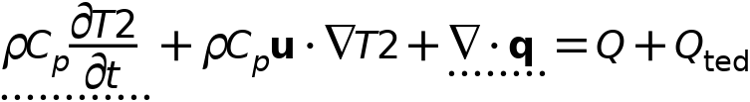



#### Heat Conduction, Solid

Settings

| **Description** | **Value** |
| --- | --- |
| Thermal conductivity | From material |

#### Thermodynamics, Solid

Settings

| **Description** | **Value** |
| --- | --- |
| Density | From material |
| Heat capacity at constant pressure | From material |

#### Coordinate System Selection

Settings

| **Description** | **Value** |
| --- | --- |
| Coordinate system | Global coordinate system |

#### Model Input

Settings

| **Description** | **Value** | **Unit** |
| --- | --- | --- |
| Volume reference temperature | Common model input |  |
| Absolute pressure | User defined |  |
| Absolute pressure | 1.0133E5 | Pa |

Properties from material

| **Property** | **Material** | **Property group** |
| --- | --- | --- |
| Thermal conductivity | Battery block | Basic |
| Density | Battery block | Basic |
| Heat capacity at constant pressure | Battery block | Basic |
| Thermal conductivity | PCM Layer | Basic |
| Density | PCM Layer | Basic |
| Heat capacity at constant pressure | PCM Layer | Basic |

#### Variables

| **Name** | **Expression** | **Unit** | **Description** | **Selection** | **Details** |
| --- | --- | --- | --- | --- | --- |
| domflux.T2x | ht2.dfluxx*ht2.d | W/m² | Domain flux, x-component | Domains 1–2 |  |
| domflux.T2y | ht2.dfluxy*ht2.d | W/m² | Domain flux, y-component | Domains 1–2 |  |
| domflux.T2z | ht2.dfluxz*ht2.d | W/m² | Domain flux, z-component | Domains 1–2 |  |
| ht2.chiT | 0 | 1/Pa | Isothermal compressibility coefficient | Domains 1–2 |  |
| ht2.alphap | -d(ht2.rho,T2)/max(ht2.rho,eps) | 1/K | Isobaric compressibility coefficient | Domains 1–2 |  |
| ht2.DeltaH_add | integrate(ht2.CpInt,ht2.TInt,ht2.DeltaH_Tlow,T2) | J/kg | Sensible enthalpy | Domains 1–2 | + operation |
| ht2.DeltaH_add_cst | ht2.Cp*(T2-ht2.DeltaH_Tlow) | J/kg | Sensible enthalpy, constant material properties | Domains 1–2 | + operation |
| ht2.H | ht2.HRef+ht2.DeltaH | J/kg | Enthalpy | Domains 1–2 | + operation |
| ht2.H_cst | ht2.HRef+ht2.DeltaH_cst | J/kg | Enthalpy, constant material properties | Domains 1–2 | + operation |
| ht2.Ei | ht2.H | J/kg | Internal energy | Domains 1–2 | + operation |
| ht2.Ei_cst | ht2.H_cst | J/kg | Internal energy, constant material properties | Domains 1–2 | + operation |
| ht2.Ek | 0.5*(ht2.ux^2+ht2.uy^2+ht2.uz^2) | J/kg | Kinetic energy | Domains 1–2 | + operation |
| ht2.dfluxx | -ht2.k_effxx*T2x-ht2.k_effxy*T2y-ht2.k_effxz*T2z | W/m² | Conductive heat flux, x-component | Domains 1–2 | + operation |
| ht2.dfluxy | -ht2.k_effyx*T2x-ht2.k_effyy*T2y-ht2.k_effyz*T2z | W/m² | Conductive heat flux, y-component | Domains 1–2 | + operation |
| ht2.dfluxz | -ht2.k_effzx*T2x-ht2.k_effzy*T2y-ht2.k_effzz*T2z | W/m² | Conductive heat flux, z-component | Domains 1–2 | + operation |
| ht2.dfluxtestx | -ht2.k_effxx*test(T2x)-ht2.k_effxy*test(T2y)-ht2.k_effxz*test(T2z) | W/m² | Conductive heat flux, x-component | Domains 1–2 | + operation |
| ht2.dfluxtesty | -ht2.k_effyx*test(T2x)-ht2.k_effyy*test(T2y)-ht2.k_effyz*test(T2z) | W/m² | Conductive heat flux, y-component | Domains 1–2 | + operation |
| ht2.dfluxtestz | -ht2.k_effzx*test(T2x)-ht2.k_effzy*test(T2y)-ht2.k_effzz*test(T2z) | W/m² | Conductive heat flux, z-component | Domains 1–2 | + operation |
| ht2.cfluxx | ht2.rho*ht2.ux*ht2.Ei | W/m² | Convective heat flux, x-component | Domains 1–2 | + operation |
| ht2.cfluxy | ht2.rho*ht2.uy*ht2.Ei | W/m² | Convective heat flux, y-component | Domains 1–2 | + operation |
| ht2.cfluxz | ht2.rho*ht2.uz*ht2.Ei | W/m² | Convective heat flux, z-component | Domains 1–2 | + operation |
| ht2.tefluxx | ht2.dfluxx+ht2.thfluxx | W/m² | Total energy flux, x-component | Domains 1–2 | + operation |
| ht2.tefluxy | ht2.dfluxy+ht2.thfluxy | W/m² | Total energy flux, y-component | Domains 1–2 | + operation |
| ht2.tefluxz | ht2.dfluxz+ht2.thfluxz | W/m² | Total energy flux, z-component | Domains 1–2 | + operation |
| ht2.teflux_cstx | ht2.dfluxx+ht2.thflux_cstx | W/m² | Total energy flux, constant material properties, x-component | Domains 1–2 | + operation |
| ht2.teflux_csty | ht2.dfluxy+ht2.thflux_csty | W/m² | Total energy flux, constant material properties, y-component | Domains 1–2 | + operation |
| ht2.teflux_cstz | ht2.dfluxz+ht2.thflux_cstz | W/m² | Total energy flux, constant material properties, z-component | Domains 1–2 | + operation |
| ht2.thfluxx | ht2.rho*ht2.ux*ht2.H0 | W/m² | Total enthalpy flux, x-component | Domains 1–2 | + operation |
| ht2.thfluxy | ht2.rho*ht2.uy*ht2.H0 | W/m² | Total enthalpy flux, y-component | Domains 1–2 | + operation |
| ht2.thfluxz | ht2.rho*ht2.uz*ht2.H0 | W/m² | Total enthalpy flux, z-component | Domains 1–2 | + operation |
| ht2.thflux_cstx | ht2.rho*ht2.ux*ht2.H0_cst | W/m² | Total enthalpy flux, constant material properties, x-component | Domains 1–2 | + operation |
| ht2.thflux_csty | ht2.rho*ht2.uy*ht2.H0_cst | W/m² | Total enthalpy flux, constant material properties, y-component | Domains 1–2 | + operation |
| ht2.thflux_cstz | ht2.rho*ht2.uz*ht2.H0_cst | W/m² | Total enthalpy flux, constant material properties, z-component | Domains 1–2 | + operation |
| ht2.ndflux_u | -uflux_spatial(T2)/up(ht2.varIntSpa) | W/m² | Internal normal conductive heat flux, upside | Boundaries 6–7, 10–11 | + operation |
| ht2.ndflux_d | -dflux_spatial(T2)/down(ht2.varIntSpa) | W/m² | Internal normal conductive heat flux, downside | Boundaries 6–7, 10–11 | + operation |
| ht2.ndflux_d | -dflux_spatial(T2)/down(ht2.varIntSpa) | W/m² | Internal normal conductive heat flux, downside | Boundaries 1–5, 8–9, 12 | + operation |
| ht2.dEiInt | ht2.solid1.dEiInt | W | Total accumulated heat rate | Global | + operation |
| ht2.dEiInt_cst | ht2.solid1.dEiInt_cst | W | Total accumulated heat rate, constant material properties | Global | + operation |
| ht2.dEi0Int | ht2.solid1.dEi0Int | W | Total accumulated energy rate | Global | + operation |
| ht2.dEi0Int_cst | ht2.solid1.dEi0Int_cst | W | Total accumulated energy rate, constant material properties | Global | + operation |
| ht2.Wstr | ht2.pA*(d(ht2.ux,x)+d(ht2.uy,y)+d(ht2.uz,z)) | W/m³ | Total stress power | Domains 1–2 | + operation |
| ht2.WstrInt | ht2.solid1.WstrInt | W | Total stress power | Global | + operation |
| ht2.WstrInt_cst | ht2.solid1.WstrInt_cst | W | Total stress power, constant material properties | Global | + operation |
| ht2.WInt | ht2.solid1.WInt | W | Total work source | Global | + operation |
| ht2.WInt_cst | ht2.solid1.WInt_cst | W | Total work source, constant material properties | Global | + operation |
| ht2.rho | material.rho | kg/m³ | Density | Domains 1–2 | Meta |
| ht2.kxx | material.k11 | W/(m·K) | Thermal conductivity, xx-component | Domains 1–2 | Meta |
| ht2.kyx | material.k21 | W/(m·K) | Thermal conductivity, yx-component | Domains 1–2 | Meta |
| ht2.kzx | material.k31 | W/(m·K) | Thermal conductivity, zx-component | Domains 1–2 | Meta |
| ht2.kxy | material.k12 | W/(m·K) | Thermal conductivity, xy-component | Domains 1–2 | Meta |
| ht2.kyy | material.k22 | W/(m·K) | Thermal conductivity, yy-component | Domains 1–2 | Meta |
| ht2.kzy | material.k32 | W/(m·K) | Thermal conductivity, zy-component | Domains 1–2 | Meta |
| ht2.kxz | material.k13 | W/(m·K) | Thermal conductivity, xz-component | Domains 1–2 | Meta |
| ht2.kyz | material.k23 | W/(m·K) | Thermal conductivity, yz-component | Domains 1–2 | Meta |
| ht2.kzz | material.k33 | W/(m·K) | Thermal conductivity, zz-component | Domains 1–2 | Meta |
| ht2.Cp | material.Cp | J/(kg·K) | Heat capacity at constant pressure | Domains 1–2 | Meta |
| ht2.solid1.pref | 1[atm] | Pa | Reference pressure level | Domains 1–2 |  |
| ht2.k_iso | if(material.k12==0&&material.k13==0&&material.k21==0&&material.k22==material.k11&&material.k23==0&&material.k31==0&&material.k32==0&&material.k33==material.k11,material.k11,error('Failed to evaluate an isotropic value of an anisotropic tensor')) | W/(m·K) | Thermal conductivity, isotropic value | Domains 1–2 | Meta |
| ht2.pA | ht2.pref | Pa | Absolute pressure | Domains 1–2 |  |
| ht2.C_eff | ht2.rho*ht2.Cp | J/(m³·K) | Effective volumetric heat capacity | Domains 1–2 |  |
| ht2.cellPe | 0.5*ht2.rho*ht2.Cp*h*sqrt(ht2.ux^2+ht2.uy^2+ht2.uz^2)/ht2.kmean | 1 | Cell Péclet number | Domains 1–2 |  |
| ht2.ux | 0 | m/s | Velocity field, x-component | Domains 1–2 | + operation |
| ht2.uy | 0 | m/s | Velocity field, y-component | Domains 1–2 | + operation |
| ht2.uz | 0 | m/s | Velocity field, z-component | Domains 1–2 | + operation |
| ht2.Qmet | 0 | W/m³ | Metabolic heat source | Domains 1–2 | + operation |
| ht2.rhoInit | subst(ht2.rho,T2,ht2.Tinit,minput.pA,ht2.pref) | kg/m³ | Initial density | Domains 1–2 |  |
| ht2.rho_eff | ht2.rho | kg/m³ | Effective density | Domains 1–2 |  |
| ht2.k_effxx | ht2.kxx | W/(m·K) | Effective thermal conductivity, xx-component | Domains 1–2 |  |
| ht2.k_effyx | ht2.kyx | W/(m·K) | Effective thermal conductivity, yx-component | Domains 1–2 |  |
| ht2.k_effzx | ht2.kzx | W/(m·K) | Effective thermal conductivity, zx-component | Domains 1–2 |  |
| ht2.k_effxy | ht2.kxy | W/(m·K) | Effective thermal conductivity, xy-component | Domains 1–2 |  |
| ht2.k_effyy | ht2.kyy | W/(m·K) | Effective thermal conductivity, yy-component | Domains 1–2 |  |
| ht2.k_effzy | ht2.kzy | W/(m·K) | Effective thermal conductivity, zy-component | Domains 1–2 |  |
| ht2.k_effxz | ht2.kxz | W/(m·K) | Effective thermal conductivity, xz-component | Domains 1–2 |  |
| ht2.k_effyz | ht2.kyz | W/(m·K) | Effective thermal conductivity, yz-component | Domains 1–2 |  |
| ht2.k_effzz | ht2.kzz | W/(m·K) | Effective thermal conductivity, zz-component | Domains 1–2 |  |
| ht2.kappaTxx | 0 | W/(m·K) | Turbulent thermal conductivity, xx-component | Domains 1–2 |  |
| ht2.kappaTyx | 0 | W/(m·K) | Turbulent thermal conductivity, yx-component | Domains 1–2 |  |
| ht2.kappaTzx | 0 | W/(m·K) | Turbulent thermal conductivity, zx-component | Domains 1–2 |  |
| ht2.kappaTxy | 0 | W/(m·K) | Turbulent thermal conductivity, xy-component | Domains 1–2 |  |
| ht2.kappaTyy | 0 | W/(m·K) | Turbulent thermal conductivity, yy-component | Domains 1–2 |  |
| ht2.kappaTzy | 0 | W/(m·K) | Turbulent thermal conductivity, zy-component | Domains 1–2 |  |
| ht2.kappaTxz | 0 | W/(m·K) | Turbulent thermal conductivity, xz-component | Domains 1–2 |  |
| ht2.kappaTyz | 0 | W/(m·K) | Turbulent thermal conductivity, yz-component | Domains 1–2 |  |
| ht2.kappaTzz | 0 | W/(m·K) | Turbulent thermal conductivity, zz-component | Domains 1–2 |  |
| ht2.kmean | (ht2.k_effxx+ht2.k_effyy+ht2.k_effzz)/3 | W/(m·K) | Mean effective thermal conductivity | Domains 1–2 |  |
| ht2.alphaTdxx | ht2.k_effxx/ht2.C_eff | m²/s | Thermal diffusivity, xx-component | Domains 1–2 |  |
| ht2.alphaTdyx | ht2.k_effyx/ht2.C_eff | m²/s | Thermal diffusivity, yx-component | Domains 1–2 |  |
| ht2.alphaTdzx | ht2.k_effzx/ht2.C_eff | m²/s | Thermal diffusivity, zx-component | Domains 1–2 |  |
| ht2.alphaTdxy | ht2.k_effxy/ht2.C_eff | m²/s | Thermal diffusivity, xy-component | Domains 1–2 |  |
| ht2.alphaTdyy | ht2.k_effyy/ht2.C_eff | m²/s | Thermal diffusivity, yy-component | Domains 1–2 |  |
| ht2.alphaTdzy | ht2.k_effzy/ht2.C_eff | m²/s | Thermal diffusivity, zy-component | Domains 1–2 |  |
| ht2.alphaTdxz | ht2.k_effxz/ht2.C_eff | m²/s | Thermal diffusivity, xz-component | Domains 1–2 |  |
| ht2.alphaTdyz | ht2.k_effyz/ht2.C_eff | m²/s | Thermal diffusivity, yz-component | Domains 1–2 |  |
| ht2.alphaTdzz | ht2.k_effzz/ht2.C_eff | m²/s | Thermal diffusivity, zz-component | Domains 1–2 |  |
| ht2.alphaTdMean | ht2.kmean/ht2.C_eff | m²/s | Mean thermal diffusivity | Domains 1–2 |  |
| ht2.gradTx | T2x | K/m | Temperature gradient, x-component | Domains 1–2 |  |
| ht2.gradTy | T2y | K/m | Temperature gradient, y-component | Domains 1–2 |  |
| ht2.gradTz | T2z | K/m | Temperature gradient, z-component | Domains 1–2 |  |
| ht2.gradTmag | sqrt(ht2.gradTx^2+ht2.gradTy^2+ht2.gradTz^2) | K/m | Temperature gradient magnitude | Domains 1–2 |  |
| ht2.pref | ht2.solid1.pref | Pa | Reference pressure level | Domains 1–2 |  |
| ht2.DeltaH_Tlow | ht2.Tref | K | Temperature lower bound for enthalpy evaluation | Domains 1–2 |  |
| ht2.DeltaH_plow | ht2.pref | Pa | Pressure lower bound for enthalpy evaluation | Domains 1–2 |  |
| ht2.dHdp | 0 | m³/kg | Intermediate variable | Domains 1–2 |  |
| ht2.mujtT | 0 | K/Pa | Isothermal Joule-Thomson coefficient | Domains 1–2 |  |
| ht2.alphapT | ht2.alphap*T2 | 1 | Help variable | Domains 1–2 |  |
| ht2.dEi | material.dt(ht2.rho*ht2.Ei) | W/m³ | Total accumulated heat rate density | Domains 1–2 |  |
| ht2.dEi_cst | material.dt(ht2.rho*ht2.Ei_cst) | W/m³ | Total accumulated heat rate density, constant material properties | Domains 1–2 |  |
| ht2.dEi0 | material.dt(ht2.rho*ht2.Ei0) | W/m³ | Total accumulated energy rate density | Domains 1–2 |  |
| ht2.dEi0_cst | material.dt(ht2.rho*ht2.Ei0_cst) | W/m³ | Total accumulated energy rate density, constant material properties | Domains 1–2 |  |
| ht2.solid1.dEiInt | ht2.solid1.intDom((ht2.dEi-ht2.Qm*ht2.Ei)*ht2.varIntSpa) | W | Total accumulated heat rate | Global |  |
| ht2.solid1.dEiInt_cst | ht2.solid1.intDom((ht2.dEi_cst-ht2.Qm*ht2.Ei_cst)*ht2.varIntSpa) | W | Total accumulated heat rate, constant material properties | Global |  |
| ht2.solid1.dEi0Int | ht2.solid1.intDom((ht2.dEi0-ht2.Qm*ht2.H)*ht2.varIntSpa) | W | Total accumulated energy rate | Global |  |
| ht2.solid1.dEi0Int_cst | ht2.solid1.intDom((ht2.dEi0_cst-ht2.Qm*ht2.H_cst)*ht2.varIntSpa) | W | Total accumulated energy rate, constant material properties | Global |  |
| ht2.solid1.QInt | ht2.solid1.intDom(ht2.Qtot*ht2.varIntSpa)+ht2.solid1.intIntLine(ht2.Qltot*ht2.varIntSpa)+ht2.intLine(subst(ht2.Qlrtot,ht2.id,isdefined(ht2.solid1.id))*ht2.varIntSpa)+ht2.solid1.intIntPnt(ht2.Qptot)+ht2.intPnt(subst(ht2.Qprtot,ht2.id,isdefined(ht2.solid1.id)))-ht2.solid1.intIntBnd(ht2.ndflux_u*up(ht2.varIntSpa)+ht2.ndflux_d*down(ht2.varIntSpa)) | W | Total heat source | Global |  |
| ht2.solid1.QInt_cst | ht2.solid1.intDom(ht2.Qtot*ht2.varIntSpa)+ht2.solid1.intIntLine(ht2.Qltot*ht2.varIntSpa)+ht2.intLine(subst(ht2.Qlrtot,ht2.id,isdefined(ht2.solid1.id))*ht2.varIntSpa)+ht2.solid1.intIntPnt(ht2.Qptot)+ht2.intPnt(subst(ht2.Qprtot,ht2.id,isdefined(ht2.solid1.id)))-ht2.solid1.intIntBnd(ht2.ndflux_u*up(ht2.varIntSpa)+ht2.ndflux_d*down(ht2.varIntSpa)) | W | Total heat source, constant material properties | Global |  |
| ht2.solid1.WstrInt | ht2.solid1.intDom(ht2.Wstr*ht2.varIntSpa) | W | Total stress power | Global |  |
| ht2.solid1.WstrInt_cst | ht2.solid1.intDom(ht2.Wstr*ht2.varIntSpa) | W | Total stress power, constant material properties | Global |  |
| ht2.solid1.WInt | ht2.solid1.intDom(ht2.Wtot*ht2.varIntSpa)+ht2.solid1.intBndUp(ht2.WBndTot_u*up(ht2.varIntSpa))+ht2.solid1.intBndDown(ht2.WBndTot_d*down(ht2.varIntSpa)) | W | Total work source | Global |  |
| ht2.solid1.WInt_cst | ht2.solid1.intDom(ht2.Wtot*ht2.varIntSpa)+ht2.solid1.intBndUp(ht2.WBndTot_u*up(ht2.varIntSpa))+ht2.solid1.intBndDown(ht2.WBndTot_d*down(ht2.varIntSpa)) | W | Total work source, constant material properties | Global |  |
| ht2.solid1.ntfluxInt | ht2.solid1.intExtBnd(ht2.ntflux*ht2.varIntSpa)+ht2.solid1.intExtBndUp(ht2.ntflux_u*up(ht2.varIntSpa))+ht2.solid1.intExtBndDown(ht2.ntflux_d*down(ht2.varIntSpa))+ht2.solid1.intIntBnd(ht2.ncflux_u*up(ht2.varIntSpa)+ht2.ncflux_d*down(ht2.varIntSpa)) | W | Total net heat rate | Global |  |
| ht2.solid1.ntfluxInt_cst | ht2.solid1.intExtBnd(ht2.ntflux_cst*ht2.varIntSpa)+ht2.solid1.intExtBndUp(ht2.ntflux_cst_u*up(ht2.varIntSpa))+ht2.solid1.intExtBndDown(ht2.ntflux_cst_d*down(ht2.varIntSpa))+ht2.solid1.intIntBnd(ht2.ncflux_u*up(ht2.varIntSpa)+ht2.ncflux_d*down(ht2.varIntSpa)) | W | Total net heat rate, constant material properties | Global |  |
| ht2.solid1.ntefluxInt | ht2.solid1.intExtBnd(ht2.nteflux*ht2.varIntSpa)+ht2.solid1.intExtBndUp(ht2.nteflux_u*up(ht2.varIntSpa))+ht2.solid1.intExtBndDown(ht2.nteflux_d*down(ht2.varIntSpa))+ht2.solid1.intIntBnd(ht2.nthflux_u*up(ht2.varIntSpa)+ht2.nthflux_d*down(ht2.varIntSpa)) | W | Total net energy rate | Global |  |
| ht2.solid1.ntefluxInt_cst | ht2.solid1.intExtBnd(ht2.nteflux_cst*ht2.varIntSpa)+ht2.solid1.intExtBndUp(ht2.nteflux_cst_u*up(ht2.varIntSpa))+ht2.solid1.intExtBndDown(ht2.nteflux_cst_d*down(ht2.varIntSpa))+ht2.solid1.intIntBnd(ht2.nthflux_cst_u*up(ht2.varIntSpa)+ht2.nthflux_cst_d*down(ht2.varIntSpa)) | W | Total net energy rate, constant material properties | Global |  |
| ht2.solid1.heatBalance | ht2.solid1.dEiInt+ht2.solid1.ntfluxInt+ht2.solid1.WstrInt-ht2.solid1.QInt | W | Heat balance | Global |  |
| ht2.solid1.heatBalance_cst | ht2.solid1.dEiInt_cst+ht2.solid1.ntfluxInt_cst+ht2.solid1.WstrInt_cst-ht2.solid1.QInt_cst | W | Heat balance, constant material properties | Global |  |
| ht2.solid1.energyBalance | ht2.solid1.dEi0Int+ht2.solid1.ntefluxInt-ht2.solid1.WInt-ht2.solid1.QInt | W | Energy balance | Global |  |
| ht2.solid1.energyBalance_cst | ht2.solid1.dEi0Int_cst+ht2.solid1.ntefluxInt_cst-ht2.solid1.WInt_cst-ht2.solid1.QInt_cst | W | Energy balance, constant material properties | Global |  |
| ht2.Tradu | ht2.Tu | K | Upside temperature | Domains 1–2 |  |
| ht2.Tradu | ht2.Tu | K | Upside temperature | Boundaries 1–12 |  |
| ht2.Tradd | ht2.Td | K | Downside temperature | Domains 1–2 |  |
| ht2.Tradd | ht2.Td | K | Downside temperature | Boundaries 1–12 |  |
| ht2.timeDerivative | material.dt(T2) | K/s | Temperature, first time derivative | Domains 1–2 |  |
| ht2.gamma | 1 | 1 | Ratio of specific heats | Domains 1–2 |  |
| ht2.Trho | ht2.Tref | K | Temperature for density evaluation | Domains 1–2 |  |
| ht2.CpInt | subst(material.Cp,ht2.solid1.minput_pressure,ht2.pref,ht2.solid1.minput_temperature,ht2.TInt) | J/(kg·K) | Specific heat capacity for integration | Domains 1–2 | Meta |
| ht2.Cp_ref | subst(material.Cp,ht2.solid1.minput_pressure,ht2.pref,ht2.solid1.minput_temperature,ht2.Tref) | J/(kg·K) | Reference heat capacity | Domains 1–2 | Meta |

#### Shape functions

| **Name** | **Shape function** | **Unit** | **Description** | **Shape frame** | **Selection** |
| --- | --- | --- | --- | --- | --- |
| T2 | Lagrange (Quadratic) | K | Temperature | Material | Domains 1–2 |
| T2 | Lagrange (Quadratic) | K | Temperature | Spatial | Domains 1–2 |
| T2 | Lagrange (Quadratic) | K | Temperature | Geometry | Domains 1–2 |
| T2 | Lagrange (Quadratic) | K | Temperature | Mesh | Domains 1–2 |

#### Weak Expressions

| **Weak expression** | **Integration order** | **Integration frame** | **Selection** |
| --- | --- | --- | --- |
| (ht2.dfluxx*test(T2x)+ht2.dfluxy*test(T2y)+ht2.dfluxz*test(T2z))*ht2.d | 4 | Spatial | Domains 1–2 |
| -ht2.C_eff*ht2.timeDerivative*test(T2)*ht2.d | 4 | Spatial | Domains 1–2 |

### Initial Values 1



Initial Values 1

Selection

|  |  |
| --- | --- |
| Geometric entity level | Domain |
| Selection | Geometry geom1: Dimension 3: All domains |

#### Initial Values

Settings

| **Description** | **Value** | **Unit** |
| --- | --- | --- |
| Temperature | User defined |  |
| Temperature | 293.15 | K |

#### Variables

| **Name** | **Expression** | **Unit** | **Description** | **Selection** |
| --- | --- | --- | --- | --- |
| ht2.Tinit | 293.15[K] | K | Initial temperature | Domains 1–2 |

### Thermal Insulation 1



Thermal Insulation 1

Selection

|  |  |
| --- | --- |
| Geometric entity level | Boundary |
| Selection | Geometry geom1: Dimension 2: All boundaries |

Equations



#### Variables

| **Name** | **Expression** | **Unit** | **Description** | **Selection** |
| --- | --- | --- | --- | --- |
| ht2.ins1.ntfluxInt | ht2.ins1.intExtBnd(ht2.ntflux*ht2.varIntSpa)+ht2.ins1.intIntBnd(ht2.ncflux_u*up(ht2.varIntSpa)+ht2.ncflux_d*down(ht2.varIntSpa)) | W | Total net heat rate | Global |
| ht2.ins1.ntfluxInt_cst | ht2.ins1.intExtBnd(ht2.ntflux*ht2.varIntSpa)+ht2.ins1.intIntBnd(ht2.ncflux_u*up(ht2.varIntSpa)+ht2.ncflux_d*down(ht2.varIntSpa)) | W | Total net heat rate, constant material properties | Global |
| ht2.ins1.ntefluxInt | ht2.ins1.intExtBnd(ht2.nteflux*ht2.varIntSpa)+ht2.ins1.intIntBnd(ht2.nthflux_u*up(ht2.varIntSpa)+ht2.nthflux_d*down(ht2.varIntSpa)) | W | Total net energy rate | Global |
| ht2.ins1.ntefluxInt_cst | ht2.ins1.intExtBnd(ht2.nteflux_cst*ht2.varIntSpa)+ht2.ins1.intIntBnd(ht2.nthflux_cst_u*up(ht2.varIntSpa)+ht2.nthflux_cst_d*down(ht2.varIntSpa)) | W | Total net energy rate, constant material properties | Global |
| ht2.ins1.ntfluxInt_u | ht2.ins1.intIntBnd(ht2.ntflux_u*up(ht2.varIntSpa)) | W | Total net heat rate, upside | Global |
| ht2.ins1.ntfluxInt_cst_u | ht2.ins1.intIntBnd(ht2.ntflux_u*up(ht2.varIntSpa)) | W | Total net heat rate, constant material properties, upside | Global |
| ht2.ins1.ntefluxInt_u | ht2.ins1.intIntBnd(ht2.nteflux_u*up(ht2.varIntSpa)) | W | Total net energy rate, upside | Global |
| ht2.ins1.ntefluxInt_cst_u | ht2.ins1.intIntBnd(ht2.nteflux_cst_u*up(ht2.varIntSpa)) | W | Total net energy rate, constant material properties, upside | Global |
| ht2.ins1.ntfluxInt_d | ht2.ins1.intIntBnd(ht2.ntflux_d*down(ht2.varIntSpa)) | W | Total net heat rate, downside | Global |
| ht2.ins1.ntfluxInt_cst_d | ht2.ins1.intIntBnd(ht2.ntflux_d*down(ht2.varIntSpa)) | W | Total net heat rate, constant material properties, downside | Global |
| ht2.ins1.ntefluxInt_d | ht2.ins1.intIntBnd(ht2.nteflux_d*down(ht2.varIntSpa)) | W | Total net energy rate, downside | Global |
| ht2.ins1.ntefluxInt_cst_d | ht2.ins1.intIntBnd(ht2.nteflux_cst_d*down(ht2.varIntSpa)) | W | Total net energy rate, constant material properties, downside | Global |
| ht2.ins1.Tave | nojac(ht2.ins1.intBnd(ht2.varIntSpa*ht2.rho*ht2.Cp*T2*max(abs(ht2.ux*ht2.nxmesh+ht2.uy*ht2.nymesh+ht2.uz*ht2.nzmesh),eps)))/nojac(ht2.ins1.intBnd(ht2.varIntSpa*ht2.rho*ht2.Cp*max(abs(ht2.ux*ht2.nxmesh+ht2.uy*ht2.nymesh+ht2.uz*ht2.nzmesh),eps))) | K | Weighted average temperature | Global |

#### Shape functions

| **Name** | **Shape function** | **Unit** | **Description** | **Shape frame** | **Selection** | **Details** |
| --- | --- | --- | --- | --- | --- | --- |
| T2 | Lagrange (Quadratic) | K | Temperature | Spatial | No boundaries | Slit |
| T2 | Lagrange (Quadratic) | K | Temperature | Material | No boundaries | Slit |
| T2 | Lagrange (Quadratic) | K | Temperature | Geometry | No boundaries | Slit |
| T2 | Lagrange (Quadratic) | K | Temperature | Mesh | No boundaries | Slit |

### Heat Source 1



Heat Source 1

Selection

|  |  |
| --- | --- |
| Geometric entity level | Domain |
| Selection | Geometry geom1: Dimension 3: Domain 2 |

Equations



#### Heat Source

Settings

| **Description** | **Value** | **Unit** |
| --- | --- | --- |
| Heat source | General source |  |
| Heat source | User defined |  |
| Heat source | 5000 | W/m³ |

#### Variables

| **Name** | **Expression** | **Unit** | **Description** | **Selection** | **Details** |
| --- | --- | --- | --- | --- | --- |
| ht2.Q | ht2.hs1.Q*spatial.detInvF | W/m³ | Heat source | Domain 2 | + operation |
| ht2.Qtot | ht2.hs1.Q*spatial.detInvF | W/m³ | Total heat source | Domain 2 | + operation |
| ht2.hs1.Q0 | 5000 | W/m³ | Heat source | Domain 2 |  |
| ht2.hs1.Q | ht2.hs1.Q0 | W/m³ | Heat source | Domain 2 |  |

#### Weak Expressions

| **Weak expression** | **Integration order** | **Integration frame** | **Selection** |
| --- | --- | --- | --- |
| ht2.hs1.Q*test(T2)*ht2.d | 4 | Material | Domain 2 |

## Heat Transfer in Fluids 3

Used products

|  |
| --- |
| COMSOL Multiphysics |



Heat Transfer in Fluids 3

Selection

|  |  |
| --- | --- |
| Geometric entity level | Domain |
| Selection | Geometry geom1: Dimension 3: Domains 1–2 |

Equations

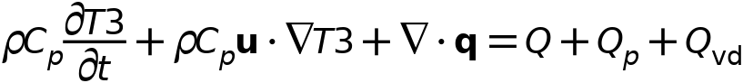



### Interface Settings

#### Discretization

Settings

| **Description** | **Value** |
| --- | --- |
| Temperature | Linear |

Settings

| **Description** | **Value** |
| --- | --- |
| Equation form | Study controlled |

#### Physical Model

Settings

| **Description** | **Value** | **Unit** |
| --- | --- | --- |
| Reference temperature | User defined |  |
| Reference temperature | 293.15 | K |

### Variables

| **Name** | **Expression** | **Unit** | **Description** | **Selection** | **Details** |
| --- | --- | --- | --- | --- | --- |
| ht3.Tref | model.input.Tref | K | Reference temperature | Global | Meta |
| ht3.C_effExt | 0 | J/(m³·K) | Effective volumetric heat capacity | Domains 1–2 | + operation |
| ht3.EMatExt | 0 | Pa | Young's modulus | Domains 1–2 | + operation |
| ht3.Tvar | T3 | K | Temperature | Domains 1–2 |  |
| ht3.Tvar | T3 | K | Temperature | Boundaries 1–12 |  |
| ht3.Tvar | T3 | K | Temperature | Edges 1–24 |  |
| ht3.Tvar | T3 | K | Temperature | Points 1–16 |  |
| ht3.nknExt | 0 | W/(m·K) | Help variable | Domains 1–2 | + operation |
| ht3.TextFace | 0 | K | External temperature | Domains 1–2 | + operation |
| ht3.nuMatExt | 0 | 1 | Poisson's ratio | Domains 1–2 | + operation |
| ht3.d | 1 | 1 | Thickness | Domains 1–2 |  |
| ht3.chiT | 0 | 1/Pa | Isothermal compressibility coefficient | Domains 1–2 |  |
| ht3.HRef | 0 | J/kg | Reference enthalpy | Domains 1–2 |  |
| ht3.alphap | 0 | 1/K | Isobaric compressibility coefficient | Domains 1–2 |  |
| ht3.DeltaH | ht3.DeltaH_add | J/kg | Sensible enthalpy | Domains 1–2 |  |
| ht3.DeltaH_cst | ht3.DeltaH_add_cst | J/kg | Sensible enthalpy, constant material properties | Domains 1–2 |  |
| ht3.DeltaH_add | 0 | J/kg | Sensible enthalpy | Domains 1–2 | + operation |
| ht3.DeltaH_add_cst | 0 | J/kg | Sensible enthalpy, constant material properties | Domains 1–2 | + operation |
| ht3.H | 0 | J/kg | Enthalpy | Domains 1–2 | + operation |
| ht3.H_cst | 0 | J/kg | Enthalpy, constant material properties | Domains 1–2 | + operation |
| ht3.H0 | ht3.H+ht3.Ek | J/kg | Total enthalpy | Domains 1–2 |  |
| ht3.H0_cst | ht3.H_cst+ht3.Ek | J/kg | Total enthalpy, constant material properties | Domains 1–2 |  |
| ht3.Ei | 0 | J/kg | Internal energy | Domains 1–2 | + operation |
| ht3.Ei_cst | 0 | J/kg | Internal energy, constant material properties | Domains 1–2 | + operation |
| ht3.Ei0 | ht3.Ei+ht3.Ek | J/kg | Total internal energy | Domains 1–2 |  |
| ht3.Ei0_cst | ht3.Ei_cst+ht3.Ek | J/kg | Total internal energy, constant material properties | Domains 1–2 |  |
| ht3.Ek | 0 | J/kg | Kinetic energy | Domains 1–2 | + operation |
| ht3.dfluxx | 0 | W/m² | Conductive heat flux, x-component | Domains 1–2 | + operation |
| ht3.dfluxy | 0 | W/m² | Conductive heat flux, y-component | Domains 1–2 | + operation |
| ht3.dfluxz | 0 | W/m² | Conductive heat flux, z-component | Domains 1–2 | + operation |
| ht3.dfluxx | mean(ht3.dfluxx) | W/m² | Conductive heat flux, x-component | Boundaries 1–12 | + operation |
| ht3.dfluxy | mean(ht3.dfluxy) | W/m² | Conductive heat flux, y-component | Boundaries 1–12 | + operation |
| ht3.dfluxz | mean(ht3.dfluxz) | W/m² | Conductive heat flux, z-component | Boundaries 1–12 | + operation |
| ht3.dfluxtestx | 0 | W/m² | Conductive heat flux, x-component | Domains 1–2 | + operation |
| ht3.dfluxtesty | 0 | W/m² | Conductive heat flux, y-component | Domains 1–2 | + operation |
| ht3.dfluxtestz | 0 | W/m² | Conductive heat flux, z-component | Domains 1–2 | + operation |
| ht3.dfluxtestx | mean(ht3.dfluxtestx) | W/m² | Conductive heat flux, x-component | Boundaries 1–12 | + operation |
| ht3.dfluxtesty | mean(ht3.dfluxtesty) | W/m² | Conductive heat flux, y-component | Boundaries 1–12 | + operation |
| ht3.dfluxtestz | mean(ht3.dfluxtestz) | W/m² | Conductive heat flux, z-component | Boundaries 1–12 | + operation |
| ht3.dfluxMag | sqrt(ht3.dfluxx^2+ht3.dfluxy^2+ht3.dfluxz^2) | W/m² | Conductive heat flux magnitude | Domains 1–2 |  |
| ht3.cfluxx | 0 | W/m² | Convective heat flux, x-component | Domains 1–2 | + operation |
| ht3.cfluxy | 0 | W/m² | Convective heat flux, y-component | Domains 1–2 | + operation |
| ht3.cfluxz | 0 | W/m² | Convective heat flux, z-component | Domains 1–2 | + operation |
| ht3.cfluxMag | sqrt(ht3.cfluxx^2+ht3.cfluxy^2+ht3.cfluxz^2) | W/m² | Convective heat flux magnitude | Domains 1–2 |  |
| ht3.tfluxx | ht3.dfluxx+ht3.cfluxx | W/m² | Total heat flux, x-component | Domains 1–2 |  |
| ht3.tfluxy | ht3.dfluxy+ht3.cfluxy | W/m² | Total heat flux, y-component | Domains 1–2 |  |
| ht3.tfluxz | ht3.dfluxz+ht3.cfluxz | W/m² | Total heat flux, z-component | Domains 1–2 |  |
| ht3.tfluxMag | sqrt(ht3.tfluxx^2+ht3.tfluxy^2+ht3.tfluxz^2) | W/m² | Total heat flux magnitude | Domains 1–2 |  |
| ht3.tefluxx | 0 | W/m² | Total energy flux, x-component | Domains 1–2 | + operation |
| ht3.tefluxy | 0 | W/m² | Total energy flux, y-component | Domains 1–2 | + operation |
| ht3.tefluxz | 0 | W/m² | Total energy flux, z-component | Domains 1–2 | + operation |
| ht3.teflux_cstx | 0 | W/m² | Total energy flux, constant material properties, x-component | Domains 1–2 | + operation |
| ht3.teflux_csty | 0 | W/m² | Total energy flux, constant material properties, y-component | Domains 1–2 | + operation |
| ht3.teflux_cstz | 0 | W/m² | Total energy flux, constant material properties, z-component | Domains 1–2 | + operation |
| ht3.tefluxMag | sqrt(ht3.tefluxx^2+ht3.tefluxy^2+ht3.tefluxz^2) | W/m² | Total energy flux magnitude | Domains 1–2 |  |
| ht3.thfluxx | 0 | W/m² | Total enthalpy flux, x-component | Domains 1–2 | + operation |
| ht3.thfluxy | 0 | W/m² | Total enthalpy flux, y-component | Domains 1–2 | + operation |
| ht3.thfluxz | 0 | W/m² | Total enthalpy flux, z-component | Domains 1–2 | + operation |
| ht3.thflux_cstx | 0 | W/m² | Total enthalpy flux, constant material properties, x-component | Domains 1–2 | + operation |
| ht3.thflux_csty | 0 | W/m² | Total enthalpy flux, constant material properties, y-component | Domains 1–2 | + operation |
| ht3.thflux_cstz | 0 | W/m² | Total enthalpy flux, constant material properties, z-component | Domains 1–2 | + operation |
| ht3.thfluxMag | sqrt(ht3.thfluxx^2+ht3.thfluxy^2+ht3.thfluxz^2) | W/m² | Total enthalpy flux magnitude | Domains 1–2 |  |
| ht3.dflux_ux | up(ht3.dfluxx) | W/m² | Conductive heat flux, x-component | Boundaries 1–12 |  |
| ht3.dflux_uy | up(ht3.dfluxy) | W/m² | Conductive heat flux, y-component | Boundaries 1–12 |  |
| ht3.dflux_uz | up(ht3.dfluxz) | W/m² | Conductive heat flux, z-component | Boundaries 1–12 |  |
| ht3.dflux_dx | down(ht3.dfluxx) | W/m² | Conductive heat flux, x-component | Boundaries 1–12 |  |
| ht3.dflux_dy | down(ht3.dfluxy) | W/m² | Conductive heat flux, y-component | Boundaries 1–12 |  |
| ht3.dflux_dz | down(ht3.dfluxz) | W/m² | Conductive heat flux, z-component | Boundaries 1–12 |  |
| ht3.dfluxtest_ux | up(ht3.dfluxtestx) | W/m² | Conductive heat flux, x-component | Boundaries 1–12 |  |
| ht3.dfluxtest_uy | up(ht3.dfluxtesty) | W/m² | Conductive heat flux, y-component | Boundaries 1–12 |  |
| ht3.dfluxtest_uz | up(ht3.dfluxtestz) | W/m² | Conductive heat flux, z-component | Boundaries 1–12 |  |
| ht3.dfluxtest_dx | down(ht3.dfluxtestx) | W/m² | Conductive heat flux, x-component | Boundaries 1–12 |  |
| ht3.dfluxtest_dy | down(ht3.dfluxtesty) | W/m² | Conductive heat flux, y-component | Boundaries 1–12 |  |
| ht3.dfluxtest_dz | down(ht3.dfluxtestz) | W/m² | Conductive heat flux, z-component | Boundaries 1–12 |  |
| ht3.rflux | 0 | W/m² | Radiative heat flux | Boundaries 1–12 | + operation |
| ht3.ncflux | mean(ht3.cfluxx)*ht3.nxmesh+mean(ht3.cfluxy)*ht3.nymesh+mean(ht3.cfluxz)*ht3.nzmesh | W/m² | Normal convective heat flux | Boundaries 1–12 |  |
| ht3.ncflux_u | up(ht3.cfluxx)*ht3.unxmesh+up(ht3.cfluxy)*ht3.unymesh+up(ht3.cfluxz)*ht3.unzmesh | W/m² | Internal normal convective heat flux, upside | Boundaries 1–12 |  |
| ht3.ncflux_d | down(ht3.cfluxx)*ht3.dnxmesh+down(ht3.cfluxy)*ht3.dnymesh+down(ht3.cfluxz)*ht3.dnzmesh | W/m² | Internal normal convective heat flux, downside | Boundaries 1–12 |  |
| ht3.ndflux | 0.5*(ht3.ndflux_d-ht3.ndflux_u) | W/m² | Normal conductive heat flux | Boundaries 1–12 | + operation |
| ht3.ndflux_u | -ht3.ndflux_d | W/m² | Internal normal conductive heat flux, upside | Boundaries 1–5, 8–9, 12 | + operation |
| ht3.ndflux_u | 0 | W/m² | Internal normal conductive heat flux, upside | Boundaries 6–7, 10–11 | + operation |
| ht3.ndflux_d | 0 | W/m² | Internal normal conductive heat flux, downside | Boundaries 1–12 | + operation |
| ht3.ntflux | ht3.ndflux+ht3.ncflux | W/m² | Normal total heat flux | Boundaries 1–12 |  |
| ht3.ntflux_cst | ht3.ndflux+ht3.ncflux | W/m² | Normal total heat flux, constant material properties | Boundaries 1–12 |  |
| ht3.ntflux_u | ht3.ndflux_u+ht3.ncflux_u | W/m² | Internal normal total flux, upside | Boundaries 1–12 |  |
| ht3.ntflux_cst_u | ht3.ndflux_u+ht3.ncflux_u | W/m² | Internal normal total heat flux, constant material properties, upside | Boundaries 1–12 |  |
| ht3.ntflux_d | ht3.ndflux_d+ht3.ncflux_d | W/m² | Internal normal total flux, downside | Boundaries 1–12 |  |
| ht3.ntflux_cst_d | ht3.ndflux_d+ht3.ncflux_d | W/m² | Internal normal total heat flux, constant material properties, downside | Boundaries 1–12 |  |
| ht3.nteflux | mean(ht3.tefluxx)*ht3.nxmesh+mean(ht3.tefluxy)*ht3.nymesh+mean(ht3.tefluxz)*ht3.nzmesh-mean(ht3.dfluxx)*ht3.nxmesh-mean(ht3.dfluxy)*ht3.nymesh-mean(ht3.dfluxz)*ht3.nzmesh+ht3.ndflux | W/m² | Normal total energy flux | Boundaries 1–12 |  |
| ht3.nteflux_cst | mean(ht3.teflux_cstx)*ht3.nxmesh+mean(ht3.teflux_csty)*ht3.nymesh+mean(ht3.teflux_cstz)*ht3.nzmesh-mean(ht3.dfluxx)*ht3.nxmesh-mean(ht3.dfluxy)*ht3.nymesh-mean(ht3.dfluxz)*ht3.nzmesh+ht3.ndflux | W/m² | Normal total energy flux, constant material properties | Boundaries 1–12 |  |
| ht3.nteflux_u | up(ht3.tefluxx)*ht3.unxmesh+up(ht3.tefluxy)*ht3.unymesh+up(ht3.tefluxz)*ht3.unzmesh-up(ht3.dfluxx)*ht3.unxmesh-up(ht3.dfluxy)*ht3.unymesh-up(ht3.dfluxz)*ht3.unzmesh+ht3.ndflux_u | W/m² | Internal normal total energy flux, upside | Boundaries 1–12 |  |
| ht3.nteflux_cst_u | up(ht3.teflux_cstx)*ht3.unxmesh+up(ht3.teflux_csty)*ht3.unymesh+up(ht3.teflux_cstz)*ht3.unzmesh-up(ht3.dfluxx)*ht3.unxmesh-up(ht3.dfluxy)*ht3.unymesh-up(ht3.dfluxz)*ht3.unzmesh+ht3.ndflux_u | W/m² | Internal normal total energy flux, constant material properties, upside | Boundaries 1–12 |  |
| ht3.nteflux_d | down(ht3.tefluxx)*ht3.dnxmesh+down(ht3.tefluxy)*ht3.dnymesh+down(ht3.tefluxz)*ht3.dnzmesh-down(ht3.dfluxx)*ht3.dnxmesh-down(ht3.dfluxy)*ht3.dnymesh-down(ht3.dfluxz)*ht3.dnzmesh+ht3.ndflux_d | W/m² | Internal normal total energy flux, downside | Boundaries 1–12 |  |
| ht3.nteflux_cst_d | down(ht3.teflux_cstx)*ht3.dnxmesh+down(ht3.teflux_csty)*ht3.dnymesh+down(ht3.teflux_cstz)*ht3.dnzmesh-down(ht3.dfluxx)*ht3.dnxmesh-down(ht3.dfluxy)*ht3.dnymesh-down(ht3.dfluxz)*ht3.dnzmesh+ht3.ndflux_d | W/m² | Internal normal total energy flux, constant material properties, downside | Boundaries 1–12 |  |
| ht3.nthflux | mean(ht3.thfluxx)*ht3.nxmesh+mean(ht3.thfluxy)*ht3.nymesh+mean(ht3.thfluxz)*ht3.nzmesh | W/m² | Normal total enthalpy flux | Boundaries 1–12 |  |
| ht3.nthflux_cst | mean(ht3.thflux_cstx)*ht3.nxmesh+mean(ht3.thflux_csty)*ht3.nymesh+mean(ht3.thflux_cstz)*ht3.nzmesh | W/m² | Normal total enthalpy flux, constant material properties | Boundaries 1–12 |  |
| ht3.nthflux_u | up(ht3.thfluxx)*ht3.unxmesh+up(ht3.thfluxy)*ht3.unymesh+up(ht3.thfluxz)*ht3.unzmesh | W/m² | Internal normal total enthalpy flux, upside | Boundaries 1–12 |  |
| ht3.nthflux_cst_u | up(ht3.thflux_cstx)*ht3.unxmesh+up(ht3.thflux_csty)*ht3.unymesh+up(ht3.thflux_cstz)*ht3.unzmesh | W/m² | Internal normal total enthalpy flux, constant material properties, upside | Boundaries 1–12 |  |
| ht3.nthflux_d | down(ht3.thfluxx)*ht3.dnxmesh+down(ht3.thfluxy)*ht3.dnymesh+down(ht3.thfluxz)*ht3.dnzmesh | W/m² | Internal normal total enthalpy flux, downside | Boundaries 1–12 |  |
| ht3.nthflux_cst_d | down(ht3.thflux_cstx)*ht3.dnxmesh+down(ht3.thflux_csty)*ht3.dnymesh+down(ht3.thflux_cstz)*ht3.dnzmesh | W/m² | Internal normal total enthalpy flux, constant material properties, downside | Boundaries 1–12 |  |
| ht3.Qm | 0 | kg/(m³·s) | Mass source | Domains 1–2 |  |
| ht3.Q | 0 | W/m³ | Heat source | Domains 1–2 | + operation |
| ht3.Qoop | 0 | W/m³ | Out-of-plane heat source | Domains 1–2 | + operation |
| ht3.Qtot | 0 | W/m³ | Total heat source | Domains 1–2 | + operation |
| ht3.Qbtot | 0 | W/m² | Total boundary heat source | Boundaries 1–12 | + operation |
| ht3.ntflux_contrib | 0 | W/m² | Boundary sources and fluxes contribution | Domains 1–2 | + operation |
| ht3.Qitot | 0 | W/m² | Total interface source | Domains 1–2 | + operation |
| ht3.qs | 0 | W/(m³·K) | Production/absorption coefficient | Domains 1–2 | + operation |
| ht3.qs_oop | 0 | W/(m³·K) | Out-of-plane production/absorption coefficient | Domains 1–2 | + operation |
| ht3.Qltot | 0 | W/m | Total line heat source | Edges 1–24 | + operation |
| ht3.Qlrtot | 0 | W/m | Total line heat source with radius | Edges 1–24 | + operation |
| ht3.Qptot | 0 | W | Total point heat source | Points 1–16 | + operation |
| ht3.Qprtot | 0 | W | Total point heat source with radius | Points 1–16 | + operation |
| ht3.q0 | 0 | W/m² | Inward heat flux | Boundaries 1–5, 8–9, 12 | + operation |
| ht3.Tu | up(T3) | K | Temperature | Boundaries 6–7, 10–11 |  |
| ht3.Tu | T3 | K | Temperature | Boundaries 1–5, 8–9, 12 |  |
| ht3.Td | down(T3) | K | Temperature | Boundaries 6–7, 10–11 |  |
| ht3.Td | T3 | K | Temperature | Boundaries 1–5, 8–9, 12 |  |
| ht3.TuIsDown | 0 | 1 | Help variable | Boundaries 6–7, 10–11 |  |
| ht3.TuIsDown | 0 | 1 | Help variable | Boundaries 1–5, 8–9, 12 |  |
| ht3.TdIsUp | 0 | 1 | Help variable | Boundaries 6–7, 10–11 |  |
| ht3.TdIsUp | 0 | 1 | Help variable | Boundaries 1–5, 8–9, 12 |  |
| ht3.du | up(ht3.d) | 1 | Thickness | Boundaries 6–7, 10–11 |  |
| ht3.du | ht3.d | 1 | Thickness | Boundaries 1–5, 8–9, 12 |  |
| ht3.dd | down(ht3.d) | 1 | Thickness | Boundaries 6–7, 10–11 |  |
| ht3.dd | ht3.d | 1 | Thickness | Boundaries 1–5, 8–9, 12 |  |
| ht3.nx | nx | 1 | Normal vector, x-component | Boundaries 6–7, 10–11 |  |
| ht3.ny | ny | 1 | Normal vector, y-component | Boundaries 6–7, 10–11 |  |
| ht3.nz | nz | 1 | Normal vector, z-component | Boundaries 6–7, 10–11 |  |
| ht3.nx | dnx | 1 | Normal vector, x-component | Boundaries 1–5, 8–9, 12 |  |
| ht3.ny | dny | 1 | Normal vector, y-component | Boundaries 1–5, 8–9, 12 |  |
| ht3.nz | dnz | 1 | Normal vector, z-component | Boundaries 1–5, 8–9, 12 |  |
| ht3.nxmesh | nxmesh | 1 | Normal vector (mesh), x-component | Boundaries 6–7, 10–11 |  |
| ht3.nymesh | nymesh | 1 | Normal vector (mesh), y-component | Boundaries 6–7, 10–11 |  |
| ht3.nzmesh | nzmesh | 1 | Normal vector (mesh), z-component | Boundaries 6–7, 10–11 |  |
| ht3.nxmesh | dnxmesh | 1 | Normal vector (mesh), x-component | Boundaries 1–5, 8–9, 12 |  |
| ht3.nymesh | dnymesh | 1 | Normal vector (mesh), y-component | Boundaries 1–5, 8–9, 12 |  |
| ht3.nzmesh | dnzmesh | 1 | Normal vector (mesh), z-component | Boundaries 1–5, 8–9, 12 |  |
| ht3.dnx | dnx | 1 | Normal vector down direction, x-component | Boundaries 1–12 |  |
| ht3.dny | dny | 1 | Normal vector down direction, y-component | Boundaries 1–12 |  |
| ht3.dnz | dnz | 1 | Normal vector down direction, z-component | Boundaries 1–12 |  |
| ht3.dnxmesh | dnxmesh | 1 | Normal vector down direction (mesh), x-component | Boundaries 1–12 |  |
| ht3.dnymesh | dnymesh | 1 | Normal vector down direction (mesh), y-component | Boundaries 1–12 |  |
| ht3.dnzmesh | dnzmesh | 1 | Normal vector down direction (mesh), z-component | Boundaries 1–12 |  |
| ht3.unx | unx | 1 | Normal vector up direction, x-component | Boundaries 1–12 |  |
| ht3.uny | uny | 1 | Normal vector up direction, y-component | Boundaries 1–12 |  |
| ht3.unz | unz | 1 | Normal vector up direction, z-component | Boundaries 1–12 |  |
| ht3.unxmesh | unxmesh | 1 | Normal vector up direction (mesh), x-component | Boundaries 1–12 |  |
| ht3.unymesh | unymesh | 1 | Normal vector up direction (mesh), y-component | Boundaries 1–12 |  |
| ht3.unzmesh | unzmesh | 1 | Normal vector up direction (mesh), z-component | Boundaries 1–12 |  |
| ht3.dEiInt | 0 | W | Total accumulated heat rate | Global | + operation |
| ht3.dEiInt_cst | 0 | W | Total accumulated heat rate, constant material properties | Global | + operation |
| ht3.dEi0Int | 0 | W | Total accumulated energy rate | Global | + operation |
| ht3.dEi0Int_cst | 0 | W | Total accumulated energy rate, constant material properties | Global | + operation |
| ht3.ntfluxInt | ht3.intExtBnd(ht3.ntflux*ht3.varIntSpa)+ht3.intIntBnd(ht3.ncflux_u*up(ht3.varIntSpa)+ht3.ncflux_d*down(ht3.varIntSpa)) | W | Total net heat rate | Global |  |
| ht3.ntfluxInt_cst | ht3.intExtBnd(ht3.ntflux_cst*ht3.varIntSpa)+ht3.intIntBnd(ht3.ncflux_u*up(ht3.varIntSpa)+ht3.ncflux_d*down(ht3.varIntSpa)) | W | Total net heat rate, constant material properties | Global |  |
| ht3.ntefluxInt | ht3.intExtBnd(ht3.nteflux*ht3.varIntSpa)+ht3.intIntBnd(ht3.nthflux_u*up(ht3.varIntSpa)+ht3.nthflux_d*down(ht3.varIntSpa)) | W | Total net energy rate | Global |  |
| ht3.ntefluxInt_cst | ht3.intExtBnd(ht3.nteflux_cst*ht3.varIntSpa)+ht3.intIntBnd(ht3.nthflux_cst_u*up(ht3.varIntSpa)+ht3.nthflux_cst_d*down(ht3.varIntSpa)) | W | Total net energy rate, constant material properties | Global |  |
| ht3.QInt | ht3.intDom(ht3.Qtot*ht3.varIntSpa)+ht3.intIntLine(ht3.Qltot*ht3.varIntSpa)+ht3.intLine(ht3.Qlrtot*ht3.varIntSpa)+ht3.intIntPnt(ht3.Qptot)+ht3.intPnt(ht3.Qprtot)-ht3.intIntBnd(ht3.ndflux_u*up(ht3.varIntSpa)+ht3.ndflux_d*down(ht3.varIntSpa)) | W | Total heat source | Global |  |
| ht3.QInt_cst | ht3.intDom(ht3.Qtot*ht3.varIntSpa)+ht3.intIntLine(ht3.Qltot*ht3.varIntSpa)+ht3.intLine(ht3.Qlrtot*ht3.varIntSpa)+ht3.intIntPnt(ht3.Qptot)+ht3.intPnt(ht3.Qprtot)-ht3.intIntBnd(ht3.ndflux_u*up(ht3.varIntSpa)+ht3.ndflux_d*down(ht3.varIntSpa)) | W | Total heat source, constant material properties | Global |  |
| ht3.Wstr | 0 | W/m³ | Total stress power | Domains 1–2 | + operation |
| ht3.WstrInt | 0 | W | Total stress power | Global | + operation |
| ht3.WstrInt_cst | 0 | W | Total stress power, constant material properties | Global | + operation |
| ht3.Wtot | 0 | W/m³ | Total work source | Domains 1–2 | + operation |
| ht3.WBndTot_u | 0 | W/m² | Total work source, upside | Boundaries 6–7, 10–11 | + operation |
| ht3.WBndTot_d | 0 | W/m² | Total work source, downside | Boundaries 1–12 | + operation |
| ht3.WInt | 0 | W | Total work source | Global | + operation |
| ht3.WInt_cst | 0 | W | Total work source, constant material properties | Global | + operation |
| ht3.heatBalance | ht3.dEiInt+ht3.ntfluxInt+ht3.WstrInt-ht3.QInt | W | Heat balance | Global |  |
| ht3.heatBalance_cst | ht3.dEiInt_cst+ht3.ntfluxInt_cst+ht3.WstrInt_cst-ht3.QInt_cst | W | Heat balance, constant material properties | Global |  |
| ht3.energyBalance | ht3.dEi0Int+ht3.ntefluxInt-ht3.WInt-ht3.QInt | W | Energy balance | Global |  |
| ht3.energyBalance_cst | ht3.dEi0Int_cst+ht3.ntefluxInt_cst-ht3.WInt_cst-ht3.QInt_cst | W | Energy balance, constant material properties | Global |  |
| ht3.id | 1 | 1 | Physics indicator | Domains 1–2 |  |
| ht3.varIntSpa | ht3.d | 1 | Intermediate variable | Domains 1–2 | Meta |

### Fluid 1



Fluid 1

Selection

|  |  |
| --- | --- |
| Geometric entity level | Domain |
| Selection | Geometry geom1: Dimension 3: All domains |

Equations

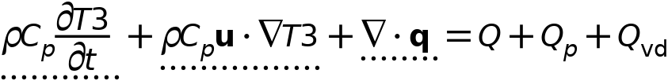



#### Heat Convection

Settings

| **Description** | **Value** | **Unit** |
| --- | --- | --- |
| Velocity field | User defined |  |
| Velocity field | {0, 0, 0} | m/s |

#### Heat Conduction, Fluid

Settings

| **Description** | **Value** |
| --- | --- |
| Thermal conductivity | From material |

#### Thermodynamics, Fluid

Settings

| **Description** | **Value** |
| --- | --- |
| Fluid type | Gas/Liquid |
| Density | From material |
| Heat capacity at constant pressure | From material |
| Ratio of specific heats | From material |

#### Coordinate System Selection

Settings

| **Description** | **Value** |
| --- | --- |
| Coordinate system | Global coordinate system |

#### Model Input

Settings

| **Description** | **Value** | **Unit** |
| --- | --- | --- |
| Absolute pressure | User defined |  |
| Absolute pressure | 1.0133E5 | Pa |

Properties from material

| **Property** | **Material** | **Property group** |
| --- | --- | --- |
| Heat capacity at constant pressure | Battery block | Basic |
| Ratio of specific heats | Battery block | Basic |
| Density | Battery block | Basic |
| Thermal conductivity | Battery block | Basic |
| Heat capacity at constant pressure | PCM Layer | Basic |
| Ratio of specific heats | PCM Layer | Basic |
| Density | PCM Layer | Basic |
| Thermal conductivity | PCM Layer | Basic |

#### Variables

| **Name** | **Expression** | **Unit** | **Description** | **Selection** | **Details** |
| --- | --- | --- | --- | --- | --- |
| domflux.T3x | ht3.dfluxx*ht3.d | W/m² | Domain flux, x-component | Domains 1–2 |  |
| domflux.T3y | ht3.dfluxy*ht3.d | W/m² | Domain flux, y-component | Domains 1–2 |  |
| domflux.T3z | ht3.dfluxz*ht3.d | W/m² | Domain flux, z-component | Domains 1–2 |  |
| ht3.chiT | d(ht3.rho,ht3.prho)/max(ht3.rho,eps) | 1/Pa | Isothermal compressibility coefficient | Domains 1–2 |  |
| ht3.alphap | -d(ht3.rho,T3)/max(ht3.rho,eps) | 1/K | Isobaric compressibility coefficient | Domains 1–2 |  |
| ht3.DeltaH_add | integrate(ht3.CpInt,ht3.TInt,ht3.DeltaH_Tlow,T3)+integrate(ht3.dHdp,ht3.fluid1.minput_pressure,ht3.DeltaH_plow,ht3.pA) | J/kg | Sensible enthalpy | Domains 1–2 | + operation |
| ht3.DeltaH_add_cst | ht3.Cp*(T3-ht3.DeltaH_Tlow)+ht3.dHdp*(ht3.pA-ht3.DeltaH_plow) | J/kg | Sensible enthalpy, constant material properties | Domains 1–2 | + operation |
| ht3.H | ht3.HRef+ht3.DeltaH | J/kg | Enthalpy | Domains 1–2 | + operation |
| ht3.H_cst | ht3.HRef+ht3.DeltaH_cst | J/kg | Enthalpy, constant material properties | Domains 1–2 | + operation |
| ht3.Ei | ht3.H-ht3.pA/ht3.rho | J/kg | Internal energy | Domains 1–2 | + operation |
| ht3.Ei_cst | ht3.H_cst-ht3.pA/ht3.rho | J/kg | Internal energy, constant material properties | Domains 1–2 | + operation |
| ht3.Ek | 0.5*(ht3.ux^2+ht3.uy^2+ht3.uz^2) | J/kg | Kinetic energy | Domains 1–2 | + operation |
| ht3.dfluxx | -ht3.k_effxx*T3x-ht3.k_effxy*T3y-ht3.k_effxz*T3z | W/m² | Conductive heat flux, x-component | Domains 1–2 | + operation |
| ht3.dfluxy | -ht3.k_effyx*T3x-ht3.k_effyy*T3y-ht3.k_effyz*T3z | W/m² | Conductive heat flux, y-component | Domains 1–2 | + operation |
| ht3.dfluxz | -ht3.k_effzx*T3x-ht3.k_effzy*T3y-ht3.k_effzz*T3z | W/m² | Conductive heat flux, z-component | Domains 1–2 | + operation |
| ht3.dfluxtestx | -ht3.k_effxx*test(T3x)-ht3.k_effxy*test(T3y)-ht3.k_effxz*test(T3z) | W/m² | Conductive heat flux, x-component | Domains 1–2 | + operation |
| ht3.dfluxtesty | -ht3.k_effyx*test(T3x)-ht3.k_effyy*test(T3y)-ht3.k_effyz*test(T3z) | W/m² | Conductive heat flux, y-component | Domains 1–2 | + operation |
| ht3.dfluxtestz | -ht3.k_effzx*test(T3x)-ht3.k_effzy*test(T3y)-ht3.k_effzz*test(T3z) | W/m² | Conductive heat flux, z-component | Domains 1–2 | + operation |
| ht3.cfluxx | ht3.rho*ht3.ux*ht3.Ei | W/m² | Convective heat flux, x-component | Domains 1–2 | + operation |
| ht3.cfluxy | ht3.rho*ht3.uy*ht3.Ei | W/m² | Convective heat flux, y-component | Domains 1–2 | + operation |
| ht3.cfluxz | ht3.rho*ht3.uz*ht3.Ei | W/m² | Convective heat flux, z-component | Domains 1–2 | + operation |
| ht3.tefluxx | ht3.dfluxx+ht3.thfluxx | W/m² | Total energy flux, x-component | Domains 1–2 | + operation |
| ht3.tefluxy | ht3.dfluxy+ht3.thfluxy | W/m² | Total energy flux, y-component | Domains 1–2 | + operation |
| ht3.tefluxz | ht3.dfluxz+ht3.thfluxz | W/m² | Total energy flux, z-component | Domains 1–2 | + operation |
| ht3.teflux_cstx | ht3.dfluxx+ht3.thflux_cstx | W/m² | Total energy flux, constant material properties, x-component | Domains 1–2 | + operation |
| ht3.teflux_csty | ht3.dfluxy+ht3.thflux_csty | W/m² | Total energy flux, constant material properties, y-component | Domains 1–2 | + operation |
| ht3.teflux_cstz | ht3.dfluxz+ht3.thflux_cstz | W/m² | Total energy flux, constant material properties, z-component | Domains 1–2 | + operation |
| ht3.thfluxx | ht3.rho*ht3.ux*ht3.H0 | W/m² | Total enthalpy flux, x-component | Domains 1–2 | + operation |
| ht3.thfluxy | ht3.rho*ht3.uy*ht3.H0 | W/m² | Total enthalpy flux, y-component | Domains 1–2 | + operation |
| ht3.thfluxz | ht3.rho*ht3.uz*ht3.H0 | W/m² | Total enthalpy flux, z-component | Domains 1–2 | + operation |
| ht3.thflux_cstx | ht3.rho*ht3.ux*ht3.H0_cst | W/m² | Total enthalpy flux, constant material properties, x-component | Domains 1–2 | + operation |
| ht3.thflux_csty | ht3.rho*ht3.uy*ht3.H0_cst | W/m² | Total enthalpy flux, constant material properties, y-component | Domains 1–2 | + operation |
| ht3.thflux_cstz | ht3.rho*ht3.uz*ht3.H0_cst | W/m² | Total enthalpy flux, constant material properties, z-component | Domains 1–2 | + operation |
| ht3.ndflux_u | -uflux_spatial(T3)/up(ht3.varIntSpa) | W/m² | Internal normal conductive heat flux, upside | Boundaries 6–7, 10–11 | + operation |
| ht3.ndflux_d | -dflux_spatial(T3)/down(ht3.varIntSpa) | W/m² | Internal normal conductive heat flux, downside | Boundaries 6–7, 10–11 | + operation |
| ht3.ndflux_d | -dflux_spatial(T3)/down(ht3.varIntSpa) | W/m² | Internal normal conductive heat flux, downside | Boundaries 1–5, 8–9, 12 | + operation |
| ht3.dEiInt | ht3.fluid1.dEiInt | W | Total accumulated heat rate | Global | + operation |
| ht3.dEiInt_cst | ht3.fluid1.dEiInt_cst | W | Total accumulated heat rate, constant material properties | Global | + operation |
| ht3.dEi0Int | ht3.fluid1.dEi0Int | W | Total accumulated energy rate | Global | + operation |
| ht3.dEi0Int_cst | ht3.fluid1.dEi0Int_cst | W | Total accumulated energy rate, constant material properties | Global | + operation |
| ht3.Wstr | ht3.pA*(d(ht3.ux,x)+d(ht3.uy,y)+d(ht3.uz,z)) | W/m³ | Total stress power | Domains 1–2 | + operation |
| ht3.WstrInt | ht3.fluid1.WstrInt | W | Total stress power | Global | + operation |
| ht3.WstrInt_cst | ht3.fluid1.WstrInt_cst | W | Total stress power, constant material properties | Global | + operation |
| ht3.WInt | ht3.fluid1.WInt | W | Total work source | Global | + operation |
| ht3.WInt_cst | ht3.fluid1.WInt_cst | W | Total work source, constant material properties | Global | + operation |
| ht3.fluid1.pref | model.input.pref | Pa | Reference pressure level | Domains 1–2 | Meta |
| ht3.u_primex | if(isdefined(model.input.u_prime1),model.input.u_prime1,0) | m/s | Subgrid velocity component, x-component | Domains 1–2 | Meta |
| ht3.u_primey | if(isdefined(model.input.u_prime2),model.input.u_prime2,0) | m/s | Subgrid velocity component, y-component | Domains 1–2 | Meta |
| ht3.u_primez | if(isdefined(model.input.u_prime3),model.input.u_prime3,0) | m/s | Subgrid velocity component, z-component | Domains 1–2 | Meta |
| ht3.res_T | ht3.timeDerivative*ht3.C_eff-ht3.k_effxx*T3xx-ht3.k_effxy*T3xy-ht3.k_effxz*T3xz-ht3.k_effyx*T3yx-ht3.k_effyy*T3yy-ht3.k_effyz*T3yz-ht3.k_effzx*T3zx-ht3.k_effzy*T3zy-ht3.k_effzz*T3zz-(ht3.qs+ht3.qs_oop)*T3+ht3.C_eff*(ht3.ux*T3x+ht3.uy*T3y+ht3.uz*T3z)-ht3.D_Hx*T3x-ht3.D_Hy*T3y-ht3.D_Hz*T3z-ht3.Q-ht3.Qoop | W/m³ | Equation residual | Domains 1–2 | + operation |
| ht3.pA | ht3.fluid1.minput_pressure | Pa | Absolute pressure | Domains 1–2 |  |
| ht3.C_eff | ht3.rho*ht3.Cp | J/(m³·K) | Effective volumetric heat capacity | Domains 1–2 |  |
| ht3.cellPe | 0.5*ht3.rho*ht3.Cp*h*sqrt(ht3.ux^2+ht3.uy^2+ht3.uz^2)/ht3.kmean | 1 | Cell Péclet number | Domains 1–2 |  |
| ht3.ux | ht3.u_inputx | m/s | Velocity field, x-component | Domains 1–2 | + operation |
| ht3.uy | ht3.u_inputy | m/s | Velocity field, y-component | Domains 1–2 | + operation |
| ht3.uz | ht3.u_inputz | m/s | Velocity field, z-component | Domains 1–2 | + operation |
| ht3.Qmet | 0 | W/m³ | Metabolic heat source | Domains 1–2 | + operation |
| ht3.rhoInit | subst(ht3.rho,T3,ht3.Tinit,minput.pA,ht3.pref) | kg/m³ | Initial density | Domains 1–2 |  |
| ht3.rho_eff | ht3.rho | kg/m³ | Effective density | Domains 1–2 |  |
| ht3.k_effxx | ht3.kxx | W/(m·K) | Effective thermal conductivity, xx-component | Domains 1–2 |  |
| ht3.k_effyx | ht3.kyx | W/(m·K) | Effective thermal conductivity, yx-component | Domains 1–2 |  |
| ht3.k_effzx | ht3.kzx | W/(m·K) | Effective thermal conductivity, zx-component | Domains 1–2 |  |
| ht3.k_effxy | ht3.kxy | W/(m·K) | Effective thermal conductivity, xy-component | Domains 1–2 |  |
| ht3.k_effyy | ht3.kyy | W/(m·K) | Effective thermal conductivity, yy-component | Domains 1–2 |  |
| ht3.k_effzy | ht3.kzy | W/(m·K) | Effective thermal conductivity, zy-component | Domains 1–2 |  |
| ht3.k_effxz | ht3.kxz | W/(m·K) | Effective thermal conductivity, xz-component | Domains 1–2 |  |
| ht3.k_effyz | ht3.kyz | W/(m·K) | Effective thermal conductivity, yz-component | Domains 1–2 |  |
| ht3.k_effzz | ht3.kzz | W/(m·K) | Effective thermal conductivity, zz-component | Domains 1–2 |  |
| ht3.kappaTxx | 0 | W/(m·K) | Turbulent thermal conductivity, xx-component | Domains 1–2 |  |
| ht3.kappaTyx | 0 | W/(m·K) | Turbulent thermal conductivity, yx-component | Domains 1–2 |  |
| ht3.kappaTzx | 0 | W/(m·K) | Turbulent thermal conductivity, zx-component | Domains 1–2 |  |
| ht3.kappaTxy | 0 | W/(m·K) | Turbulent thermal conductivity, xy-component | Domains 1–2 |  |
| ht3.kappaTyy | 0 | W/(m·K) | Turbulent thermal conductivity, yy-component | Domains 1–2 |  |
| ht3.kappaTzy | 0 | W/(m·K) | Turbulent thermal conductivity, zy-component | Domains 1–2 |  |
| ht3.kappaTxz | 0 | W/(m·K) | Turbulent thermal conductivity, xz-component | Domains 1–2 |  |
| ht3.kappaTyz | 0 | W/(m·K) | Turbulent thermal conductivity, yz-component | Domains 1–2 |  |
| ht3.kappaTzz | 0 | W/(m·K) | Turbulent thermal conductivity, zz-component | Domains 1–2 |  |
| ht3.kmean | (ht3.k_effxx+ht3.k_effyy+ht3.k_effzz)/3 | W/(m·K) | Mean effective thermal conductivity | Domains 1–2 |  |
| ht3.alphaTdxx | ht3.k_effxx/ht3.C_eff | m²/s | Thermal diffusivity, xx-component | Domains 1–2 |  |
| ht3.alphaTdyx | ht3.k_effyx/ht3.C_eff | m²/s | Thermal diffusivity, yx-component | Domains 1–2 |  |
| ht3.alphaTdzx | ht3.k_effzx/ht3.C_eff | m²/s | Thermal diffusivity, zx-component | Domains 1–2 |  |
| ht3.alphaTdxy | ht3.k_effxy/ht3.C_eff | m²/s | Thermal diffusivity, xy-component | Domains 1–2 |  |
| ht3.alphaTdyy | ht3.k_effyy/ht3.C_eff | m²/s | Thermal diffusivity, yy-component | Domains 1–2 |  |
| ht3.alphaTdzy | ht3.k_effzy/ht3.C_eff | m²/s | Thermal diffusivity, zy-component | Domains 1–2 |  |
| ht3.alphaTdxz | ht3.k_effxz/ht3.C_eff | m²/s | Thermal diffusivity, xz-component | Domains 1–2 |  |
| ht3.alphaTdyz | ht3.k_effyz/ht3.C_eff | m²/s | Thermal diffusivity, yz-component | Domains 1–2 |  |
| ht3.alphaTdzz | ht3.k_effzz/ht3.C_eff | m²/s | Thermal diffusivity, zz-component | Domains 1–2 |  |
| ht3.alphaTdMean | ht3.kmean/ht3.C_eff | m²/s | Mean thermal diffusivity | Domains 1–2 |  |
| ht3.gradTx | T3x | K/m | Temperature gradient, x-component | Domains 1–2 |  |
| ht3.gradTy | T3y | K/m | Temperature gradient, y-component | Domains 1–2 |  |
| ht3.gradTz | T3z | K/m | Temperature gradient, z-component | Domains 1–2 |  |
| ht3.gradTmag | sqrt(ht3.gradTx^2+ht3.gradTy^2+ht3.gradTz^2) | K/m | Temperature gradient magnitude | Domains 1–2 |  |
| ht3.pref | ht3.fluid1.pref | Pa | Reference pressure level | Domains 1–2 |  |
| ht3.DeltaH_Tlow | ht3.Tref | K | Temperature lower bound for enthalpy evaluation | Domains 1–2 |  |
| ht3.DeltaH_plow | ht3.pref | Pa | Pressure lower bound for enthalpy evaluation | Domains 1–2 |  |
| ht3.dHdp | (1-ht3.alphap*T3)/max(ht3.rho,eps) | m³/kg | Intermediate variable | Domains 1–2 |  |
| ht3.chiT_ref | d(ht3.rhoref,ht3.pref)/max(ht3.rhoref,eps) | 1/Pa | Reference isothermal compressibility coefficient | Domains 1–2 |  |
| ht3.mujtT | -ht3.dHdp/ht3.Cp | K/Pa | Isothermal Joule-Thomson coefficient | Domains 1–2 |  |
| ht3.alphap_ref | -d(ht3.rhoref,ht3.Tref)/max(ht3.rhoref,eps) | 1/K | Reference isobaric compressibility coefficient | Domains 1–2 |  |
| ht3.alphapT | ht3.alphap*T3 | 1 | Help variable | Domains 1–2 |  |
| ht3.dEi | material.dt(ht3.rho*ht3.Ei) | W/m³ | Total accumulated heat rate density | Domains 1–2 |  |
| ht3.dEi_cst | material.dt(ht3.rho*ht3.Ei_cst) | W/m³ | Total accumulated heat rate density, constant material properties | Domains 1–2 |  |
| ht3.dEi0 | material.dt(ht3.rho*ht3.Ei0) | W/m³ | Total accumulated energy rate density | Domains 1–2 |  |
| ht3.dEi0_cst | material.dt(ht3.rho*ht3.Ei0_cst) | W/m³ | Total accumulated energy rate density, constant material properties | Domains 1–2 |  |
| ht3.fluid1.dEiInt | ht3.fluid1.intDom((ht3.dEi-ht3.Qm*ht3.Ei)*ht3.varIntSpa) | W | Total accumulated heat rate | Global |  |
| ht3.fluid1.dEiInt_cst | ht3.fluid1.intDom((ht3.dEi_cst-ht3.Qm*ht3.Ei_cst)*ht3.varIntSpa) | W | Total accumulated heat rate, constant material properties | Global |  |
| ht3.fluid1.dEi0Int | ht3.fluid1.intDom((ht3.dEi0-ht3.Qm*ht3.H)*ht3.varIntSpa) | W | Total accumulated energy rate | Global |  |
| ht3.fluid1.dEi0Int_cst | ht3.fluid1.intDom((ht3.dEi0_cst-ht3.Qm*ht3.H_cst)*ht3.varIntSpa) | W | Total accumulated energy rate, constant material properties | Global |  |
| ht3.fluid1.QInt | ht3.fluid1.intDom(ht3.Qtot*ht3.varIntSpa)+ht3.fluid1.intIntLine(ht3.Qltot*ht3.varIntSpa)+ht3.intLine(subst(ht3.Qlrtot,ht3.id,isdefined(ht3.fluid1.id))*ht3.varIntSpa)+ht3.fluid1.intIntPnt(ht3.Qptot)+ht3.intPnt(subst(ht3.Qprtot,ht3.id,isdefined(ht3.fluid1.id)))-ht3.fluid1.intIntBnd(ht3.ndflux_u*up(ht3.varIntSpa)+ht3.ndflux_d*down(ht3.varIntSpa)) | W | Total heat source | Global |  |
| ht3.fluid1.QInt_cst | ht3.fluid1.intDom(ht3.Qtot*ht3.varIntSpa)+ht3.fluid1.intIntLine(ht3.Qltot*ht3.varIntSpa)+ht3.intLine(subst(ht3.Qlrtot,ht3.id,isdefined(ht3.fluid1.id))*ht3.varIntSpa)+ht3.fluid1.intIntPnt(ht3.Qptot)+ht3.intPnt(subst(ht3.Qprtot,ht3.id,isdefined(ht3.fluid1.id)))-ht3.fluid1.intIntBnd(ht3.ndflux_u*up(ht3.varIntSpa)+ht3.ndflux_d*down(ht3.varIntSpa)) | W | Total heat source, constant material properties | Global |  |
| ht3.fluid1.WstrInt | ht3.fluid1.intDom(ht3.Wstr*ht3.varIntSpa) | W | Total stress power | Global |  |
| ht3.fluid1.WstrInt_cst | ht3.fluid1.intDom(ht3.Wstr*ht3.varIntSpa) | W | Total stress power, constant material properties | Global |  |
| ht3.fluid1.WInt | ht3.fluid1.intDom(ht3.Wtot*ht3.varIntSpa)+ht3.fluid1.intBndUp(ht3.WBndTot_u*up(ht3.varIntSpa))+ht3.fluid1.intBndDown(ht3.WBndTot_d*down(ht3.varIntSpa)) | W | Total work source | Global |  |
| ht3.fluid1.WInt_cst | ht3.fluid1.intDom(ht3.Wtot*ht3.varIntSpa)+ht3.fluid1.intBndUp(ht3.WBndTot_u*up(ht3.varIntSpa))+ht3.fluid1.intBndDown(ht3.WBndTot_d*down(ht3.varIntSpa)) | W | Total work source, constant material properties | Global |  |
| ht3.fluid1.ntfluxInt | ht3.fluid1.intExtBnd(ht3.ntflux*ht3.varIntSpa)+ht3.fluid1.intExtBndUp(ht3.ntflux_u*up(ht3.varIntSpa))+ht3.fluid1.intExtBndDown(ht3.ntflux_d*down(ht3.varIntSpa))+ht3.fluid1.intIntBnd(ht3.ncflux_u*up(ht3.varIntSpa)+ht3.ncflux_d*down(ht3.varIntSpa)) | W | Total net heat rate | Global |  |
| ht3.fluid1.ntfluxInt_cst | ht3.fluid1.intExtBnd(ht3.ntflux_cst*ht3.varIntSpa)+ht3.fluid1.intExtBndUp(ht3.ntflux_cst_u*up(ht3.varIntSpa))+ht3.fluid1.intExtBndDown(ht3.ntflux_cst_d*down(ht3.varIntSpa))+ht3.fluid1.intIntBnd(ht3.ncflux_u*up(ht3.varIntSpa)+ht3.ncflux_d*down(ht3.varIntSpa)) | W | Total net heat rate, constant material properties | Global |  |
| ht3.fluid1.ntefluxInt | ht3.fluid1.intExtBnd(ht3.nteflux*ht3.varIntSpa)+ht3.fluid1.intExtBndUp(ht3.nteflux_u*up(ht3.varIntSpa))+ht3.fluid1.intExtBndDown(ht3.nteflux_d*down(ht3.varIntSpa))+ht3.fluid1.intIntBnd(ht3.nthflux_u*up(ht3.varIntSpa)+ht3.nthflux_d*down(ht3.varIntSpa)) | W | Total net energy rate | Global |  |
| ht3.fluid1.ntefluxInt_cst | ht3.fluid1.intExtBnd(ht3.nteflux_cst*ht3.varIntSpa)+ht3.fluid1.intExtBndUp(ht3.nteflux_cst_u*up(ht3.varIntSpa))+ht3.fluid1.intExtBndDown(ht3.nteflux_cst_d*down(ht3.varIntSpa))+ht3.fluid1.intIntBnd(ht3.nthflux_cst_u*up(ht3.varIntSpa)+ht3.nthflux_cst_d*down(ht3.varIntSpa)) | W | Total net energy rate, constant material properties | Global |  |
| ht3.fluid1.heatBalance | ht3.fluid1.dEiInt+ht3.fluid1.ntfluxInt+ht3.fluid1.WstrInt-ht3.fluid1.QInt | W | Heat balance | Global |  |
| ht3.fluid1.heatBalance_cst | ht3.fluid1.dEiInt_cst+ht3.fluid1.ntfluxInt_cst+ht3.fluid1.WstrInt_cst-ht3.fluid1.QInt_cst | W | Heat balance, constant material properties | Global |  |
| ht3.fluid1.energyBalance | ht3.fluid1.dEi0Int+ht3.fluid1.ntefluxInt-ht3.fluid1.WInt-ht3.fluid1.QInt | W | Energy balance | Global |  |
| ht3.fluid1.energyBalance_cst | ht3.fluid1.dEi0Int_cst+ht3.fluid1.ntefluxInt_cst-ht3.fluid1.WInt_cst-ht3.fluid1.QInt_cst | W | Energy balance, constant material properties | Global |  |
| ht3.Tradu | ht3.Tu | K | Upside temperature | Domains 1–2 |  |
| ht3.Tradu | ht3.Tu | K | Upside temperature | Boundaries 1–12 |  |
| ht3.Tradd | ht3.Td | K | Downside temperature | Domains 1–2 |  |
| ht3.Tradd | ht3.Td | K | Downside temperature | Boundaries 1–12 |  |
| ht3.kxx | ht3.kmatxx | W/(m·K) | Thermal conductivity, xx-component | Domains 1–2 |  |
| ht3.kyx | ht3.kmatyx | W/(m·K) | Thermal conductivity, yx-component | Domains 1–2 |  |
| ht3.kzx | ht3.kmatzx | W/(m·K) | Thermal conductivity, zx-component | Domains 1–2 |  |
| ht3.kxy | ht3.kmatxy | W/(m·K) | Thermal conductivity, xy-component | Domains 1–2 |  |
| ht3.kyy | ht3.kmatyy | W/(m·K) | Thermal conductivity, yy-component | Domains 1–2 |  |
| ht3.kzy | ht3.kmatzy | W/(m·K) | Thermal conductivity, zy-component | Domains 1–2 |  |
| ht3.kxz | ht3.kmatxz | W/(m·K) | Thermal conductivity, xz-component | Domains 1–2 |  |
| ht3.kyz | ht3.kmatyz | W/(m·K) | Thermal conductivity, yz-component | Domains 1–2 |  |
| ht3.kzz | ht3.kmatzz | W/(m·K) | Thermal conductivity, zz-component | Domains 1–2 |  |
| ht3.kmatxx | material.k11 | W/(m·K) | Thermal conductivity, xx-component | Domains 1–2 | Meta |
| ht3.kmatyx | material.k21 | W/(m·K) | Thermal conductivity, yx-component | Domains 1–2 | Meta |
| ht3.kmatzx | material.k31 | W/(m·K) | Thermal conductivity, zx-component | Domains 1–2 | Meta |
| ht3.kmatxy | material.k12 | W/(m·K) | Thermal conductivity, xy-component | Domains 1–2 | Meta |
| ht3.kmatyy | material.k22 | W/(m·K) | Thermal conductivity, yy-component | Domains 1–2 | Meta |
| ht3.kmatzy | material.k32 | W/(m·K) | Thermal conductivity, zy-component | Domains 1–2 | Meta |
| ht3.kmatxz | material.k13 | W/(m·K) | Thermal conductivity, xz-component | Domains 1–2 | Meta |
| ht3.kmatyz | material.k23 | W/(m·K) | Thermal conductivity, yz-component | Domains 1–2 | Meta |
| ht3.kmatzz | material.k33 | W/(m·K) | Thermal conductivity, zz-component | Domains 1–2 | Meta |
| ht3.rho | ht3.rhomat | kg/m³ | Density | Domains 1–2 |  |
| ht3.rhomat | subst(material.rho,ht3.fluid1.minput_pressure,ht3.prho) | kg/m³ | Density | Domains 1–2 | Meta |
| ht3.rhoref | subst(material.rho,ht3.fluid1.minput_pressure,ht3.pref,ht3.fluid1.minput_temperature,ht3.Tref) | kg/m³ | Reference density | Domains 1–2 | Meta |
| ht3.Cp | ht3.Cpmat | J/(kg·K) | Heat capacity at constant pressure | Domains 1–2 |  |
| ht3.CpInt | subst(material.Cp,ht3.fluid1.minput_pressure,ht3.pref,ht3.fluid1.minput_temperature,ht3.TInt) | J/(kg·K) | Specific heat capacity for integration | Domains 1–2 | Meta |
| ht3.Cp_ref | subst(material.Cp,ht3.fluid1.minput_pressure,ht3.pref,ht3.fluid1.minput_temperature,ht3.Tref) | J/(kg·K) | Reference heat capacity | Domains 1–2 | Meta |
| ht3.Cpmat | material.Cp | J/(kg·K) | Heat capacity at constant pressure | Domains 1–2 | Meta |
| ht3.gamma | material.gamma_not_IG | 1 | Ratio of specific heats | Domains 1–2 | Meta |
| ht3.gamma_ref | subst(material.gamma_not_IG,ht3.fluid1.minput_pressure,ht3.pref,ht3.fluid1.minput_temperature,ht3.Tref) | 1 | Reference ratio of specific heats | Domains 1–2 | Meta |
| ht3.c_s | sqrt((-1+ht3.gamma)*ht3.Cp/(ht3.Trho*ht3.alphap^2)) | m/s | Speed of sound | Domains 1–2 |  |
| ht3.Ma | sqrt(model.input.u1^2+model.input.u2^2+model.input.u3^2)/ht3.c_s | 1 | Mach number | Domains 1–2 | Meta |
| ht3.prho | ht3.fluid1.minput_pressure | Pa | Pressure for the evaluation of density | Domains 1–2 |  |
| ht3.T | ht3.fluid1.minput_temperature | K | Temperature | Domains 1–2 |  |
| ht3.Trho | ht3.fluid1.minput_temperature | K | Temperature for density evaluation | Domains 1–2 |  |
| ht3.timeDerivative | material.dt(T3) | K/s | Temperature, first time derivative | Domains 1–2 |  |
| ht3.helem | h_spatial | m | Element size | Domains 1–2 |  |

#### Shape functions

| **Name** | **Shape function** | **Unit** | **Description** | **Shape frame** | **Selection** |
| --- | --- | --- | --- | --- | --- |
| T3 | Lagrange (Linear) | K | Temperature | Spatial | Domains 1–2 |
| T3 | Lagrange (Linear) | K | Temperature | Material | Domains 1–2 |
| T3 | Lagrange (Linear) | K | Temperature | Geometry | Domains 1–2 |
| T3 | Lagrange (Linear) | K | Temperature | Mesh | Domains 1–2 |

#### Weak Expressions

| **Weak expression** | **Integration order** | **Integration frame** | **Selection** |
| --- | --- | --- | --- |
| ht3.crosswind | 2 | Spatial | Domains 1–2 |
| ht3.streamline | 2 | Spatial | Domains 1–2 |
| (ht3.dfluxx*test(T3x)+ht3.dfluxy*test(T3y)+ht3.dfluxz*test(T3z))*ht3.d | 2 | Spatial | Domains 1–2 |
| -ht3.C_eff*ht3.timeDerivative*test(T3)*ht3.d | 2 | Spatial | Domains 1–2 |
| -ht3.C_eff*(ht3.ux*T3x+ht3.uy*T3y+ht3.uz*T3z)*test(T3)*ht3.d | 2 | Spatial | Domains 1–2 |

### Initial Values 1



Initial Values 1

Selection

|  |  |
| --- | --- |
| Geometric entity level | Domain |
| Selection | Geometry geom1: Dimension 3: All domains |

#### Initial Values

Settings

| **Description** | **Value** | **Unit** |
| --- | --- | --- |
| Temperature | User defined |  |
| Temperature | 333.15 | K |

#### Variables

| **Name** | **Expression** | **Unit** | **Description** | **Selection** |
| --- | --- | --- | --- | --- |
| ht3.Tinit | 333.15[K] | K | Initial temperature | Domains 1–2 |

### Thermal Insulation 1



Thermal Insulation 1

Selection

|  |  |
| --- | --- |
| Geometric entity level | Boundary |
| Selection | Geometry geom1: Dimension 2: All boundaries |

Equations



#### Variables

| **Name** | **Expression** | **Unit** | **Description** | **Selection** |
| --- | --- | --- | --- | --- |
| ht3.ins1.ntfluxInt | ht3.ins1.intExtBnd(ht3.ntflux*ht3.varIntSpa)+ht3.ins1.intIntBnd(ht3.ncflux_u*up(ht3.varIntSpa)+ht3.ncflux_d*down(ht3.varIntSpa)) | W | Total net heat rate | Global |
| ht3.ins1.ntfluxInt_cst | ht3.ins1.intExtBnd(ht3.ntflux*ht3.varIntSpa)+ht3.ins1.intIntBnd(ht3.ncflux_u*up(ht3.varIntSpa)+ht3.ncflux_d*down(ht3.varIntSpa)) | W | Total net heat rate, constant material properties | Global |
| ht3.ins1.ntefluxInt | ht3.ins1.intExtBnd(ht3.nteflux*ht3.varIntSpa)+ht3.ins1.intIntBnd(ht3.nthflux_u*up(ht3.varIntSpa)+ht3.nthflux_d*down(ht3.varIntSpa)) | W | Total net energy rate | Global |
| ht3.ins1.ntefluxInt_cst | ht3.ins1.intExtBnd(ht3.nteflux_cst*ht3.varIntSpa)+ht3.ins1.intIntBnd(ht3.nthflux_cst_u*up(ht3.varIntSpa)+ht3.nthflux_cst_d*down(ht3.varIntSpa)) | W | Total net energy rate, constant material properties | Global |
| ht3.ins1.ntfluxInt_u | ht3.ins1.intIntBnd(ht3.ntflux_u*up(ht3.varIntSpa)) | W | Total net heat rate, upside | Global |
| ht3.ins1.ntfluxInt_cst_u | ht3.ins1.intIntBnd(ht3.ntflux_u*up(ht3.varIntSpa)) | W | Total net heat rate, constant material properties, upside | Global |
| ht3.ins1.ntefluxInt_u | ht3.ins1.intIntBnd(ht3.nteflux_u*up(ht3.varIntSpa)) | W | Total net energy rate, upside | Global |
| ht3.ins1.ntefluxInt_cst_u | ht3.ins1.intIntBnd(ht3.nteflux_cst_u*up(ht3.varIntSpa)) | W | Total net energy rate, constant material properties, upside | Global |
| ht3.ins1.ntfluxInt_d | ht3.ins1.intIntBnd(ht3.ntflux_d*down(ht3.varIntSpa)) | W | Total net heat rate, downside | Global |
| ht3.ins1.ntfluxInt_cst_d | ht3.ins1.intIntBnd(ht3.ntflux_d*down(ht3.varIntSpa)) | W | Total net heat rate, constant material properties, downside | Global |
| ht3.ins1.ntefluxInt_d | ht3.ins1.intIntBnd(ht3.nteflux_d*down(ht3.varIntSpa)) | W | Total net energy rate, downside | Global |
| ht3.ins1.ntefluxInt_cst_d | ht3.ins1.intIntBnd(ht3.nteflux_cst_d*down(ht3.varIntSpa)) | W | Total net energy rate, constant material properties, downside | Global |
| ht3.ins1.Tave | nojac(ht3.ins1.intBnd(ht3.varIntSpa*ht3.rho*ht3.Cp*T3*max(abs(ht3.ux*ht3.nxmesh+ht3.uy*ht3.nymesh+ht3.uz*ht3.nzmesh),eps)))/nojac(ht3.ins1.intBnd(ht3.varIntSpa*ht3.rho*ht3.Cp*max(abs(ht3.ux*ht3.nxmesh+ht3.uy*ht3.nymesh+ht3.uz*ht3.nzmesh),eps))) | K | Weighted average temperature | Global |

#### Shape functions

| **Name** | **Shape function** | **Unit** | **Description** | **Shape frame** | **Selection** | **Details** |
| --- | --- | --- | --- | --- | --- | --- |
| T3 | Lagrange (Linear) | K | Temperature | Spatial | No boundaries | Slit |
| T3 | Lagrange (Linear) | K | Temperature | Material | No boundaries | Slit |
| T3 | Lagrange (Linear) | K | Temperature | Geometry | No boundaries | Slit |
| T3 | Lagrange (Linear) | K | Temperature | Mesh | No boundaries | Slit |

### Temperature 1



Temperature 1

Selection

|  |  |
| --- | --- |
| Geometric entity level | Boundary |
| Selection | Geometry geom1: Dimension 2: No boundaries |

Equations



#### Temperature

Settings

| **Description** | **Value** | **Unit** |
| --- | --- | --- |
| Temperature | User defined |  |
| Temperature | 293.15 | K |

## Mesh 1

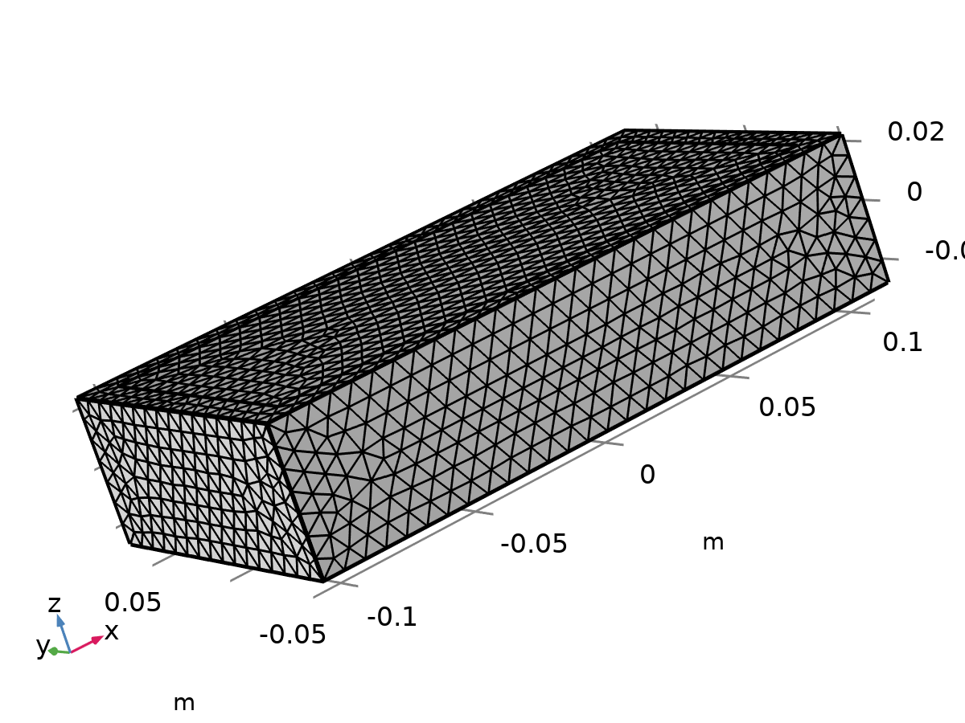

Mesh 1

Mesh statistics

| **Description** | **Value** |
| --- | --- |
| Status | Complete mesh |
| Mesh vertices | 8343 |
| Tetrahedra | 44131 |
| Triangles | 5064 |
| Edge elements | 392 |
| Vertex elements | 16 |
| Number of elements | 44131 |
| Minimum element quality | 0.2314 |
| Average element quality | 0.6733 |
| Element volume ratio | 0.076257 |
| Mesh volume | 0.00132 m³ |

### Size (size)

Settings

| **Description** | **Value** |
| --- | --- |
| Calibrate for | Fluid dynamics |
| Maximum element size | 0.00775 |
| Minimum element size | 0.00232 |
| Curvature factor | 0.7 |
| Resolution of narrow regions | 0.6 |
| Maximum element growth rate | 1.2 |
| Predefined size | Coarse |

### Free Tetrahedral 1 (ftet1)

Selection

|  |  |
| --- | --- |
| Geometric entity level | Domain |
| Selection | Remaining |

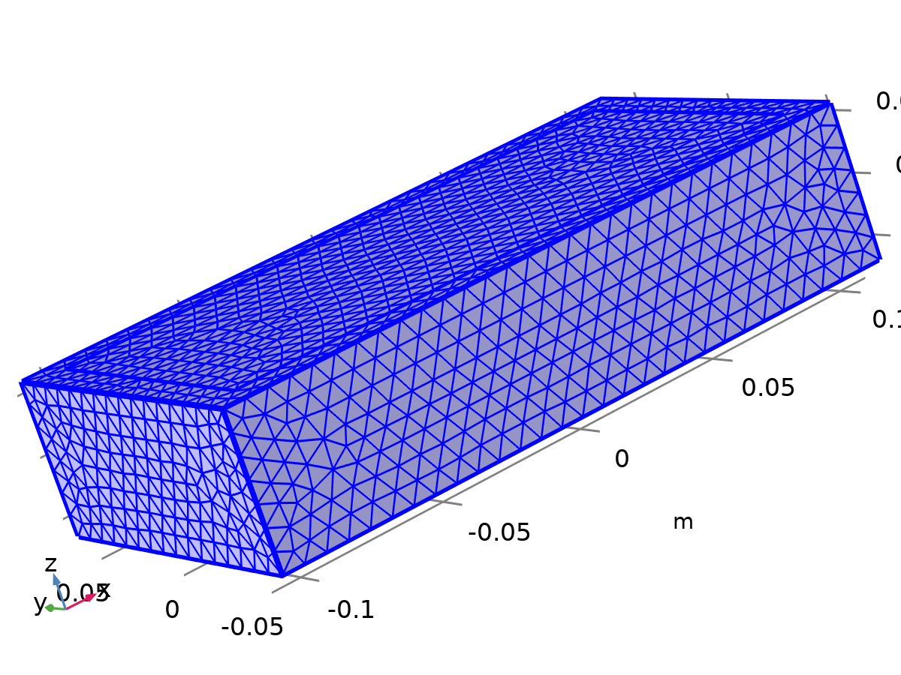

Free Tetrahedral 1

Settings

| **Description** | **Value** |
| --- | --- |
| Avoid inverted curved elements | On |

Information

| **Description** | **Value** |
| --- | --- |
| Last build time | < 1 second |
| Built with | COMSOL 6.3.0.335 (win64), Apr 29, 2025, 6:05:04 AM |

# Study 1

Computation information

|  |  |
| --- | --- |
| Computation time | 2 min 33 s |

## Time Dependent

| **Times** | **Unit** |
| --- | --- |
| 0 300 | s |

Study settings

| **Description** | **Value** |
| --- | --- |
| Include geometric nonlinearity | Off |

Study settings

| **Description** | **Value** |
| --- | --- |
| Output times | {0, 300} |

Physics and variables selection

| **Key** | **Solve for** |
| --- | --- |
| Laminar Flow (spf) | On |
| Heat Transfer in Solids 2 (ht2) | On |
| Heat Transfer in Fluids 3 (ht3) | On |

Store in output

| **Interface** | **Output** | **Selection** |
| --- | --- | --- |
| Laminar Flow (spf) | Physics controlled |  |
| Heat Transfer in Solids 2 (ht2) | Physics controlled |  |
| Heat Transfer in Fluids 3 (ht3) | Physics controlled |  |

Mesh selection

| **Component** | **Mesh** |
| --- | --- |
| Component 1 | Mesh 1 |

## Solver Configurations

### Solution 1

#### Compile Equations: Time Dependent (st1)

Study and step

| **Description** | **Value** |
| --- | --- |
| Use study | Study 1 |
| Use study step | Time Dependent |

Log

<---- Compile Equations: Time Dependent in Study 1/Solution 1 (sol1) -----------

Started at Apr 29, 2025, 6:04:47 AM.

Running on Intel64 Family 6 Model 140 Stepping 1, GenuineIntel.

Using 1 socket with 4 cores in total on DESKTOP-J7DCJNQ.

Available memory: 7.87 GB.

Geometry shape function: Linear Lagrange

Number of vertex elements: 16

Number of edge elements: 392

Number of boundary elements: 5064

Number of elements: 44131

Minimum element quality: 0.2314

Time: 21 s.

Physical memory: 728 MB

Virtual memory: 1246 MB

Ended at Apr 29, 2025, 6:05:08 AM.

----- Compile Equations: Time Dependent in Study 1/Solution 1 (sol1) ---------->

#### Dependent Variables 1 (v1)

General

| **Description** | **Value** |
| --- | --- |
| Defined by study step | Step 1: Time Dependent |

Residual scaling

| **Description** | **Value** |
| --- | --- |
| Method | Manual |

Initial value calculation constants

| **Constant name** | **Initial-value source** |
| --- | --- |
| t | {0, 300}[s} |
| timestep | 0.1[s] |

Log

<---- Dependent Variables 1 in Study 1/Solution 1 (sol1) -----------------------

Started at Apr 29, 2025, 6:05:08 AM.

Solution time: 0 s.

Physical memory: 666 MB

Virtual memory: 1223 MB

Ended at Apr 29, 2025, 6:05:08 AM.

----- Dependent Variables 1 in Study 1/Solution 1 (sol1) ---------------------->

##### Pressure (comp1.p) (comp1_p)

General

| **Description** | **Value** |
| --- | --- |
| Field components | comp1.p |

##### Temperature (comp1.T2) (comp1_T2)

General

| **Description** | **Value** |
| --- | --- |
| Field components | comp1.T2 |
| Internal variables | {comp1.ht2.dt2Inv_T, comp1.uflux.T2, comp1.dflux.T2} |

##### Temperature (comp1.T3) (comp1_T3)

General

| **Description** | **Value** |
| --- | --- |
| Field components | comp1.T3 |
| Internal variables | {comp1.uflux.T3, comp1.dflux.T3, comp1.ht3.dt2Inv_T} |

##### Velocity Field (comp1.u) (comp1_u)

General

| **Description** | **Value** |
| --- | --- |
| Field components | {comp1.u, comp1.v, comp1.w} |
| Internal variables | {comp1.spf.dt2Inv_u, comp1.spf.isFluidHasBeenSolved} |

#### Time-Dependent Solver 1 (t1)

General

| **Description** | **Value** |
| --- | --- |
| Output times | {0, 300} |
| Relative tolerance | 0.005 |

Absolute tolerance

| **Description** | **Value** |
| --- | --- |
| Tolerance factor | 0.05 |

Absolute tolerance

| **Field** | **Method** | **Tolerance method** | **Tolerance factor** | **Derivative tolerance method** | **Time derivative factor** | **Tolerance** | **Tolerance for time derivatives** |
| --- | --- | --- | --- | --- | --- | --- | --- |
| Pressure (comp1.p) | Scaled | Factor | 1 | Automatic | 1 | 0.001 | 0.001 |
| Temperature (comp1.T2) | Use global | Factor | 0.1 | Automatic | 1 | 0.001 | 0.001 |
| Temperature (comp1.T3) | Use global | Factor | 0.1 | Automatic | 1 | 0.001 | 0.001 |
| Velocity Field (comp1.u) | Use global | Factor | 0.1 | Automatic | 1 | 0.001 | 0.001 |

Time stepping

| **Description** | **Value** |
| --- | --- |
| Initial step | 0.1 |
| Initial step | On |
| Maximum BDF order | 2 |
| Nonlinear controller | On |
| Fraction of initial step for Backward Euler | 0.01 |
| Error estimation | Exclude algebraic |

Log

<---- Time-Dependent Solver 1 in Study 1/Solution 1 (sol1) ---------------------

Started at Apr 29, 2025, 6:05:10 AM.

Time-dependent solver (BDF)

Number of degrees of freedom solved for: 104417 (plus 105909 internal DOFs).

Symmetric matrices found.

Scales for dependent variables:

Temperature (comp1.T2): 2.9e+02

Orthonormal null-space function used.

Symmetric matrices found.

Scales for dependent variables:

Temperature (comp1.T3): 3.3e+02

Orthonormal null-space function used.

Nonsymmetric matrix found.

Scales for dependent variables:

Pressure (comp1.p): 0.014

Velocity Field (comp1.u): 1

Orthonormal null-space function used.

Nonsymmetric matrix found.

Step        Time    Stepsize      Res  Jac  Sol Order Tfail NLfail   LinErr   LinRes

   0           0           - out    6    9    6                  0

                   Group #1:        2    3    2                     1.2e-15  2.7e-16

                   Group #2:        2    3    2                     4.2e-16  4.6e-16

                   Group #3:        2    3    2                           0        0

   1       0.102         0.1        9   12    9     1     0      0

                   Group #1:        3    4    3                     1.1e-15  2.8e-16

                   Group #2:        3    4    3                     4.1e-16  4.5e-16

                   Group #3:        3    4    3                           0        0

   2       0.202         0.1       12   15   12     1     0      0

                   Group #1:        4    5    4                     9.5e-16  3.2e-16

                   Group #2:        4    5    4                     4.7e-16  3.7e-16

                   Group #3:        4    5    4                           0        0

   3       0.402         0.2       15   18   15     2     0      0

                   Group #1:        5    6    5                     1.1e-15  2.9e-16

                   Group #2:        5    6    5                     4.7e-16  3.7e-16

                   Group #3:        5    6    5                           0        0

   4       0.802         0.4       18   21   18     2     0      0

                   Group #1:        6    7    6                     8.7e-16  3.3e-16

                   Group #2:        6    7    6                       5e-16  4.1e-16

                   Group #3:        6    7    6                           0        0

   5       1.602         0.8       21   24   21     2     0      0

                   Group #1:        7    8    7                     7.1e-16  5.6e-16

                   Group #2:        7    8    7                     5.1e-16  4.3e-16

                   Group #3:        7    8    7                           0        0

   6       3.202         1.6       24   27   24     2     0      0

                   Group #1:        8    9    8                     7.2e-16  4.9e-16

                   Group #2:        8    9    8                     4.8e-16  4.3e-16

                   Group #3:        8    9    8                           0        0

   7       6.402         3.2       27   30   27     2     0      0

                   Group #1:        9   10    9                     6.7e-16  4.3e-16

                   Group #2:        9   10    9                     4.4e-16  4.1e-16

                   Group #3:        9   10    9                           0        0

   8      12.802         6.4       30   33   30     2     0      0

                   Group #1:       10   11   10                     6.7e-16  4.2e-16

                   Group #2:       10   11   10                     3.9e-16  3.7e-16

                   Group #3:       10   11   10                           0        0

   9      25.602        12.8       33   36   33     2     0      0

                   Group #1:       11   12   11                     6.6e-16  4.6e-16

                   Group #2:       11   12   11                     4.1e-16  3.6e-16

                   Group #3:       11   12   11                           0        0

  10      51.202        25.6       36   39   36     2     0      0

                   Group #1:       12   13   12                     6.9e-16    5e-16

                   Group #2:       12   13   12                     4.4e-16  3.8e-16

                   Group #3:       12   13   12                           0        0

  11      81.202          30       39   42   39     2     0      0

                   Group #1:       13   14   13                       7e-16  5.3e-16

                   Group #2:       13   14   13                     4.4e-16  3.4e-16

                   Group #3:       13   14   13                           0        0

  12       111.2          30       42   45   42     2     0      0

                   Group #1:       14   15   14                     6.8e-16  5.7e-16

                   Group #2:       14   15   14                     4.6e-16  3.5e-16

                   Group #3:       14   15   14                           0        0

  13       141.2          30       45   48   45     2     0      0

                   Group #1:       15   16   15                     6.9e-16  6.8e-16

                   Group #2:       15   16   15                     4.2e-16  3.3e-16

                   Group #3:       15   16   15                           0        0

  14       171.2          30       48   51   48     2     0      0

                   Group #1:       16   17   16                     7.1e-16    7e-16

                   Group #2:       16   17   16                     4.6e-16  3.4e-16

                   Group #3:       16   17   16                           0        0

  15       201.2          30       51   54   51     2     0      0

                   Group #1:       17   18   17                     7.5e-16    6e-16

                   Group #2:       17   18   17                     4.5e-16  3.6e-16

                   Group #3:       17   18   17                           0        0

  16       231.2          30       54   57   54     2     0      0

                   Group #1:       18   19   18                       7e-16  6.1e-16

                   Group #2:       18   19   18                     4.5e-16  3.5e-16

                   Group #3:       18   19   18                           0        0

  17       261.2          30       57   60   57     2     0      0

                   Group #1:       19   20   19                     6.9e-16  6.3e-16

                   Group #2:       19   20   19                     4.3e-16  3.5e-16

                   Group #3:       19   20   19                           0        0

  18       291.2          30       60   63   60     2     0      0

                   Group #1:       20   21   20                     6.9e-16  8.2e-16

                   Group #2:       20   21   20                     4.6e-16  3.7e-16

                   Group #3:       20   21   20                           0        0

   -         300           - out

  19       321.2          30       63   66   63     2     0      0

                   Group #1:       21   22   21                     7.1e-16  7.1e-16

                   Group #2:       21   22   21                     4.5e-16  3.7e-16

                   Group #3:       21   22   21                           0        0

Time-stepping completed.

Solution time: 129 s. (2 minutes, 9 seconds)

Physical memory: 1.45 GB

Virtual memory: 2.52 GB

Ended at Apr 29, 2025, 6:07:18 AM.

----- Time-Dependent Solver 1 in Study 1/Solution 1 (sol1) -------------------->

##### Advanced (aDef)

Assembly settings

| **Description** | **Value** |
| --- | --- |
| Reuse sparsity pattern | On |

##### Segregated 1 (se1)

General

| **Description** | **Value** |
| --- | --- |
| Tolerance factor | 0.5 |
| Stabilization and acceleration | Anderson acceleration |
| Dimension of iteration space | 5 |
| Mixing parameter | 0.9 |
| Iteration delay | 1 |

###### Heat transfer T2 (ss1)

General

| **Description** | **Value** |
| --- | --- |
| Variables | Temperature (comp1.T2) |
| Linear solver | PARDISO (ht2) |

Method and termination

| **Description** | **Value** |
| --- | --- |
| Damping factor | 0.8 |
| Jacobian update | Once per time step |

###### Heat transfer T3 (ss2)

General

| **Description** | **Value** |
| --- | --- |
| Variables | Temperature (comp1.T3) |
| Linear solver | PARDISO (ht3) |

Method and termination

| **Description** | **Value** |
| --- | --- |
| Damping factor | 0.8 |
| Jacobian update | Once per time step |

###### Velocity u, Pressure p (ss3)

General

| **Description** | **Value** |
| --- | --- |
| Variables | {Velocity Field (comp1.u), Pressure (comp1.p)} |
| Linear solver | Direct 3 |

Method and termination

| **Description** | **Value** |
| --- | --- |
| Damping factor | 0.9 |
| Jacobian update | Once per time step |

###### Lower Limit 1 (ll1)

Lower limit

| **Description** | **Value** |
| --- | --- |
| Lower limits (field variables) | comp1.T3 0 comp1.T2 0 |

##### PARDISO (ht2) (d1)

General

| **Description** | **Value** |
| --- | --- |
| Solver | PARDISO |
| Pivoting perturbation | 1E-13 |

##### PARDISO (ht3) (d2)

General

| **Description** | **Value** |
| --- | --- |
| Solver | PARDISO |
| Pivoting perturbation | 1E-13 |

##### Direct 3 (d3)

General

| **Description** | **Value** |
| --- | --- |
| Solver | PARDISO |
| Pivoting perturbation | 1E-13 |

# Results

## Data Sets

### Study 1/Solution 1

Solution

| **Description** | **Value** |
| --- | --- |
| Solution | Solution 1 (sol1) |
| Component | Component 1 (comp1) |

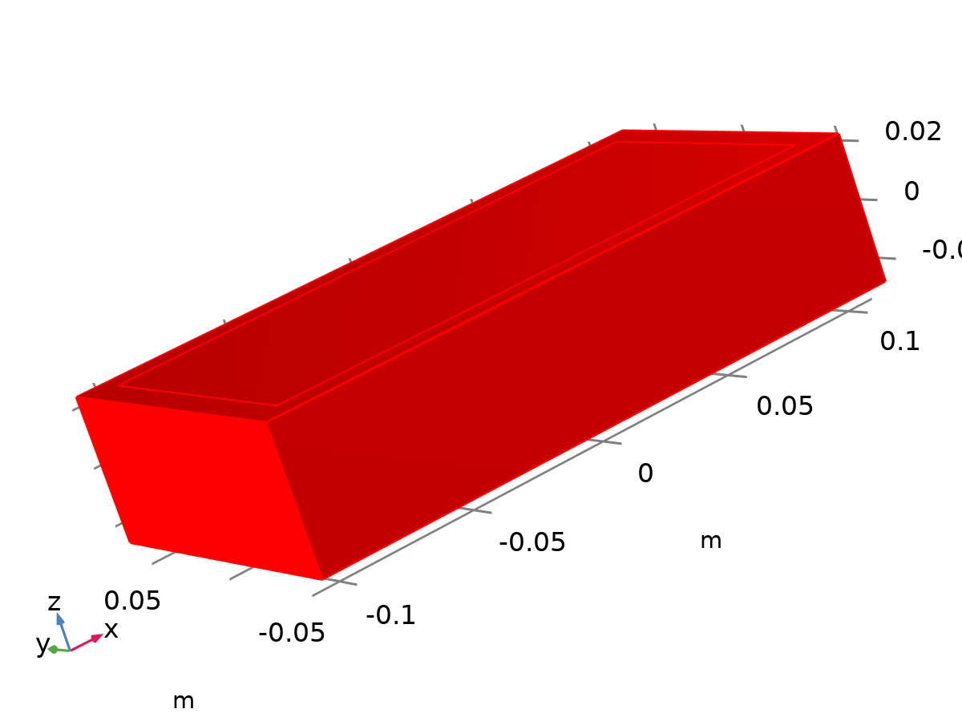

Dataset: Study 1/Solution 1

### Exterior Walls

Data

| **Description** | **Value** |
| --- | --- |
| Dataset | Study 1/Solution 1 (sol1) |

Parameterization

| **Description** | **Value** |
| --- | --- |
| x- and y-axes | Surface parameters |

## Derived Values

### Surface Integration 1

Data

| **Description** | **Value** |
| --- | --- |
| Dataset | Study 1/Solution 1 (sol1) |

Expressions

| **Expression** | **Unit** | **Description** |
| --- | --- | --- |
| T2 | m^2*K | Temperature |
| T3 | m^2*K | Temperature |

Integration settings

| **Description** | **Value** |
| --- | --- |
| Integration order | 4 |

## Plot Groups

### Velocity (spf)

[COMSOLlink[]]

Slice: Velocity magnitude (m/s)

### Pressure (spf)

[COMSOLlink[]]

Contour: Pressure (Pa)

### Temperature (ht2)

[COMSOLlink[]]

Surface: Temperature (K)

### Isothermal Contours (ht2)

[COMSOLlink[]]

Isosurface: Temperature (K)

### Temperature (ht3)

[COMSOLlink[]]

Surface: Temperature (K)

### Isothermal Contours (ht3)

[COMSOLlink[]]

Isosurface: Temperature (K)

### 1D Plot Group 7

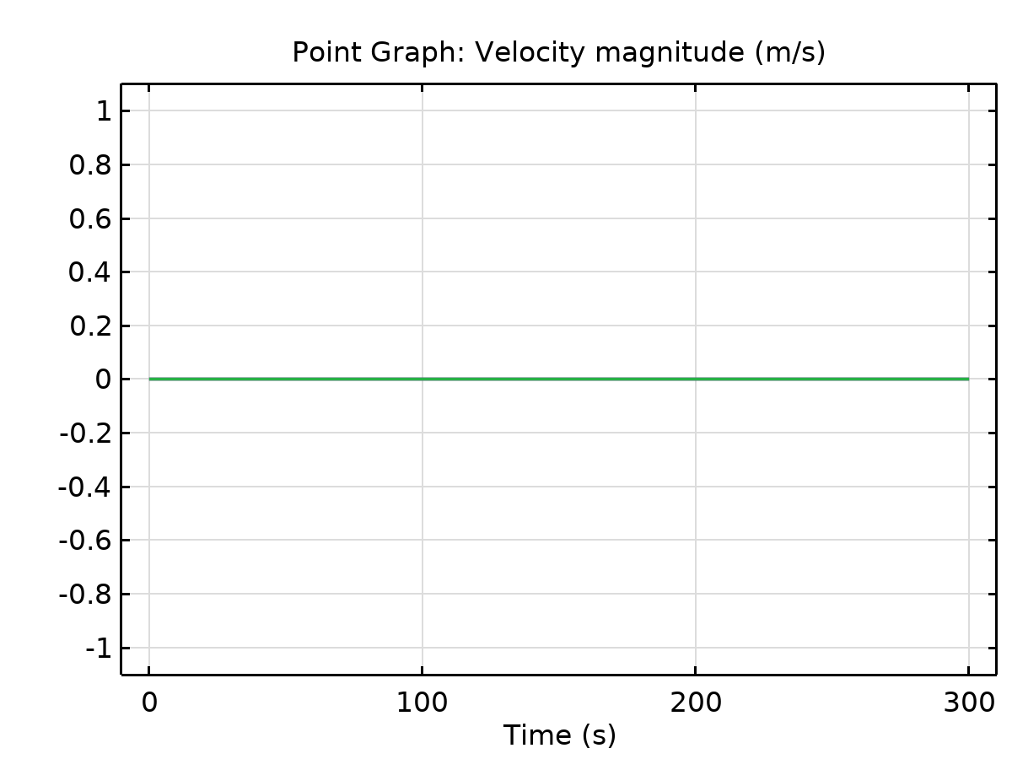

Point Graph: Velocity magnitude (m/s) Global: Average 1

### Cooling Power vs Time

